Third Quarter 2022

 | Giliberto-Levy Commercial Mortgage Performance Index
 | Third Quarter 2022 Summary
 | Total Return: | Total (all sectors) |  | -4.07
 | (in %) | Office |  | -3.52
 |  | Multi-family |  | -4.48
 |  | Retail |  | -3.56
 |  | Industrial |  | -4.04
 | Index Statistics: | Capitalization ($ billion) |  | 271.55
 | (as of 9/30/2022) | Duration (years) |  | 4.85
 |  | Coupon (%) |  | 3.91
 |  | Maturity (years) |  | 6.76
 |  | Book LTV (%) |  | 44.71
 | Source: Giliberto-Levy

Increasing yields on U.S. Treasury issues and increases in commercial mortgage credit spreads caused the Giliberto-Levy Commercial Mortgage Performance Index (G-L 1) to generate a -4.07% total return for 3Q 2022. Year to date, the index is down 10.08%. Trailing four-quarter total return is sightly better at -9.83% due to 4Q 2021’s positive total return. The current result essentially matches the previous worst-ever four-quarter return, which was posted in 1Q 1980. Guess what? The Fed was raising rates dramatically then to quell inflation. And, yes, a recession had already begun, although it was not apparent at the time.

Commercial mortgage credit spreads gained about 20 basis points (bp) in July and August 2022 and appeared to be generally flat during September (see Chart 1). These data are from reported transactions; lenders’ hypothetical asking spreads at quarter end could have differed.

Other investment-grade fixed income investments also got clobbered. That includes U.S. Treasury notes: intermediate-term issues were down more than 3%, according to Bloomberg Barclays Indices. CMBS returns were ahead of G-L 1, producing -3.82% total return. (G-L 1’s duration is slightly longer than the CMBS index, making G-L 1 a bit more sensitive to movements in yields.)

We also note that the ten-year Treasury yield was above 4% (as of October 26, 2022), exceeding the index’s weighted-average coupon rate. The last time this occurred was in September 1982, a few months before the economy hit bottom – of its second recession in the early 1980s.

Chart 1. Spreads over Treasuries for Ten-year Commercial Mortgages
In basis points, reflecting 30/360-day count convention

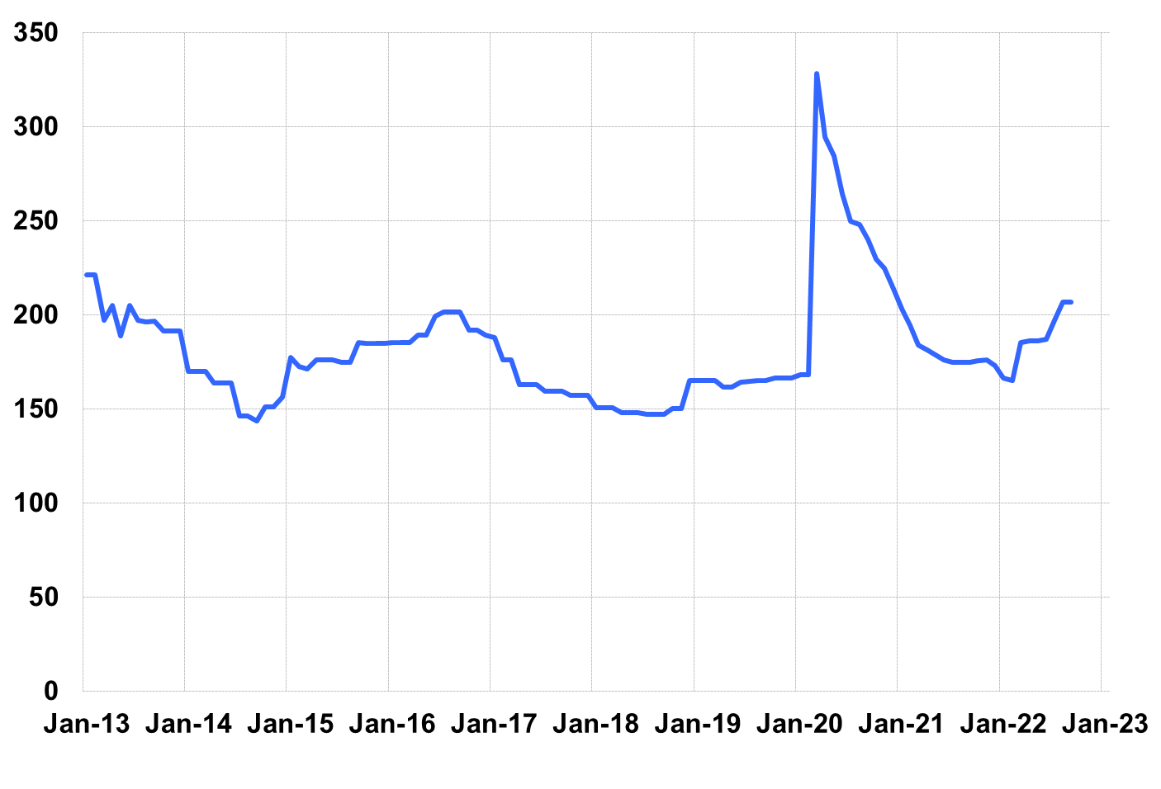

Source: Giliberto-Levy. Chart data are averages of office, apartment, retail and industrial property loans at 60% to 65% LTV for a term of ten years.

The table below summarizes G-L 1 results and statistics. Added detail and analysis will appear in the 3Q 2022 Giliberto-Levy Monitor.

 | G-L 1 Summary
 |  | Most Recent Period |  | Prior Period |  | Year Ago Comp. Period
 |  | 3Q 2022 |  | 2Q 2022 |  | 3Q 2021
 | Index Results:
 | Total Return | -4.07% |  | -1.94% |  | 0.42%
 | Income Return | 0.99% |  | 0.98% |  | 0.94%
 | Capital Value Return | -5.06% |  | -2.93% |  | -0.52%
 | Credit Effect (bp; annualized) | 3 |  | 4 |  | 3
 | Index-eligible Lending Activity [Note 1]:
 | Loan Volume ($ billions) | 4.1 |  | 6.8 |  | 11.0
 | Weighted Average:
 | LTV | 59.7% |  | 59.7% |  | 61.9%
 | DSCR | 1.50 |  | 1.51 |  | 2.37
 | Coupon Rate | 5.05% |  | 4.68% |  | 2.93%
 | Spread (basis points) [Note 2] | 192 |  | 175 |  | 166
 | Term to Maturity (years) | 10.0 |  | 9.8 |  | 10.1
 | Loan Size ($ millions) | 24.6 |  | 29.9 |  | 31.1
 | Notes:
 | 1. Lending activity statistics are subject to revision as additional data are received.
 | 2. Spread is measured with respect to comparable maturity U.S. Treasury yield.
 | Source: Giliberto-Levy

The Index's components are fixed-rate commercial mortgage loans held on balance sheets of institutions such as life insurance companies and pension funds. Index returns are a market-value-weighted blend of office, apartment, retail, industrial, lodging, mixed-use and other miscellaneous property types. Index performance tracks senior loans only; it does not include construction loans, mezzanine and other subordinate instruments and bridge loans made by such institutions.

