**Giliberto-Levy Commercial Mortgage Performance Index (G-L 1)**

**Fourth Quarter 2022 Flash Report**

|  |  |  |  |  |  |
| --- | --- | --- | --- | --- | --- |
|  | **Giliberto-Levy Commercial Mortgage Performance Index** | | | |  |
|  | **Fourth Quarter 2022 Summary** | | |  |  |
|  |  |  |  |  |  |
|  | **Total Return:** | Total (all sectors) | | 1.22 |  |
|  | (in %) | Office |  | 1.09 |  |
|  |  | Multi-family | | 1.24 |  |
|  |  | Retail |  | 1.31 |  |
|  |  | Industrial |  | 1.17 |  |
|  | **Index Statistics:** | Capitalization ($ billion) | | 270.27 |  |
|  | (as of 12/31/2022) | Duration (years) | | 4.77 |  |
|  |  | Coupon (%) | | 3.94 |  |
|  |  | Maturity (years) | | 6.64 |  |
|  |  | Book LTV (%) |  | 46.65 |  |
|  |  |  |  |  |  |
|  | Source: Giliberto-Levy | |  |  |  |

**The Giliberto-Levy Commercial Mortgage Performance Index (G-L 1) moved back into positive return territory in 4Q 2022, posting 1.22% total return.** [1]The index’s capital value return for 4Q 2022 was 0.14%; income return was 1.08%. While 0.14% is not a lot, it marks a pleasant change from a string of negative quarterly capital value results reaching back to and including 3Q 2021.

Commercial mortgage spreads on priced transactions did not change much (see Chart 1). And, for the first time in a while, neither did some U.S. Treasury yields.[2] As a result, discount rates on commercial mortgages on roughly 85% of the index finally stopped getting propelled sharply upward. That’s what kept the capital value outcome (barely) in the black.

Chart 1. Spreads over Treasuries for Ten-year Commercial Mortgages

In basis points, reflecting 30/360-day count convention

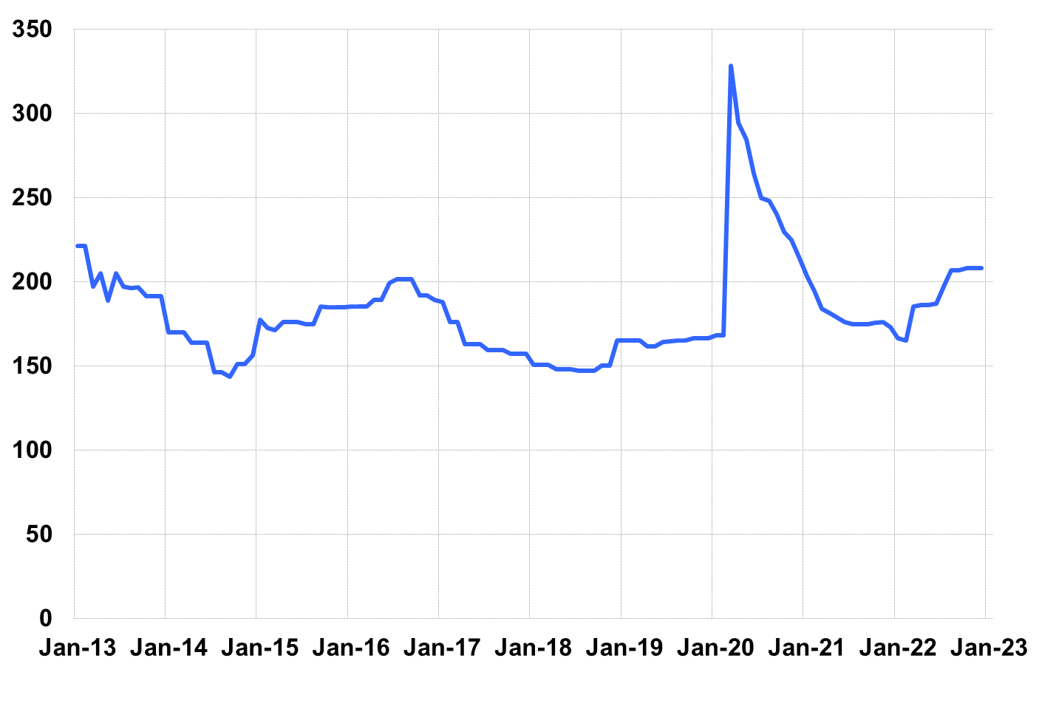

Source: Giliberto-Levy. Chart data are averages of office, apartment, retail and industrial property loans at 60% to 65% LTV for a term of ten years.

Total return for 2022 came in at -8.98%. This is the worst calendar-year G-L 1 performance in its 51-year history. (The weakest-ever trailing four-quarter result occurred as of 3Q 2022 at -9.83%; before 2022, the worst showing was -9.81% as of 3Q 1980.)

Other investment-grade fixed income investments also fared well, and in many cases did better than commercial mortgages. For example, Bloomberg Index Services reported that intermediate-term Baa-rated corporate bonds produced 3.07% total return. Other corporate credit issues, including high yield, also outperformed. But G-L 1 was not an isolated case. Investment investment-grade CMBS produced 0.95% total return, and intermediate Treasuries generated 1.02%.

Lending volume was down substantially, as shown in the G-L 1 summary below. Several lenders reported that they made zero new loans in December 2022, for instance. Added detail and analysis will appear in the 4Q 2022 *Giliberto-Levy Monitor*.

|  |  |  |  |  |  |  |  |
| --- | --- | --- | --- | --- | --- | --- | --- |
|  | **G-L 1 Summary** |  |  |  |  |  |  |
|  |  | **Most Recent Period** |  | **Prior Period** |  | **Year Ago Comp. Period** |  |
|  |  | **4Q 2022** |  | **3Q 2022** |  | **4Q 2021** |  |
|  |  |  |  |  |  |  |  |
|  | **Index Results:** |  |  |  |  |  |  |
|  |  |  |  |  |  |  |  |
|  | Total Return | 1.22% |  | -4.07% |  | 0.28% |  |
|  | Income Return | 1.08% |  | 0.99% |  | 0.94% |  |
|  | Capital Value Return | 0.14% |  | -5.06% |  | -0.66% |  |
|  | Credit Effect (bp; annualized) | 5 |  | 3 |  | 3 |  |
|  |  |  |  |  |  |  |  |
|  | **Index-eligible Lending Activity** [Note 1]**:** | |  |  |  |  |  |
|  |  |  |  |  |  |  |  |
|  | Loan Volume ($ billions) | 3.3 |  | 5.1 |  | 10.3 |  |
|  | Weighted Average: |  |  |  |  |  |  |
|  | LTV | 57.7% |  | 59.2% |  | 60.7% |  |
|  | DSCR | 1.49 |  | 1.47 |  | 2.17 |  |
|  | Coupon Rate | 5.97% |  | 5.19% |  | 3.09% |  |
|  | Spread (basis points) [Note 2] | 200 |  | 195 |  | 159 |  |
|  | Term to Maturity (years) | 8.6 |  | 9.3 |  | 9.4 |  |
|  | Loan Size ($ millions) | 36.6 |  | 26.3 |  | 34.2 |  |
|  |  |  |  |  |  |  |  |
|  | Notes: |  |  |  |  |  |  |
|  | 1. Lending activity statistics are subject to revision as additional data are received. | | | | | | |
|  | 2. Spread is measured with respect to comparable maturity U.S. Treasury yield. | | | | | | |
|  |  |  |  |  |  |  |  |
|  | Source: Giliberto-Levy |  |  |  |  |  |  |

1. The Index's components are fixed-rate commercial mortgage loans held on balance sheets of institutions such as life insurance companies and pension funds. Index returns are a market-value-weighted blend of office, apartment, retail, industrial, lodging, mixed-use and other miscellaneous property types. Index performance tracks senior loans only; it does not include construction loans, mezzanine and other subordinate instruments and bridge loans made by such institutions.
2. U.S. Treasury yields in the three- to ten-year maturity range were nearly unchanged from their September 30, 2022 levels at year end, and longer-dated yields were only moderately higher. Short-term yields increased considerably more. For example, the three-month yield hit 4.42%, up more than 100 basis points (bp) from the prior quarter end.