**Giliberto-Levy Commercial Mortgage Performance Index (G-L 1)**

**Second Quarter 2023 Flash Report**

|  |  |  |  |  |  |
| --- | --- | --- | --- | --- | --- |
|  | **Giliberto-Levy Commercial Mortgage Performance Index** | | | |  |
|  | **Second Quarter 2023 Summary** | | |  |  |
|  |  |  |  |  |  |
|  | **Total Return:** | Total (all sectors) | | -0.74 |  |
|  | (in %) | Office |  | -0.75 |  |
|  |  | Multi-family | | -0.80 |  |
|  |  | Retail |  | -0.45 |  |
|  |  | Industrial |  | -0.81 |  |
|  | **Index Statistics:** | Principal ($ billion) | | 299.21 |  |
|  | (as of 6/30/2023) | Capitalization ($ billion) | | 270.40 |  |
|  |  | Duration (years) | | 4.66 |  |
|  |  | Coupon (%) | | 4.00 |  |
|  |  | Maturity (years) | | 6.45 |  |
|  |  | Book LTV (%) |  | 49.73 |  |
|  |  |  |  |  |  |
|  | Source: Giliberto-Levy | |  |  |  |

**The Giliberto-Levy Commercial Mortgage Performance Index (G-L 1) slipped in 2Q 2023, generating -0.74% total return.** [1]Income return was 1.06%, down from 1.09% in 1Q 2023 due to first quarter’s increase in the index’s value. Rising yields caused capital value to decline 1.80%, reversing some of the gain recorded in 1Q. Year to date G-L 1 total return is 2.38%.

U.S. Treasury yields rose across the board. For example, the benchmark ten-year yield went from 3.48% to 3.81%, a 33-basis point (bp) increase over the quarter. Yields for maturities shorter than ten years were up more. For issues with two to seven years remaining, the average increase was more than 60 bp.

These increases in base rates implied that absent other factors, fixed-income investment values would go down.

Reduced credit spreads are one potential offsetting factor that can blunt the deleterious effect of Treasury yield increases. Good fortune smiled on some corporate bond sectors, with spread declines providing some support for valuations. Unfortunately, commercial mortgage spreads during the quarter held relatively steady (see Chart 1). As a result, no buffer materialized, and Treasury yield moves swamped capital values.

Chart 1. Spreads over Treasuries for Ten-year Commercial Mortgages

In basis points, reflecting 30/360-day count convention

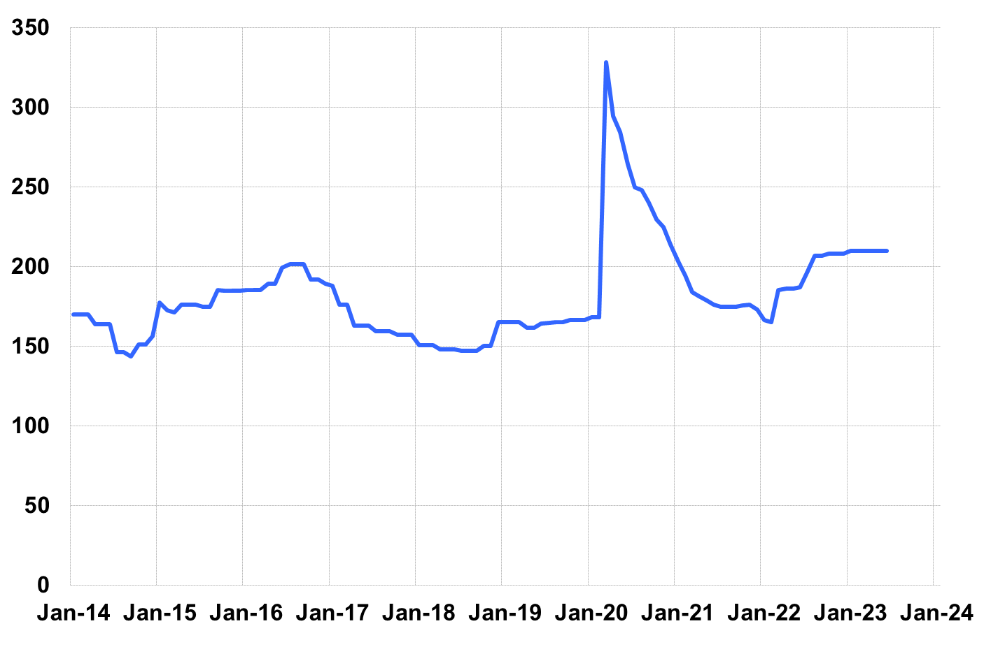

Source: Giliberto-Levy. Chart data are averages of office, apartment, retail and industrial property loans at 60% to 65% LTV for a term of ten years.

Securitized commercial mortgages experienced similar results: investment-grade CMBS returned -0.63%, according to Bloomberg Index Services.

Lending volume rebounded from 1Q’s anemic pace. Lenders continue to favor multifamily and industrial assets. Office loans remain hard to come by and we did see some spread widening. Selective retail lending, concentrated in neighborhood and community centers, continues. Retail loans with moderate LTVs benefitted from small reductions in credit spreads. It’s also worth noting the shorter average loan term posted in the two most recent quarters. A substantial increase in the share (of total volume) of five-year loans accounts for this. Added detail and analysis will appear in the 2Q 2023 *Giliberto-Levy Monitor.*

|  |  |  |  |  |  |  |  |
| --- | --- | --- | --- | --- | --- | --- | --- |
|  | **G-L 1 Summary** |  |  |  |  |  |  |
|  |  | **Most Recent Period** |  | **Prior Period** |  | **Year Ago Comp. Period** |  |
|  |  | **2Q 2023** |  | **1Q 2023** |  | **2Q 2022** |  |
|  |  |  |  |  |  |  |  |
|  | **Index Results:** |  |  |  |  |  |  |
|  |  |  |  |  |  |  |  |
|  | Total Return | -0.74% |  | 3.13% |  | -1.94% |  |
|  | Income Return | 1.06% |  | 1.10% |  | 0.98% |  |
|  | Capital Value Return | -1.80% |  | 2.04% |  | -2.93% |  |
|  | Credit Effect (bp; annualized) | 6 |  | 6 |  | 4 |  |
|  |  |  |  |  |  |  |  |
|  | **Index-eligible Lending Activity** [Note 1]**:** | |  |  |  |  |  |
|  |  |  |  |  |  |  |  |
|  | Loan Volume ($ billions) | 6.2 |  | 4.6 |  | 6.8 |  |
|  | Weighted Average: |  |  |  |  |  |  |
|  | LTV | 61.0% |  | 59.4% |  | 59.7% |  |
|  | DSCR | 1.63 |  | 1.70 |  | 1.71 |  |
|  | Coupon Rate | 5.74% |  | 5.74% |  | 4.68% |  |
|  | Spread (basis points) [Note 2] | 195 |  | 182 |  | 175 |  |
|  | Term to Maturity (years) | 7.8 |  | 7.0 |  | 9.8 |  |
|  | Loan Size ($ millions) | 39.2 |  | 27.2 |  | 29.9 |  |
|  |  |  |  |  |  |  |  |
|  | Notes: |  |  |  |  |  |  |
|  | 1. Lending activity statistics are subject to revision as additional data are received. | | | | | | |
|  | 2. Spread is measured with respect to comparable maturity U.S. Treasury yield. | | | | | | |
|  |  |  |  |  |  |  |  |
|  | Source: Giliberto-Levy |  |  |  |  |  |  |

1. The Index's components are fixed-rate commercial mortgage loans held on balance sheets of institutions such as life insurance companies and pension funds. Index returns are a market-value-weighted blend of office, apartment, retail, industrial, lodging, mixed-use and other miscellaneous property types. Index performance tracks senior loans only; it does not include construction loans, mezzanine and other subordinate instruments and bridge loans made by such institutions.