**Giliberto-Levy Commercial Mortgage Performance Index (G-L 1)**

**Third Quarter 2023 Flash Report**

|  |  |  |  |  |  |
| --- | --- | --- | --- | --- | --- |
|  | **Giliberto-Levy Commercial Mortgage Performance Index** | | | |  |
|  | **Third Quarter 2023 Summary** | | |  |  |
|  |  |  |  |  |  |
|  | **Total Return:** | Total (all sectors) | | -1.36 |  |
|  | (in %) | Office |  | -1.30 |  |
|  |  | Multi-family | | -1.65 |  |
|  |  | Retail |  | -0.52 |  |
|  |  | Industrial |  | -1.21 |  |
|  | **Index Statistics:** | Principal ($ billion) | | 302.79 |  |
|  | (as of 9/30/2023) | Capitalization ($ billion) | | 267.22 |  |
|  |  | Duration (years) | | 4.46 |  |
|  |  | Coupon (%) | | 4.06 |  |
|  |  | Maturity (years) | | 6.21 |  |
|  |  | Book LTV (%) |  | 50.97 |  |
|  |  |  |  |  |  |
|  | Source: Giliberto-Levy | |  |  |  |

**The Giliberto-Levy Commercial Mortgage Performance Index (G-L 1) declined again in 3Q 2023: a sharp rise in yields pushed values lower, resulting in -1.36% total return.** [1] Capital value fell 2.45%. Income return was 1.09%, slightly higher than in 2Q. The increase came mainly from lower loan values at the start of 3Q due to capital value declines posted in 2Q. Year-to-date G-L 1 total return dropped to 0.99%, and trailing four-quarter return as of September 30, 2023 was 2.22%.

U.S. Treasury yields rose between 6 and (almost) 90 basis points (bp) across the yield curve. The benchmark ten-year yield went from 3.81% to 4.59%. The five-year yield, which underpins coupon rates on many new loans, rose 47 bp over the quarter.

Credit spreads were slightly higher on average (see Chart 1). Spread changes varied by sector. Office spreads, not surprisingly, moved up. In contrast, retail spreads came down a bit. Apartment and industrial were slightly higher. Increases were larger at loan-to-value ratios (LTV) above 60%. Again, no surprise there.

Chart 1. Spreads over Treasuries for Ten-year Commercial Mortgages

In basis points, reflecting 30/360-day count convention

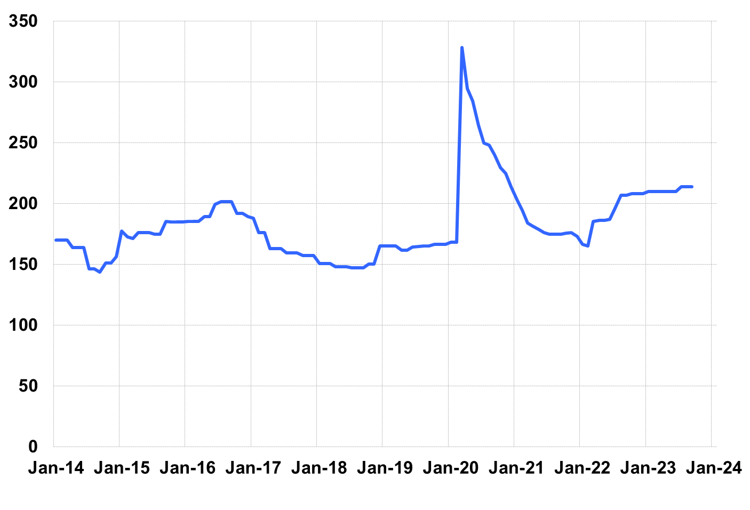

Source: Giliberto-Levy. Chart data are averages of office, apartment, retail and industrial property loans at 60% to 65% LTV for a term of ten years.

Securitized commercial mortgages continued to generate investment returns similar to G-L 1. Investment-grade CMBS returned -1.00%, according to Bloomberg Index Services.

Lending volume in 3Q expanded. Historically, 3Q volume often exceeded the quarterly pace generated in the first half of the year, so there likely was a seasonal component to reported growth. In addition, we heard anecdotally that “blend and extend” deals have increased. That would also boost reported volume. (We are sifting G-L 1 data to see if a more definitive assessment can be made.) Finally, falling collateral values and uncertainty around future property earnings led to a higher percentage of at-risk loans in the G-L 1. Added detail and analysis of these trends will appear in the 3Q 2023 *Giliberto-Levy Monitor.*

|  |  |  |  |  |  |  |  |
| --- | --- | --- | --- | --- | --- | --- | --- |
|  | **G-L 1 Summary** |  |  |  |  |  |  |
|  |  | **Most Recent Period** |  | **Prior Period** |  | **Year Ago Comp. Period** |  |
|  |  | **3Q 2023** |  | **2Q 2023** |  | **3Q 2022** |  |
|  |  |  |  |  |  |  |  |
|  | **Index Results:** |  |  |  |  |  |  |
|  |  |  |  |  |  |  |  |
|  | Total Return | -1.36% |  | -0.74% |  | -1.94% |  |
|  | Income Return | 1.09% |  | 1.06% |  | 0.98% |  |
|  | Capital Value Return | -2.45% |  | -1.80% |  | -2.93% |  |
|  | Credit Effect (bp; annualized) | 6 |  | 6 |  | 3 |  |
|  |  |  |  |  |  |  |  |
|  | **Index-eligible Lending Activity** [Note 1]**:** | |  |  |  |  |  |
|  |  |  |  |  |  |  |  |
|  | Loan Volume ($ billions) | 7.8 |  | 6.6 |  | 5.1 |  |
|  | Weighted Average: |  |  |  |  |  |  |
|  | LTV | 58.6% |  | 61.0% |  | 59.2% |  |
|  | DSCR | 1.51 |  | 1.62 |  | 1.47 |  |
|  | Coupon Rate | 6.10% |  | 5.75% |  | 5.19% |  |
|  | Spread (basis points) [Note 2] | 188 |  | 195 |  | 195 |  |
|  | Term to Maturity (years) | 6.7 |  | 7.7 |  | 9.3 |  |
|  | Loan Size ($ millions) | 38.7 |  | 37.8 |  | 26.3 |  |
|  |  |  |  |  |  |  |  |
|  | Notes: |  |  |  |  |  |  |
|  | 1. Lending activity statistics are subject to revision as additional data are received. | | | | | | |
|  | 2. Spread is measured with respect to comparable maturity U.S. Treasury yield. | | | | | | |
|  |  |  |  |  |  |  |  |
|  | Source: Giliberto-Levy |  |  |  |  |  |  |

1. The Index's components are fixed-rate commercial mortgage loans held on balance sheets of institutions such as life insurance companies and pension funds. Index returns are a market-value-weighted blend of office, apartment, retail, industrial, lodging, mixed-use and other miscellaneous property types. Index performance tracks senior loans only; it does not include construction loans, mezzanine and other subordinate instruments and bridge loans made by such institutions.