**Giliberto-Levy Commercial Mortgage Performance Index (G-L 1)**

**Fourth Quarter 2023 Flash Report**

|  |  |  |  |  |  |
| --- | --- | --- | --- | --- | --- |
|  | **Giliberto-Levy Commercial Mortgage Performance Index** | | | |  |
|  | **Fourth Quarter 2023 Summary** | | |  |  |
|  |  |  |  |  |  |
|  | **Total Return:** | Total (all sectors) | | 4.59 |  |
|  | (in %) | Office |  | 3.77 |  |
|  |  | Multi-family | | 4.86 |  |
|  |  | Retail |  | 4.21 |  |
|  |  | Industrial |  | 4.68 |  |
|  | **Index Statistics:** | Principal ($ billion) | | 302.34 |  |
|  | (as of 12/31/2023) | Capitalization ($ billion) | | 275.96 |  |
|  |  | Duration (years) | | 4.45 |  |
|  |  | Coupon (%) | | 4.10 |  |
|  |  | Maturity (years) | | 6.13 |  |
|  |  | Book LTV (%) |  | 53.11 |  |
|  |  |  |  |  |  |
|  | Source: Giliberto-Levy | |  |  |  |

**The Giliberto-Levy Commercial Mortgage Performance Index (G-L 1) posted a 4.59% total return, its strongest quarterly result since 2Q 2010.** [1]Declines in U.S. Treasury yields powered a 3.42% pop in capital value. Income return was 1.17%. Calendar-year 2023 G-L 1 total return was 5.62%, up significantly from 2022’s -8.98%.

U.S. Treasury yields fell 70 to 80 basis points (bp) at maturities greater than one year. The benchmark ten-year yield went from 4.59% on September 29, 2023 to 3.88% on December 29, 2023 for example. On January 3, 2023, its yield was 3.79%, and the peak was 4.98% on October 19. These swings made for volatile investment results in fixed-income markets.

Credit spreads moved little on average (see Chart 1). We continued to see upward movement for the few office deals that got done in 4Q 2023. The other major sectors barely budged.

Chart 1. Spreads over Treasuries for Ten-year Commercial Mortgages

In basis points, reflecting 30/360-day count convention

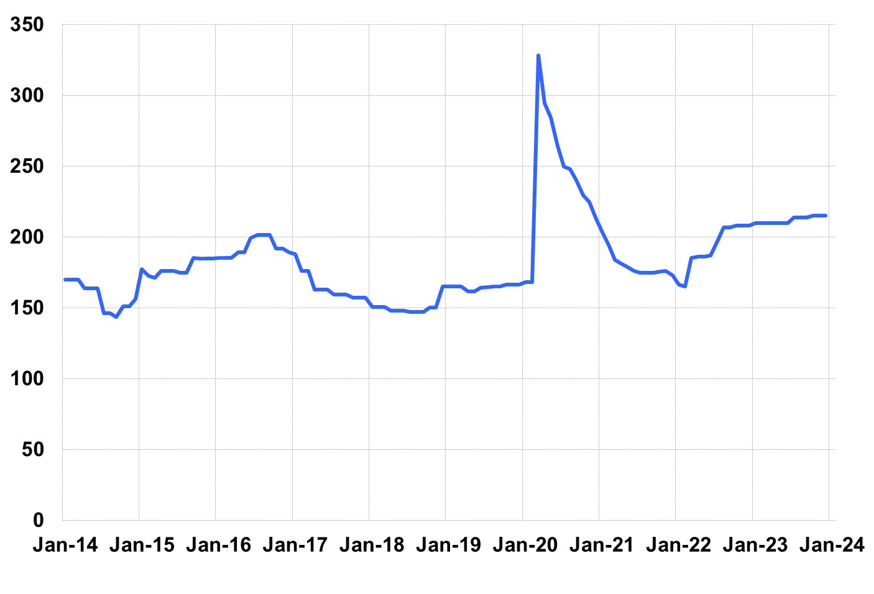

Source: Giliberto-Levy. Chart data are averages of office, apartment, retail and industrial property loans at 60% to 65% LTV for a term of ten years.

Investment-grade CMBS returned 5.24% in 4Q, according to Bloomberg Index Services. Full-year CMBS returns were 5.29%, about 30 bp less than G-L 1.

Lending volume in 4Q fell back, similar to what happened in 2022. Credit effects increased, led by – no surprise here – an uptick in office delinquency. The forthcoming 4Q 2023 *Giliberto-Levy Monitor* will cover results and trends in detail.

|  |  |  |  |  |  |  |  |
| --- | --- | --- | --- | --- | --- | --- | --- |
|  | **G-L 1 Summary** |  |  |  |  |  |  |
|  |  | **Most Recent Period** |  | **Prior Period** |  | **Year Ago Comp. Period** |  |
|  |  | **4Q 2023** |  | **3Q 2023** |  | **4Q 2022** |  |
|  |  |  |  |  |  |  |  |
|  | **Index Results:** |  |  |  |  |  |  |
|  |  |  |  |  |  |  |  |
|  | Total Return | 4.59% |  | -1.36% |  | 1.22% |  |
|  | Income Return | 1.17% |  | 1.09% |  | 1.08% |  |
|  | Capital Value Return | 3.42% |  | -2.45% |  | 0.14% |  |
|  | Credit Effect (bp; annualized) | 7 |  | 6 |  | 5 |  |
|  |  |  |  |  |  |  |  |
|  | **Index-eligible Lending Activity** [Note 1]**:** | |  |  |  |  |  |
|  |  |  |  |  |  |  |  |
|  | Loan Volume ($ billions) | 5.7 |  | 8.5 |  | 3.7 |  |
|  | Weighted Average: |  |  |  |  |  |  |
|  | LTV | 58.4% |  | 58.6% |  | 57.8% |  |
|  | DSCR | 1.43 |  | 1.51 |  | 1.51 |  |
|  | Coupon Rate | 6.50% |  | 6.17% |  | 5.98% |  |
|  | Spread (basis points) [Note 2] | 177 |  | 184 |  | 202 |  |
|  | Term to Maturity (years) | 6.6 |  | 6.6 |  | 8.6 |  |
|  | Loan Size ($ millions) | 28.5 |  | 38.3 |  | 36.0 |  |
|  |  |  |  |  |  |  |  |
|  | Notes: |  |  |  |  |  |  |
|  | 1. Lending activity statistics are subject to revision as additional data are received. | | | | | | |
|  | 2. Spread is measured with respect to comparable maturity U.S. Treasury yield. | | | | | | |
|  |  |  |  |  |  |  |  |
|  | Source: Giliberto-Levy |  |  |  |  |  |  |

1. The Index's components are fixed-rate commercial mortgage loans held on balance sheets of institutions such as life insurance companies and pension funds. Index returns are a market-value-weighted blend of office, apartment, retail, industrial, lodging, mixed-use and other miscellaneous property types. Index performance tracks senior loans only; it does not include construction loans, mezzanine and other subordinate instruments and bridge loans made by such institutions.