**Giliberto-Levy Commercial Mortgage Performance Index (G-L 1)**

**First Quarter 2024 Flash Report**

|  |  |  |  |  |  |
| --- | --- | --- | --- | --- | --- |
|  | **Giliberto-Levy Commercial Mortgage Performance Index** | | | |  |
|  | **First Quarter 2024 Summary** | | |  |  |
|  |  |  |  |  |  |
|  | **Total Return:** | Total (all sectors) | | 0.29 |  |
|  | (in %) | Office |  | -0.21 |  |
|  |  | Multi-family | | 0.34 |  |
|  |  | Retail |  | 0.55 |  |
|  |  | Industrial |  | 0.36 |  |
|  | **Index Statistics:** | Principal ($ billion) | | 303.26 |  |
|  | (as of 3/31/2024) | Capitalization ($ billion) | | 274.81 |  |
|  |  | Duration (years) | | 4.31 |  |
|  |  | Coupon (%) | | 4.14 |  |
|  |  | Maturity (years) | | 5.94 |  |
|  |  | Book LTV (%) |  | 54.19 |  |
|  |  |  |  |  |  |
|  | Source: Giliberto-Levy | |  |  |  |

**The Giliberto-Levy Commercial Mortgage Performance Index (G-L 1) generated 0.29% total return for 1Q 2024.** [1] Surging intermediate and long-term U.S. Treasury yields caused this abrupt reversal from the strong return posted in 4Q 2023.

Treasury yields rose roughly 25 to 40 basis points (bp) at maturities greater than one year. The benchmark ten-year yield went from 3.88% at year-end 2023 to 4.20% at the end of March 2024. The five-year yield – the majority of recent new lending has been five-year deals – experienced a 37-bp increase.

In contrast, credit spreads moved down about 10 bp for all major sectors except office. The few fixed-rate office deals reported had spreads comparable to 4Q 2024. Chart 1 (below) shows the average spread for major sectors over time.

Chart 1. Spreads over Treasuries for Ten-year Commercial Mortgages

In basis points, reflecting 30/360-day count convention

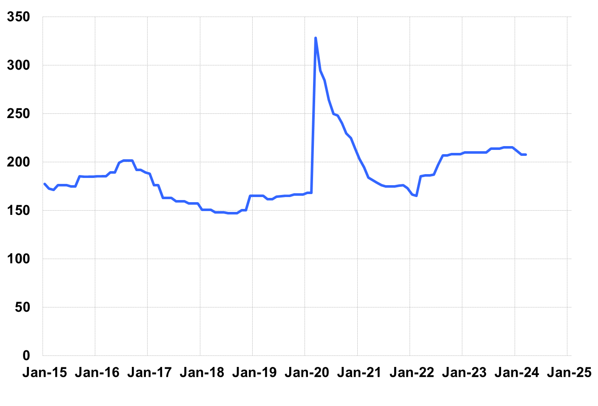

Source: Giliberto-Levy. Chart data are averages of office, apartment, retail and industrial property loans at 60% to 65% LTV for a term of ten years.

Investment-grade CMBS returned 1.00 in 1Q 2024, according to Bloomberg Index Services. Spreads declined about 30 bp for these bonds. That factor kept the increase in yields or discount rates to about 5 bp. In contrast, G-L 1 yield increased 28 bp. As a result, G-L 1 returns were in line with those for Baa-rate intermediate term corporate bonds with similar duration.

Lending volume was down in 1Q. We believe some of this is a seasonal effect, as the same pattern occurred moving from 4Q 2022 to 1Q 2023.

Credit effects continued to increase. The overall change was small, but we note that both office and retail trailing four-quarter credit effects now are in double digits at 14 bp and 11 bp, respectively. The last time this was so occurred in late 2014 as credit effects from the GFC finally died down after peaking in 2012.

The forthcoming 1Q 2024 *Giliberto-Levy Monitor* will cover results and trends in detail.

|  |  |  |  |  |  |  |  |
| --- | --- | --- | --- | --- | --- | --- | --- |
|  | **G-L 1 Summary** |  |  |  |  |  |  |
|  |  | **Most Recent Period** |  | **Prior Period** |  | **Year Ago Comp. Period** |  |
|  |  | **1Q 2024** |  | **4Q 2023** |  | **1Q 2023** |  |
|  |  |  |  |  |  |  |  |
|  | **Index Results:** |  |  |  |  |  |  |
|  |  |  |  |  |  |  |  |
|  | Total Return | 0.29% |  | 4.59% |  | 3.13% |  |
|  | Income Return | 1.12% |  | 1.17% |  | 1.10% |  |
|  | Capital Value Return | -0.83% |  | 3.42% |  | 2.04% |  |
|  | Credit Effect (bp; annualized) | 7 |  | 7 |  | 6 |  |
|  |  |  |  |  |  |  |  |
|  | **Index-eligible Lending Activity** [Note 1]**:** | |  |  |  |  |  |
|  |  |  |  |  |  |  |  |
|  | Loan Volume ($ billions) | 3.7 |  | 6.0 |  | 4.6 |  |
|  | Weighted Average: |  |  |  |  |  |  |
|  | LTV | 58.8% |  | 59.7% |  | 59.4% |  |
|  | DSCR | 1.55 |  | 1.40 |  | 1.7 |  |
|  | Coupon Rate | 5.96% |  | 6.39% |  | 5.74% |  |
|  | Spread (basis points) [Note 2] | 173 |  | 185 |  | 182 |  |
|  | Term to Maturity (years) | 6.9 |  | 6.4 |  | 7.0 |  |
|  | Loan Size ($ millions) | 28.8 |  | 30.4 |  | 27.2 |  |
|  |  |  |  |  |  |  |  |
|  | Notes: |  |  |  |  |  |  |
|  | 1. Lending activity statistics are subject to revision as additional data are received. | | | | | | |
|  | 2. Spread is measured with respect to comparable maturity U.S. Treasury yield. | | | | | | |
|  |  |  |  |  |  |  |  |
|  | Source: Giliberto-Levy |  |  |  |  |  |  |

1. The Index's components are fixed-rate commercial mortgage loans held on balance sheets of institutions such as life insurance companies and pension funds. Index returns are a market-value-weighted blend of office, apartment, retail, industrial, lodging, mixed-use and other miscellaneous property types. Index performance tracks senior loans only; it does not include construction loans, mezzanine and other subordinate instruments and bridge loans made by such institutions.