**Giliberto-Levy Commercial Mortgage Performance Index (G-L 1)**

**Second Quarter 2024 Flash Report**

|  |  |  |  |  |  |
| --- | --- | --- | --- | --- | --- |
|  | **Giliberto-Levy Commercial Mortgage Performance Index** | | | |  |
|  | **Second Quarter 2024 Summary** | | |  |  |
|  |  |  |  |  |  |
|  | **Total Return:** | Total (all sectors) | | 1.10 |  |
|  | (in %) | Office |  | 0.65 |  |
|  |  | Multi-family | | 1.13 |  |
|  |  | Retail |  | 1.25 |  |
|  |  | Industrial |  | 1.17 |  |
|  | **Index Statistics:** | Principal ($ billion) | | 301.91 |  |
|  | (as of 6/30/2024) | Capitalization ($ billion) | | 273.03 |  |
|  |  | Duration (years) | | 4.23 |  |
|  |  | Coupon (%) | | 4.18 |  |
|  |  | Maturity (years) | | 5.83 |  |
|  |  | Book LTV (%) |  | 54.89 |  |
|  |  |  |  |  |  |
|  | Source: Giliberto-Levy | |  |  |  |

**The Giliberto-Levy Commercial Mortgage Performance Index (G-L 1) posted 1.10% total return for 2Q 2024.** [1] The index registered a 4.60% trailing four-quarter total return.

Treasury yields rose again during 2Q, but by less than in 1Q. Yields on issues with two to ten years to maturity increased 12 to 16 basis points (bp). The benchmark ten-year yield went from 4.20% at the end of 1Q to 4.36% on the last trading day in June. The five-year yield – the majority of recent new lending has been five-year deals – experienced a 12-bp increase.

Echoing results from the first quarter, credit spreads moved down. The decline was about 10 bp in April, when Treasury yields shot up. As yields declined in May and June, spreads ticked up 5 bp, ending the quarter about 5 bp lower than where they finished in the first quarter (see Chart 1). Office, to no one’s surprise, did not participate in the spread narrowing.

Chart 1. Spreads over Treasuries for Ten-year Commercial Mortgages

In basis points, reflecting 30/360-day count convention

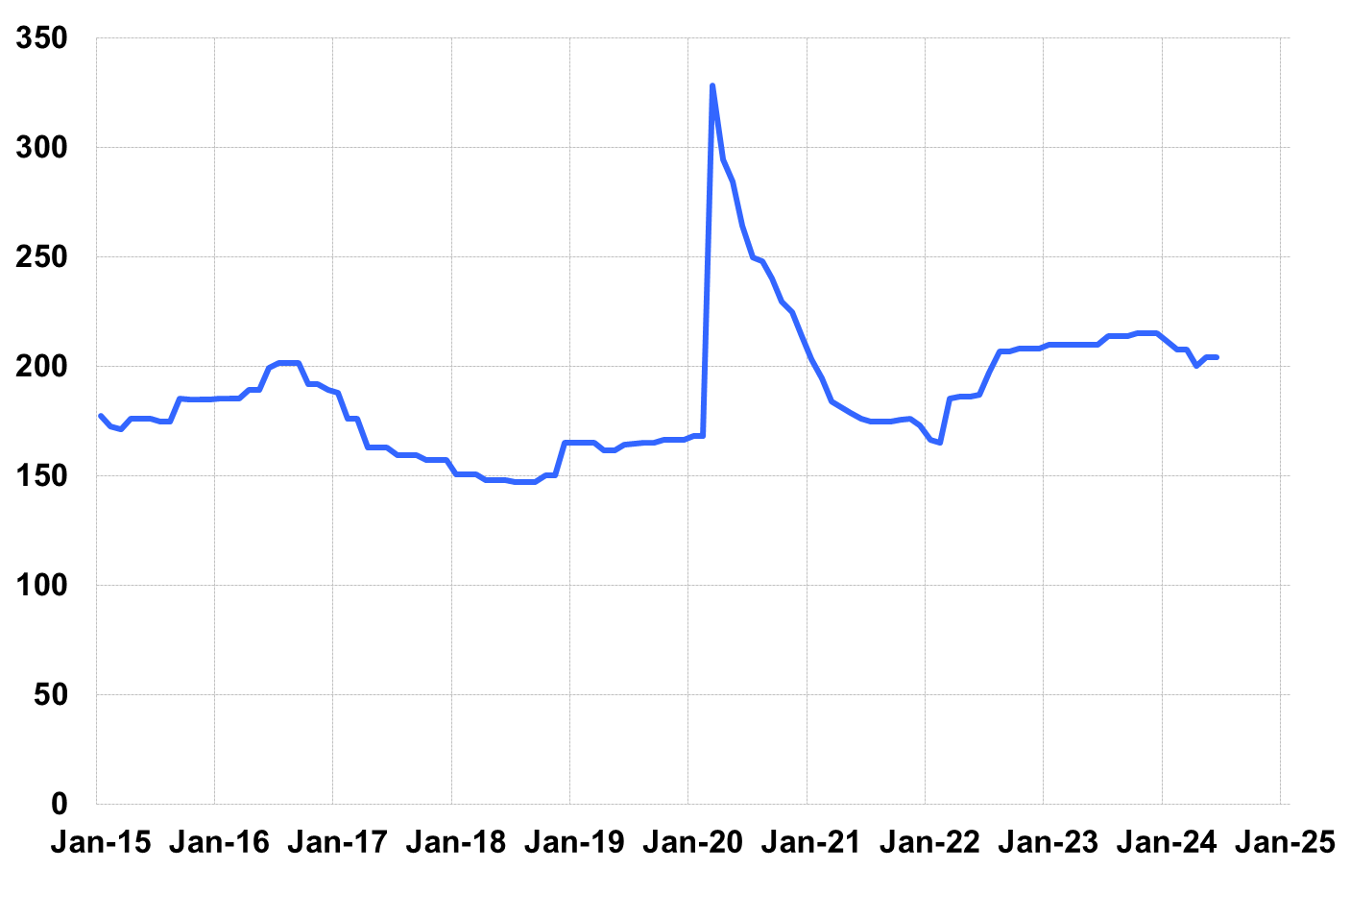

Source: Giliberto-Levy. Chart data are averages of office, apartment, retail and industrial property loans at 60% to 65% LTV for a term of ten years.

Investment-grade CMBS returned 0.74% in 2Q 2024, according to Bloomberg Index Services. G-L 1 produces about 25 bp higher income return than CMBS. That accounts for a large part of G-L 1’s relative outperformance in 2Q. The remaining 11 bp reflects differences in duration and index composition, such as property type mix.

Lending volume picked up in 2Q. Late reporting of 1Q lending activity improved that quarter’s result by more than 25%. However, even with that gain, 1Q volume still came in below 2Q. This outcome is consistent with the first quarter volume “dip” we discussed in the 1Q 2024 *Flash Report*.

Credit effects showed a further increase. The annualized pace moved from 6 bp to 9 bp, a large relative move. Of course, this is still quite low in a historical context.

The 2Q 2024 *Giliberto-Levy Monitor* will cover results and trends in detail.

|  |  |  |  |  |  |  |  |
| --- | --- | --- | --- | --- | --- | --- | --- |
|  | **G-L 1 Summary** |  |  |  |  |  |  |
|  |  | **Most Recent Period** |  | **Prior Period** |  | **Year Ago Comp. Period** |  |
|  |  | **2Q 2024** |  | **1Q 2024** |  | **2Q 2023** |  |
|  |  |  |  |  |  |  |  |
|  | **Index Results:** |  |  |  |  |  |  |
|  |  |  |  |  |  |  |  |
|  | Total Return | 1.10% |  | 0.29% |  | 3.13% |  |
|  | Income Return | 1.15% |  | 1.12% |  | 1.10% |  |
|  | Capital Value Return | -0.05% |  | -0.83% |  | 2.04% |  |
|  | Credit Effect (bp; annualized) | 9 |  | 6 |  | 6 |  |
|  |  |  |  |  |  |  |  |
|  | **Index-eligible Lending Activity** [Note 1]**:** | |  |  |  |  |  |
|  |  |  |  |  |  |  |  |
|  | Loan Volume ($ billions) | 5.3 |  | 4.7 |  | 6.6 |  |
|  | Weighted Average: |  |  |  |  |  |  |
|  | LTV | 63.2% |  | 59.4% |  | 61.0% |  |
|  | DSCR | 1.44 |  | 1.52 |  | 1.62 |  |
|  | Coupon Rate | 6.07% |  | 5.98% |  | 5.75% |  |
|  | Spread (basis points) [Note 2] | 170 |  | 174 |  | 195 |  |
|  | Term to Maturity (years) | 7.4 |  | 6.9 |  | 7.7 |  |
|  | Loan Size ($ millions) | 32.3 |  | 30.5 |  | 37.8 |  |
|  |  |  |  |  |  |  |  |
|  | Notes: |  |  |  |  |  |  |
|  | 1. Lending activity statistics are subject to revision as additional data are received. | | | | | | |
|  | 2. Spread is measured with respect to comparable maturity U.S. Treasury yield. | | | | | | |
|  |  |  |  |  |  |  |  |
|  | Source: Giliberto-Levy |  |  |  |  |  |  |

1. The Index's components are fixed-rate commercial mortgage loans held on balance sheets of institutions such as life insurance companies and pension funds. Index returns are a market-value-weighted blend of office, apartment, retail, industrial, lodging, mixed-use and other miscellaneous property types. Index performance tracks senior loans only; it does not include construction loans, mezzanine and other subordinate instruments and bridge loans made by such institutions.