**Giliberto-Levy Commercial Mortgage Performance Index (G-L 1)**

**Third Quarter 2024 Flash Report**

|  |  |  |  |  |  |
| --- | --- | --- | --- | --- | --- |
|  | **Giliberto-Levy Commercial Mortgage Performance Index** | | | |  |
|  | **Third Quarter 2024 Summary** | | |  |  |
|  |  |  |  |  |  |
|  | **Total Return:** | Total (all sectors) | | 4.63 |  |
|  | (in %) | Office |  | 4.15 |  |
|  |  | Multi-family | | 4.91 |  |
|  |  | Retail |  | 4.62 |  |
|  |  | Industrial |  | 4.39 |  |
|  | **Index Statistics:** | Principal ($ billion) | | 303.54 |  |
|  | (as of 9/30/2024) | Capitalization ($ billion) | | 284.23 |  |
|  |  | Duration (years) | | 4.22 |  |
|  |  | Coupon (%) | | 4.24 |  |
|  |  | Maturity (years) | | 5.77 |  |
|  |  | Book LTV (%) |  | 55.10 |  |
|  |  |  |  |  |  |
|  | Source: Giliberto-Levy | |  |  |  |

**The Giliberto-Levy Commercial Mortgage Performance Index (G-L 1) generated 4.63% total return for 3Q 2024.** [1] This is the largest quarterly return since 2Q 2010 during the recovery from the global financial crisis (GFC). The index’s trailing four-quarter total return was 10.96%, marking the first double-digit level for this measure in five years.

Sharp declines in U.S. Treasury yields powered this strong result. The five-year rate moved down 75 basis points (bp), and the ten-year came down 55 bp. Commercial mortgage coupon rates and valuation yields followed suit. This shift produced a 3.47% capital value return. Income return was 1.16%.

Credit spreads, other than for offices, tightened modestly (see Chart 1). This ran counter to the more typical response of credit spreads moving up when Treasury yields decline. We think this may indicate that lenders feel property valuations are unlikely to decline much further, office excepted. That said, spreads did increase slightly in September.

Chart 1. Spreads over Treasuries for Ten-year Commercial Mortgages

In basis points, reflecting 30/360-day count convention

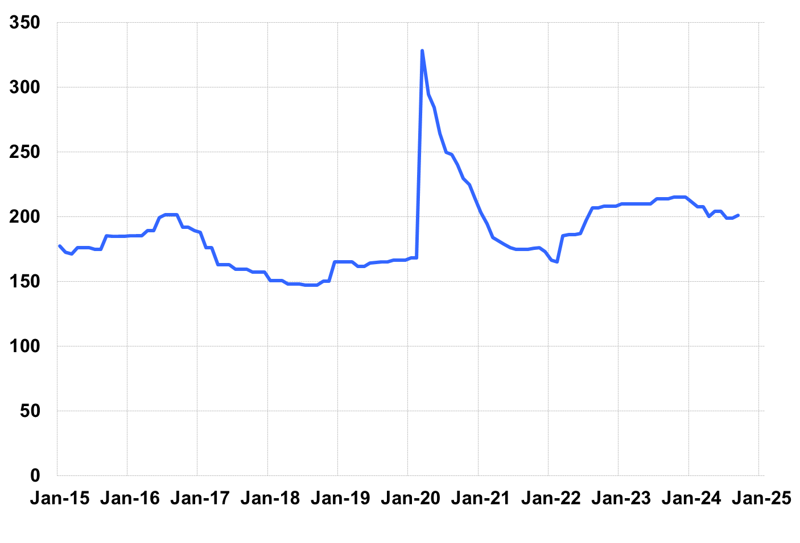

Source: Giliberto-Levy. Chart data are averages of office, apartment, retail and industrial property loans at 60% to 65% LTV for a term of ten years.

Investment-grade CMBS posted a 4.66% total return in 3Q 2024, according to Bloomberg Index Services.

Lending volume showed another quarter-over-quarter gain in 3Q. Volume was comparable to that posted in 3Q 2023. (Late reporting of 3Q lending will likely put 3Q 2024 volume ahead of 3Q 2023.) Multifamily and industrial together accounted for 75% of total activity. Loans on retail properties made up 13% of volume. Loans on lodging, mixed use and miscellaneous other property types collectively outpaced lending on offices. The latter sector continues to be challenging to underwrite.

Trailing four-quarter credit effects once again edged higher, although the annualized 3Q rate was down one bp (see the table below). As we have noted before, credit effect is a lagging indicator. Its cyclical peak often occurs after asset valuations have started to rebound.

The 3Q 2024 *Giliberto-Levy Monitor* will cover results and trends in detail.

|  |  |  |  |  |  |  |  |
| --- | --- | --- | --- | --- | --- | --- | --- |
|  | **G-L 1 Summary** |  |  |  |  |  |  |
|  |  | **Most Recent Period** |  | **Prior Period** |  | **Year Ago Comp. Period** |  |
|  |  | **3Q 2024** |  | **2Q 2024** |  | **3Q 2023** |  |
|  |  |  |  |  |  |  |  |
|  | **Index Results:** |  |  |  |  |  |  |
|  |  |  |  |  |  |  |  |
|  | Total Return | 4.63% |  | 1.10% |  | -1.36% |  |
|  | Income Return | 1.16% |  | 1.15% |  | 1.09% |  |
|  | Capital Value Return | 3.47% |  | -0.05% |  | -2.45% |  |
|  | Credit Effect (bp; annualized) | 8 |  | 9 |  | 6 |  |
|  |  |  |  |  |  |  |  |
|  | **Index-eligible Lending Activity** [Note 1]**:** | |  |  |  |  |  |
|  |  |  |  |  |  |  |  |
|  | Loan Volume ($ billions) | 8.2 |  | 6.0 |  | 8.5 |  |
|  | Weighted Average: |  |  |  |  |  |  |
|  | LTV | 61.4% |  | 62.9% |  | 58.6% |  |
|  | DSCR | 1.60 |  | 1.46 |  | 1.51 |  |
|  | Coupon Rate | 5.71% |  | 6.08% |  | 6.17% |  |
|  | Spread (basis points) [Note 2] | 177 |  | 172 |  | 184 |  |
|  | Term to Maturity (years) | 7.1 |  | 7.8 |  | 6.6 |  |
|  | Loan Size ($ millions) | 35.4 |  | 31.8 |  | 38.3 |  |
|  |  |  |  |  |  |  |  |
|  | Notes: |  |  |  |  |  |  |
|  | 1. Lending activity statistics are subject to revision as additional data are received. | | | | | | |
|  | 2. Spread is measured with respect to comparable maturity U.S. Treasury yield. | | | | | | |
|  |  |  |  |  |  |  |  |
|  | Source: Giliberto-Levy |  |  |  |  |  |  |

1. The Index's components are fixed-rate commercial mortgage loans held on balance sheets of institutions such as life insurance companies and pension funds. Index returns are a market-value-weighted blend of office, apartment, retail, industrial, lodging, mixed-use and other miscellaneous property types. Index performance tracks senior loans only; it does not include construction loans, mezzanine and other subordinate instruments and bridge loans made by such institutions.