**Giliberto-Levy Commercial Mortgage Performance Index (G-L 1)**

**Fourth Quarter 2024 Flash Report**

|  |  |  |  |  |  |
| --- | --- | --- | --- | --- | --- |
|  | **Giliberto-Levy Commercial Mortgage Performance Index** | | | |  |
|  | **Fourth Quarter 2024 Summary** | | |  |  |
|  |  |  |  |  |  |
|  | **Total Return:** | Total (all sectors) | | -1.05 |  |
|  | (in %) | Office |  | -0.96 |  |
|  |  | Multi-family | | -1.12 |  |
|  |  | Retail |  | -0.68 |  |
|  |  | Industrial |  | -1.10 |  |
|  | **Index Statistics:** | Principal ($ billion) | | 306.60 |  |
|  | (as of 12/31/2024) | Capitalization ($ billion) | | 281.00 |  |
|  |  | Duration (years) | | 4.08 |  |
|  |  | Coupon (%) | | 4.25 |  |
|  |  | Maturity (years) | | 5.60 |  |
|  |  | Book LTV (%) |  | 55.24 |  |
|  |  |  |  |  |  |
|  | Source: Giliberto-Levy | |  |  |  |

**Rising U.S. Treasury yields caused the Giliberto-Levy Commercial Mortgage Performance Index (G-L 1) total return for 4Q 2024 to drop to -1.05%.** [1] Income return, as usual, was fairly steady, coming in at 1.24% compared with 1.16% in 3Q. Yield increases led to a -2.29% capital-value return. Credit effects had a slight effect. Most of the decline reflected loan values being marked to align with market yields.

Calendar-year 2024 total return was 4.98%. In 2023, G-L 1 posted a 5.62% total return. Most of 2023’s higher return was due to mark-to-market capital-value gains of more than 1%. In contrast, in 2024 the index eked out less than 25 basis points (bp) of gain.

The upward move in U.S. Treasury yields was largely unexpected since the Federal Reserve’s policy stance had tilted toward reducing interest rates. Indeed, rates at the short end of the yield curve went down in 4Q. However, yields on issues with two or more years of term rose 60 to 80 bp.

As Treasury yields rose, credit spreads started to decline (see Chart 1). This pattern is normal: we have observed commercial mortgage spreads moving inversely with Treasury yields about two-thirds of the time.

Chart 1. Spreads over Treasuries for Ten-year Commercial Mortgages

In basis points, reflecting 30/360-day count convention

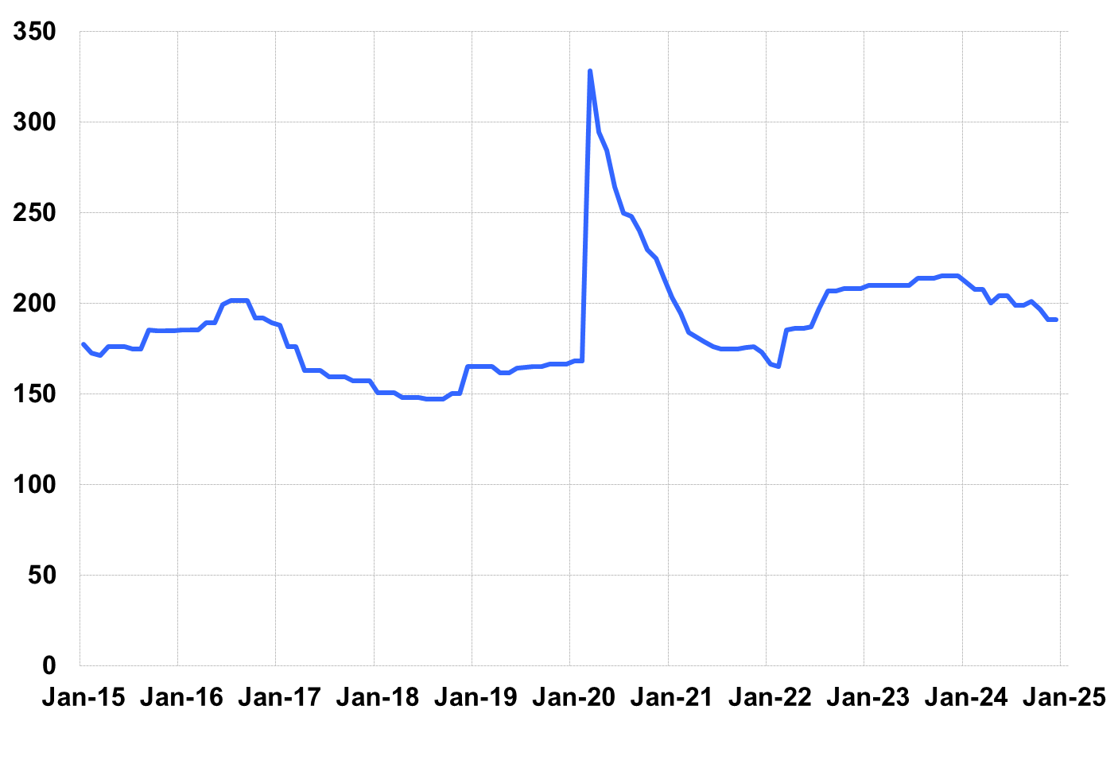

Source: Giliberto-Levy. Chart data are averages of office, apartment, retail and industrial property loans at 60% to 65% LTV for a term of ten years.

Investment-grade CMBS generated -1.42% total return in 4Q 2024, according to Bloomberg Index Services.

Lending volume held up despite higher coupon rates. (There is often a push to close deals before year end.) Increased lending on retail assets was notable in 2024, with volume nearly doubling.

Trailing four-quarter credit effects registered a moderate increase. This mainly reflects higher losses on office assets. That sector’s impact was muted by its relatively low 12% share within G-L 1.

The 4Q 2024 *Giliberto-Levy Monitor* will cover results and trends in detail.

|  |  |  |  |  |  |  |  |
| --- | --- | --- | --- | --- | --- | --- | --- |
|  | **G-L 1 Summary** |  |  |  |  |  |  |
|  |  | **Most Recent Period** |  | **Prior Period** |  | **Year Ago Comp. Period** |  |
|  |  | **4Q 2024** |  | **3Q 2024** |  | **4Q 2023** |  |
|  |  |  |  |  |  |  |  |
|  | **Index Results:** |  |  |  |  |  |  |
|  |  |  |  |  |  |  |  |
|  | Total Return | -1.05% |  | 4.63% |  | 4.59% |  |
|  | Income Return | 1.24% |  | 1.16% |  | 1.17% |  |
|  | Capital Value Return | -2.29% |  | 3.47% |  | 3.42% |  |
|  | Credit Effect (bp; annualized) | 8 |  | 8 |  | 7 |  |
|  |  |  |  |  |  |  |  |
|  | **Index-eligible Lending Activity** [Note 1]**:** | |  |  |  |  |  |
|  |  |  |  |  |  |  |  |
|  | Loan Volume ($ billions) | 9.0 |  | 9.5 |  | 6.0 |  |
|  | Weighted Average: |  |  |  |  |  |  |
|  | LTV | 59.6% |  | 61.3% |  | 59.7% |  |
|  | DSCR | 1.53 |  | 1.62 |  | 1.4 |  |
|  | Coupon Rate | 5.95% |  | 5.68% |  | 6.39% |  |
|  | Spread (basis points) [Note 2] | 187 |  | 179 |  | 185 |  |
|  | Term to Maturity (years) | 6.5 |  | 7.0 |  | 6.4 |  |
|  | Loan Size ($ millions) | 41.8 |  | 35.6 |  | 30.4 |  |
|  |  |  |  |  |  |  |  |
|  | Notes: |  |  |  |  |  |  |
|  | 1. Lending activity statistics are subject to revision as additional data are received. | | | | | | |
|  | 2. Spread is measured with respect to comparable maturity U.S. Treasury yield. | | | | | | |
|  |  |  |  |  |  |  |  |
|  | Source: Giliberto-Levy |  |  |  |  |  |  |

1. The Index's components are fixed-rate commercial mortgage loans held on balance sheets of institutions such as life insurance companies and pension funds. Index returns are a market-value-weighted blend of office, apartment, retail, industrial, lodging, mixed-use and other miscellaneous property types. Index performance tracks senior loans only; it does not include construction loans, mezzanine and other subordinate instruments and bridge loans made by such institutions.