

Giliberto-Levy Commercial Mortgage Performance Index (G-L 1)
First Quarter 2025 Flash Report

 | Giliberto-Levy Commercial Mortgage Performance Index
 | First Quarter 2025 Summary
 | Total Return: | Total (all sectors) |  | 3.23
 | (in %) | Office |  | 2.75
 |  | Multi-family |  | 3.35
 |  | Retail |  | 3.14
 |  | Industrial |  | 3.30
 | Index Statistics: | Principal ($ billion) |  | 307.45
 | (as of 3/31/2025) | Capitalization ($ billion) |  | 287.68
 |  | Duration (years) |  | 4.05
 |  | Coupon (%) |  | 4.35
 |  | Maturity (years) |  | 5.53
 |  | Book LTV (%) |  | 55.42
 | Source: Giliberto-Levy

The Giliberto-Levy Commercial Mortgage Performance Index (G-L 1) generated 3.23% total return for 1Q 2025, reversing 4Q 2024’s -1.05% result and then some. Movement in the U.S. Treasury yield curve was again the main driver of performance through its effect on capital value. Last quarter, capital value return was -2.29% due to increased Treasury yields. This quarter, yields declined, powering a 2.06% capital value return. Income return remained solid at 1.17%. (G-L 1 income return fluctuates as capital value, which is the denominator in the return calculation, moves up and down.)

Commercial mortgage credit spreads on priced transactions in January 2025 were about the same as in December 2024. They declined slightly in February and March (see Chart 1). However, the spread reduction only appeared for favored property types: multifamily, industrial and select retail. Spreads on high-LTV office loans increased.

Chart 1. Spreads over Treasuries for Ten-year Commercial Mortgages
In basis points, reflecting 30/360-day count convention

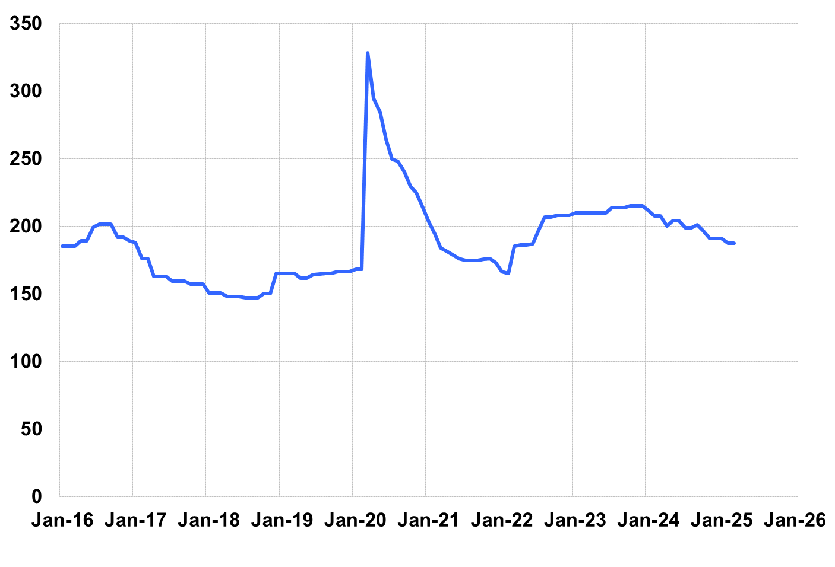
Source: Giliberto-Levy. Chart data are averages of office, apartment, retail and industrial property loans at 60% to 65% LTV for a term of ten years.

We also found a term premium averaging about 30 basis points (bp) embedded in spreads for newly originated fixed-rate loans with terms to maturity below 49 months. This premium caused coupon rates for these loans to roughly match coupon rates on new loans with ten-year terms. We believe lenders sought compensation for short-term extensions and or refinancings of existing loans. However, we did not think it was appropriate to apply this premium to seasoned loans with similar maturities and credit characteristics.

Investment-grade CMBS produced 2.57% total return in 1Q 2025, according to Bloomberg Index Services.

First quarter lending volume is typically lower than other quarters. The table below shows that 1Q 2025 production was comparable to 1Q 2024 production. (Data for 2024 includes loans originated in 1Q but not reported until later in 2024; 2025 revisions, which will increase reported volume, are likely.)

The 1Q 2025 Giliberto-Levy Monitor will cover results and trends in detail.
 | G-L 1 Summary
 |  | Most Recent Period |  | Prior Period |  | Year Ago Comp. Period
 |  | 1Q 2025 |  | 4Q 2024 |  | 1Q 2024
 | Index Results:
 | Total Return | 3.23% |  | -1.05% |  | 0.29%
 | Income Return | 1.17% |  | 1.24% |  | 1.12%
 | Capital Value Return | 2.06% |  | -2.29% |  | -0.83%
 | Credit Effect (bp; annualized) | 8 |  | 8 |  | 7
 | Index-eligible Lending Activity [Note 1]:
 | Loan Volume ($ billions) | 4.0 |  | 9.2 |  | 4.7
 | Weighted Average:
 | LTV | 58.4% |  | 59.2% |  | 59.4%
 | DSCR | 1.68 |  | 1.60 |  | 1.52
 | Coupon Rate | 5.96% |  | 5.91% |  | 5.98%
 | Spread (basis points) [Note 2] | 172 |  | 181 |  | 174
 | Term to Maturity (years) | 7.7 |  | 6.7 |  | 6.9
 | Loan Size ($ millions) | 26.4 |  | 39.9 |  | 30.5
 | Notes:
 | 1. Lending activity statistics are subject to revision as more data are received.
 | 2. Spread is measured with respect to comparable maturity U.S. Treasury yield.
 | Source: Giliberto-Levy

The Index's components are fixed-rate commercial mortgage loans held on balance sheets of institutions such as life insurance companies and pension funds. Index returns are a market-value-weighted blend of office, apartment, retail, industrial, lodging, mixed-use and other miscellaneous property types. Index performance tracks senior loans only; it does not include construction loans, mezzanine and other subordinate instruments and bridge loans made by such institutions.

