

Giliberto-Levy Commercial Mortgage Performance Index (G-L 1)
Second Quarter 2025 Flash Report

 | Giliberto-Levy Commercial Mortgage Performance Index
 | Second Quarter 2025 Summary
 | Total Return: | Total (all sectors) |  | 1.87
 | (in %) | Office |  | 2.22
 |  | Multi-family |  | 1.74
 |  | Retail |  | 2.09
 |  | Industrial |  | 1.78
 | Index Statistics: | Principal ($ billion) |  | 306.90
 | (as of 6/30/2025) | Capitalization ($ billion) |  | 289.20
 |  | Duration (years) |  | 3.97
 |  | Coupon (%) |  | 4.38
 |  | Maturity (years) |  | 5.41
 |  | Book LTV (%) |  | 55.33
 | Source: Giliberto-Levy

The Giliberto-Levy Commercial Mortgage Performance Index (G-L 1) posted a 1.87% total return for 2Q 2025. Income return was 1.15%, and capital value return came in at 0.72%.

Commercial mortgage credit spreads on priced transactions changed little during the quarter (see Chart 1). Spreads on retail loans, which were primarily on neighborhood and community centers, dipped about 5 basis points (bp), consistent with an ongoing recovery in asset values. Multifamily and industrial spreads increased slightly, but these changes did not seem to mark the start of an upward trend. Office lending remained sparse, and spreads continued to be high.

Chart 1. Spreads over Treasuries for Ten-year Commercial Mortgages
In basis points, reflecting 30/360-day count convention
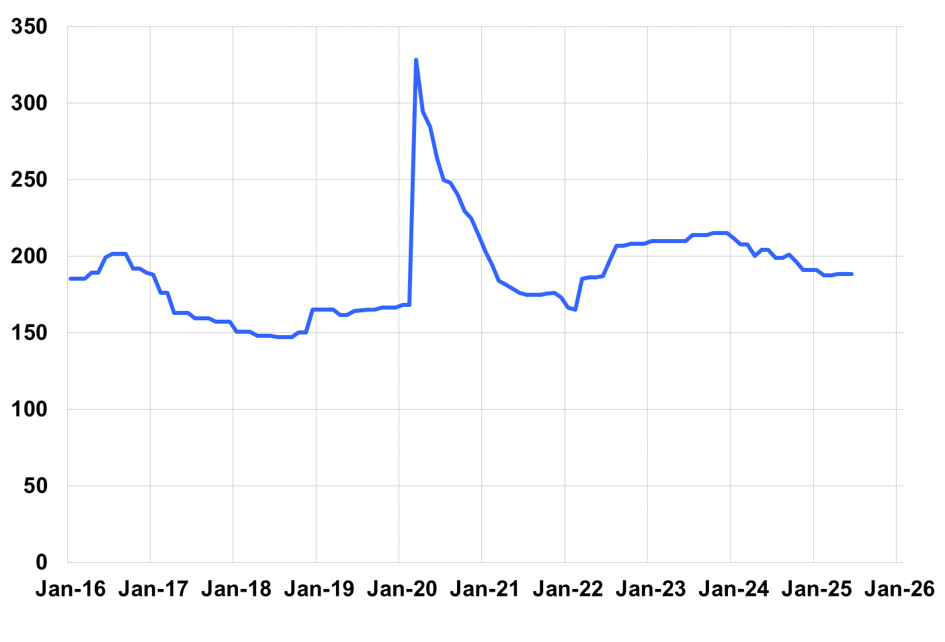
Source: Giliberto-Levy. Chart data are averages of office, apartment, retail and industrial property loans at 60% to 65% LTV for a term of ten years.

In contrast to credit spreads, the U.S. Treasury yield curve showed unusual changes. The benchmark ten-year yield was up only 1 bp, but longer-term rates increased 15 to 20 bp. However, intermediate-term yields declined. For example, the five-year yield was down 17 bp. But short-term yields increased, with the three-month yield up 9 bp.

These shifts also produced seemingly counter-intuitive total returns for sectors. For instance, how could office be the top-performing major sector? The answer: the pattern of Treasury yield changes interacted with the distribution of remaining terms to maturity in the office sector to produce a 1.05% capital value return. For comparison, the same factors generated a 0.63% capital value return for apartments.

Investment-grade CMBS produced 1.86% total return, according to Bloomberg Index Services data for 2Q 2025.

We were surprised that second quarter lending volume, as reported to date, was roughly the same as first quarter. The typical seasonal pattern is for higher volume in 2Q. In addition, there was a nearly 20% upward revision to 1Q 2025 volume, reflecting loans priced during the quarter but not previously reported. Consequently, we could see a bump in 2Q activity as more data arrive.

The 2Q 2025 Giliberto-Levy Monitor will cover results and trends in detail.
 | G-L 1 Summary
 |  | Most Recent Period |  | Prior Period |  | Year Ago Comp. Period
 |  | 2Q 2025 |  | 1Q 2025 |  | 2Q 2024
 | Index Results:
 | Total Return | 1.87% |  | 3.23% |  | -0.74%
 | Income Return | 1.15% |  | 1.17% |  | 1.06%
 | Capital Value Return | 0.72% |  | 2.06% |  | -1.80%
 | Credit Effect (bp; annualized) | 10 |  | 8 |  | 9
 | Index-eligible Lending Activity [Note 1]:
 | Loan Volume ($ billions) | 4.8 |  | 4.8 |  | 6.0
 | Weighted Average:
 | LTV | 60.5% |  | 58.9% |  | 62.9%
 | DSCR | 1.64 |  | 1.66 |  | 1.46
 | Coupon Rate | 5.83% |  | 5.92% |  | 6.08%
 | Spread (basis points) [Note 2] | 179 |  | 172 |  | 172
 | Term to Maturity (years) | 7.1 |  | 7.5 |  | 7.8
 | Loan Size ($ millions) | 30.1 |  | 25.7 |  | 31.8
 | Notes:
 | 1. Lending activity statistics are subject to revision as additional data are received.
 | 2. Spread is measured with respect to comparable maturity U.S. Treasury yield.
 | Source: Giliberto-Levy

The Index's components are fixed-rate commercial mortgage loans held on balance sheets of institutions such as life insurance companies and pension funds. Index returns are a market-value-weighted blend of office, apartment, retail, industrial, lodging, mixed-use and other miscellaneous property types. Index performance tracks senior loans only; it does not include construction loans, mezzanine and other subordinate instruments and bridge loans made by such institutions.

