

Giliberto-Levy Commercial Mortgage Performance Index (G-L 1)
Third Quarter 2025 Flash Report

 | Giliberto-Levy Commercial Mortgage Performance Index
 | Third Quarter 2025 Summary
 | Total Return: | Total (all sectors) |  | 1.78
 | (in %) | Office |  | 2.08
 |  | Multi-family |  | 1.75
 |  | Retail |  | 1.84
 |  | Industrial |  | 1.58
 | Index Statistics: | Principal ($ billion) |  | 302.90
 | (as of 9/30/2025) | Capitalization ($ billion) |  | 287.10
 |  | Duration (years) |  | 3.90
 |  | Coupon (%) |  | 4.41
 |  | Maturity (years) |  | 5.32
 |  | Book LTV (%) |  | 55.23
 | Source: Giliberto-Levy

The Giliberto-Levy Commercial Mortgage Performance Index (G-L 1) produced a 1.78% total return for 3Q 2025. Income return held steady at 1.15%, and capital value return came in at 0.63%. Measured year to date, G-L 1 has provided 7.04% total return.

It was another relatively quiet quarter on the credit spread front: the average spread on priced transactions across the four major sectors scarcely budged (see Chart 1). Continuing a trend that started in the second half of 2023, retail loan spreads registered another decrease. Although they were down a scant 3 basis points (bp) this quarter, the cumulative spread decline since June 2023 has been 40 to 50 bp. Office lending activity remained soft, and spreads continued to be high.

Chart 1. Spreads over Treasuries for Ten-year Commercial Mortgages
In basis points, reflecting 30/360-day count convention
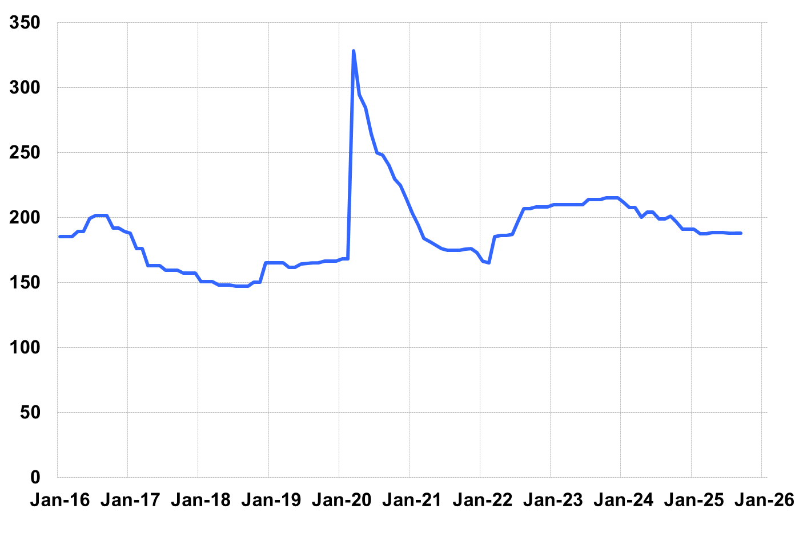
Source: Giliberto-Levy. Chart data are averages of office, apartment, retail and industrial property loans at 60% to 65% LTV for a term of ten years.

With credit spreads relatively stable, changes in the U.S. Treasury yield curve drove most of the capital value return posted in 3Q. Yields at all maturities showed declines. The big action was at the short end, reflecting the influence of Federal Reserve policy on that segment of the curve. Yields on Treasury issues with one year or less to maturity declined roughly 30 to 45 bp. Beyond the one-year mark, yields fell 5 to 10 bp.

As we noted last quarter, yield curve effects explain much of the seemingly counter-intuitive result that showed office posting the highest sector total return.

Investment-grade CMBS produced 1.75% total return, according to Bloomberg Index Services data for 3Q 2025. Intermediate-term investment-grade corporate bonds returned 1.98%.

Please note that lending volume in the table below is likely to be revised upward, possibly substantially. In addition to late reporting that occurs every quarter, the Federal government shutdown affected GSE data availability.

The 3Q 2025 Giliberto-Levy Monitor will cover results and trends in detail.
 | G-L 1 Summary
 |  | Most Recent Period |  | Prior Period |  | Year Ago Comp. Period
 |  | 3Q 2025 |  | 2Q 2025 |  | 3Q 2024
 | Index Results:
 | Total Return | 1.78% |  | 1.87% |  | 4.63%
 | Income Return | 1.15% |  | 1.15% |  | 1.16%
 | Capital Value Return | 0.63% |  | 0.72% |  | 3.47%
 | Credit Effect (bp; annualized) | 8 |  | 10 |  | 8
 | Index-eligible Lending Activity [Note 1]:
 | Loan Volume ($ billions) | 3.8 |  | 5.4 |  | 9.5
 | Weighted Average:
 | LTV | 59.1% |  | 60.6% |  | 61.3%
 | DSCR | 1.71 |  | 1.63 |  | 1.62
 | Coupon Rate | 5.77% |  | 5.83% |  | 5.68%
 | Spread (basis points) [Note 2] | 186 |  | 179 |  | 179
 | Term to Maturity (years) | 7.0 |  | 7.3 |  | 7.0
 | Loan Size ($ millions) | 24.3 |  | 28.3 |  | 35.6
 | Notes:
 | 1. Lending activity statistics are subject to revision as additional data are received.
 | 2. Spread is measured with respect to comparable maturity U.S. Treasury yield.
 | Source: Giliberto-Levy

The Index's components are fixed-rate commercial mortgage loans held on balance sheets of institutions such as life insurance companies and pension funds. Index returns are a market-value-weighted blend of office, apartment, retail, industrial, lodging, mixed-use and other miscellaneous property types. Index performance tracks senior loans only; it does not include construction loans, mezzanine and other subordinate instruments and bridge loans made by such institutions.

