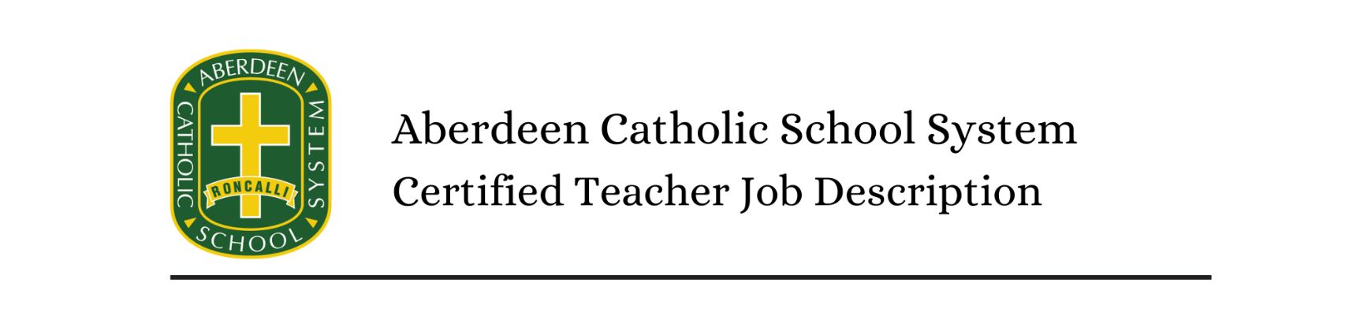
Certified Teacher

Reports To: Building Principal

Requirements:

Education Level: High School diploma. Bachelor’s degree or higher from an accredited Institution. Meet professional teacher education requirements of school, district, state. Single subject teaching credential or certification if teaching a specialized subject. State certification.

Experience Desired: Successful student teaching experience. Prior teaching experience preferred but not required. Knowledge of relevant technology

Other Requirements: Excellent verbal and written communication. Self-motivated with high energy and excellent interpersonal relations skills. Good organizational, critical thinking and planning skills. High work standards. Good problem solving and decision makes skills. Healthy stress tolerance with flexibility and adaptability. Initiative and learning orientation.

Physical Requirements This position requires regular periods of speaking, standing, walking, sitting, crouching, reaching, pushing/pulling and writing. Lifting and carrying of up to twenty-five pounds.

GENERAL PURPOSE:
- To support the mission statement of the school system, “Instilling Catholic values and promoting academic excellence by nurturing mind, body and soul”.
- To plan, organize and implement an appropriate instructional program in a learning environment that guides and encourages students to develop and fulfill their spiritual and academic potential..

ESSENTIAL FUNCTIONS AND DUTIES:

- Articulate and advance the Catholic identity for the school system through example, collaboration, encouragement, and reinforcement.
- Plan, prepare and deliver instructional activities that facilitate active learning experiences.
- Develop schemes of work and lesson plans.
- Establish and communicate clear objectives for all learning activities.
- Prepare classroom for class activities.
- Provide a variety of learning materials and resources for use in educational activities.
- Identify and select different instructional resources and methods to meet students’ varying needs.
- Instruct and monitor students in the use of learning materials and equipment.
- Use relevant technology to support instruction.
- Observe and evaluate student’s performance and development.
- Assign and grade class work, homework, tests, and assignments.
- Provide appropriate feedback on work to students.
- Encourage and monitor the progress of individual students.
- Maintain accurate and complete records of students’ progress and development.
- Update all necessary records accurately and completely as required by law, district policies and school regulations.
- Prepare required reports on students and activities.
- Manage student behavior in the classroom by establishing and enforcing rules and procedures.
- Maintain discipline in accordance with the rules and disciplinary systems of the school.
- Apply appropriate disciplinary measures where necessary.
- Perform certain pastoral duties including student support, counseling students with academic problems and providing student encouragement.
- Participate in extracurricular activities such as social activities, sporting activities, clubs, and student organizations.
- Participate in department and school meetings, parent meetings.
- Communicate necessary information regularly to students, colleagues and parents regarding student progress and student needs.
- Keep updated with developments in subject area, teaching resources and methods and make relevant changes to instructional plans and activities.
- Adhere to all diocesan and school policies, handbooks, and regulations.
- Perform other duties as assigned.

