Greater Woodbine Chamber of Commerce
15th ANNUAL CAR SHOW & SWAP MEET!
Route 550 in Woodbine
Saturday October 10, 2026 (New Rain Date Sunday October 18,2026) 9AM - 3PM
Vehicle Pre – register: $15 by 10/1 awards/Free giveaways
Day of Show $20 Dash Plaques to the first 250 entries!
No Alcoholic Beverages!!!
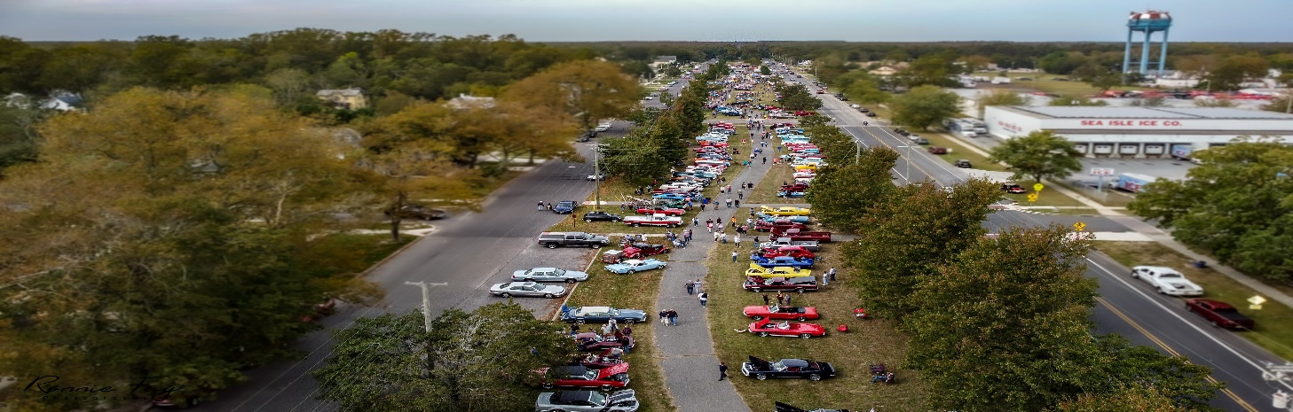
SHOW CARS & ANTIQUES, MUSCLE CARS -RACE CARS – RODS, MILITARY VEHICLES,
OLD TRACTORS,TRUCKS, ANYTHING UNIQUE SWAP & SELL, BRING ALL YOUR EXTRA PARTS!!
A PORTION OF PROCEEDS FROM THIS YEAR`S SHOW WILL BENEFIT THE WOODBINE
AMERICAN LEGION POST 298 FOR MUCH NEEDED REPAIRS TO THEIR BUILDING

NAME:________________________________________________________________________

Address:_______________________________________________________________________

Phone:_______________________Email:_____________________________________________

Year:________Make:_______________________Model:______________ Color:_____________
By signing this entry form I attest my vehicle has complete Liability Insurance Coverage and I
will be Fully responsible for its actions and movements.

Signature:_____________________________________ Amount enclosed:_______________

Mail application & Check`s payable to: GWCC, PO Box 792, Woodbine, NJ 08270
For more information contact Lisa (609) 780 – 3088 Email: lisamcveyfisher@yahoo.com

LIVE BROADCAST FREE RACING
