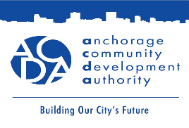
April 16, 2026
Fireweed Flats - A workforce housing complex bringing 24 units to the Anchorage Market
Addendum #1:

The purpose of this addendum is to:

- Add following passage to Appendix A: Scope of Work section 1. Subsection 5) Ownership structure d. “ACDA seeks developer to build, own, and/or operate and maintain the improvements comprising the complex on ACDA-owned land under a long-term ground lease for a period of at least thirty (30) years. It is anticipated the ground lease will have an initial term of thirty (30) years with options for two (2) five-year (5) period extensions. ACDA will provide the selected developer with a nominal ground lease rental rate for an initial period of time under the ground lease offered to enhance project feasibility and cost recovery. These terms are subject to negotiation.”
###

