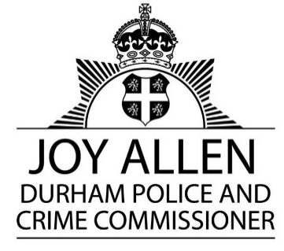

DURHAM POLICE AND CRIME COMMISSIONER’S OFFICE

EXECUTIVE BOARD

Date: Wednesday 21st January 2026

Time: 1.00 p.m.

Venue: Mycroft Room, Police HQ, Aykley Heads & Microsoft Teams

AGENDA

Item No. | Item | Paper/ Verbal | Presenter
1. | Introductions and Apologies | Verbal | PCC
2. | Minutes of the meetings held on 17th December 2025 | Paper | PCC
3. | Action Log | Paper | A Petty
4. | Draft Executive Board Forward Plan 2026 | Verbal | A Petty
5. | Review of Terms of Reference | Paper | A Petty
6. | Draft Accountability Framework | Paper | A Petty
7. | Firearms Licensing | Paper | DCC Irvine/ACC Allen
8. | DDAT 2025/6 Roadmap Overview | Paper | DCC Irvine
9. | Draft PCC Victim’s Champion Annual Report | Paper to follow | M Banks
10. | AOB  - Subject of Public Accountability Meetings  - Date of next meeting: 2nd March 2026 | Verbal | PCC

The Members of the Executive Board:
OPCC: PCC J Allen, Deputy PCC G Hall, Mrs A Petty, Ms S Sahani, Mrs R Allsop
Durham Constabulary: CC R Bacon, DCC C Irvine, ACC J McAdam, ACC R Allen, Mrs S Urwin, Mrs J Diamond

