 | Reference No: 2025-007


DURHAM POLICE & CRIME COMMISSIONER’S OFFICE
DECISION RECORD FORM

REQUEST: For Deputy PCC Approval
Title: Commissioning Board Decisions 11th June 2025
OPCC Lead Officer: Andrea Petty
PCC Joy Allen made the following decisions at the Commissioning Board held 11th June 2025.

The PCC was unable to support the below proposals:
- TryLife in partnership with Cornforth Partnership requested £60,000 to deliver a film covering all the main issues in the force area. The Office of the Durham Police and Crime Commissioner has not yet allocated any funding for this type of activity and are currently considering a range of options to deliver Community Safety messaging to Young People.
- The OPCC supports the concept of the departure lounge at HMP Holme House but declined funding of the proposal. It is an excellent project, but more information is needed on what the Probation Service is doing nationally (and what might be replacing this service). This is an item that needs to be discussed at the County Durham and Darlington Reducing Reoffending Group.

Contractor Details (if applicable): Not applicable
Implications:
Has consideration been taken of the following? | Yes | No
Financial
Legal
Equality & Diversity
Human Rights
Sustainability
Risk
Consultation
Victim Impact Assessment
(If yes please provide further details below)

Decision Required – Supporting Information
Financial Implications: (Must include comments of the PCC’s CFO where the decision has financial implications)
This has been considered as part of and is included in the 2025/26 PCC strategic budgets.

Legal Implications: (Must include comments of the Monitoring Officer where the decision has legal implication)
Having read this form and considered such information as has been provided at the time of being asked to express this view, the Monitoring Officer approver is satisfied that this form does not ask the PCC to decide which would (or would be likely to) give rise to a contravention of the law.

Equality and Diversity Implications
Characteristics considered including Age (i.e. services for young people)

Human Rights Implications
No specific human rights implications.

Sustainability Implications
Successful projects will be monitored and reviewed by the Office of the PCC to inform future commissioning/grant funding opportunities.

Risk Management Implications
Any risk minimised and mitigated by performance framework requirements in grant agreements.

Consultations
No specific consultation undertaken.

Victim Impact Assessment
Considered.
Police and Crime Commissioner:
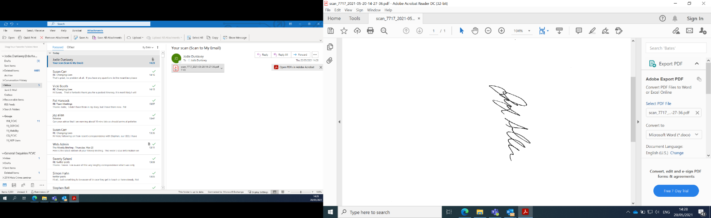
Signed:
Police and Crime Commissioner (Durham) Date: 13/06/2025

Deputy Police and Crime Commissioner:
The above request has my approval.

Signed: 
Police and Crime Commissioner (Durham)
Date: 13/06/2025
Date: 13/06/2025
Chief of Staff and Monitoring Officer:
I have been consulted about the decision and confirm that financial, legal, and equalities advice has been considered. I am satisfied this is an appropriate request to be submitted to the Police and Crime Commissioner.
Signed:

Chief of Staff and Monitoring Officer

