 | Reference No: 2026-001


DURHAM POLICE & CRIME COMMISSIONER’S OFFICE
RECORD FORM

REQUEST: For PCC Approval
Title: Decisions: 2026 -27 Financial Year
OPCC Lead Officer: Andrea Petty
PCC Joy Allen, Deputy PCC Graham Hall, Chief of Staff Andrea Petty made the following decision on spend for 2026/27.

Recommendations around what the Board considered as a Must Do for 2026/27 and agreed by the PCC were:
Multi- Agency Risk - £37,470
Regional Adult SARC Service - £120,341
Regional Adult SARC Estates Costs - £13,460
Regional Paediatric SARC – ISO Costs - £40,000
Regional Adult SARC – ISO Costs - £40,000
Community Based Support – Women at Risk - £70,000
VCAS - £49,000
Sexual Violence Counselling Service - £32,025
Drug Testing on Arrest - £8,333
Contribution to CCTV Network (Darlington) - £25,000
Darlington Young Peoples’ Engagement and Justice Service (Victim Enhancement) - £22,000

North East Business IQ - £12,000
Future Pathways – Her Pathway Programme - £4,961 – approved from PAVE.
2026-001 Harbour – Specialist Court IDVA, Family Court Liaison – £20,334
2026-002 Harbour – Specialist Hospital IDVA - £43,500
2026-003 Brake – Support the NRVS - £2,000
2026-004 RSACC – ISVA Core – £70,132.50 (3-month contract extension)
2026-005 RSACC – Child ISVA – £12,642.50 (3-month contract extension)
2026-006 RSACC – Engagement ISVA - £7,104.75 (3-month contract extension)
2026-007 UTASS – Rural Coordinators Post - £38,400
2026-008 Tees Valley Inclusion Project – Specialist Service - £65,250
2026-009 Changing Lives - £22,756.25 (3-month contract extension)
2026-011 ASN – Anti-slavery Network Coordinator - £22,500
Small Sponsorship requests: Darlington and Durham Pride Events sponsorship has been supported for 2026/27

In relation to the POP Plans
2025-068 Rurali Signs - £856.75 approved
2025-103 Drink/Drug Drive Campaign - £2,275 approved
2025-119 Hollie Guard - £600 approved
2025-120 Shop Lifting Ferryhill - £750 approved funded from PAVE
2025-123 Rough Sleepers – not supported – alternative funding from Local authority to be explored.
2025-125 Bettaways - £800 approved - £200 funded from PAVE
2025-126 Bullion Hall SEN Worker- £440 approved
2025-128 Arsons Seaham - £2,000 approved
2025-146 Tint Meter - £1,423 approved with match funding from DRAP
2026-003 Passive Drug Dog - £600 approved funded from PAVE
2026-004 Youth Work Support Chester Front street – deferred to explore Youth Plan
ASB Youth Provision Newton Aycliffe - £3,710 - approved
Seaham Community Fun Day - £2,000 – approved
RTC Activity Day 2026 - £1,110 approved
Virtual Reality Headsets - £4,500 approved
Contractor Details (if applicable): Not applicable
Implications:
Has consideration been taken of the following? | Yes | No
Financial
Legal
Equality & Diversity
Human Rights
Sustainability
Risk
Consultation
Victim Impact Assessment
(If yes please provide further details below)

Decision Required – Supporting Information
Financial Implications: (Must include comments of the PCC’s CFO where the decision has financial implications)
This has been considered as part of and is included in the 2025/26 PCC strategic budgets.

Legal Implications: (Must include comments of the Monitoring Officer where the decision has legal implication)
Having read this form and considered such information as has been provided at the time of being asked to express this view, the Monitoring Officer approver is satisfied that this form does not ask the PCC to decide which would (or would be likely to) give rise to a contravention of the law.

Equality and Diversity Implications
Characteristics considered including Age (i.e. services for young people)

Human Rights Implications
No specific human rights implications.

Sustainability Implications
Successful projects will be monitored and reviewed by the Office of the PCC to inform future commissioning/grant funding opportunities.

Risk Management Implications
Any risk minimised and mitigated by performance framework requirements in grant agreements.

Consultations
No specific consultation undertaken.

Victim Impact Assessment
Considered.
Police and Crime Commissioner:
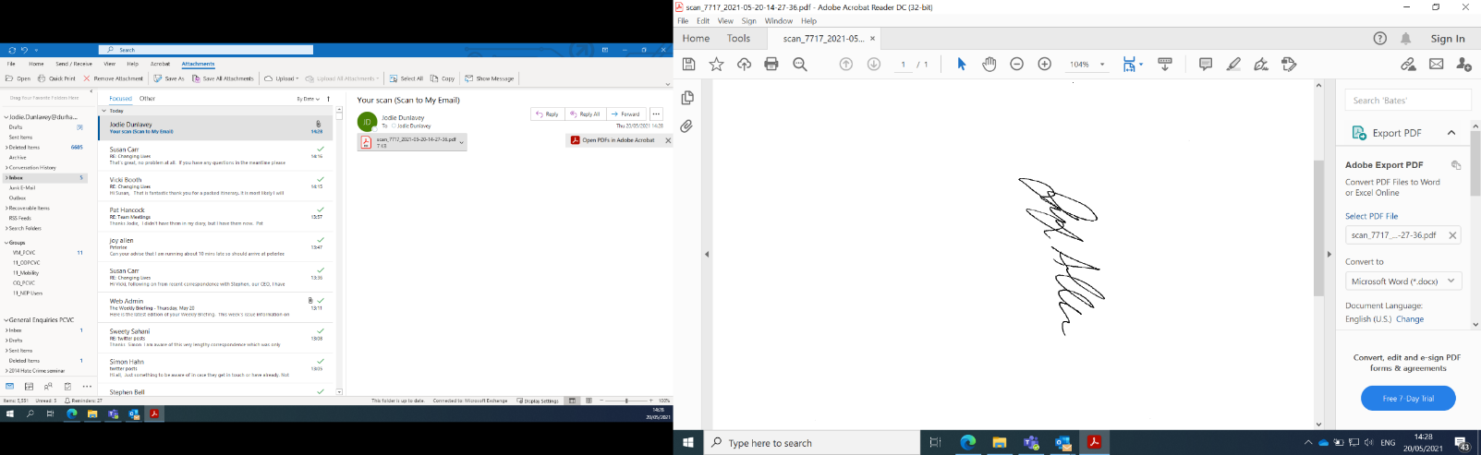
Signed:
Police and Crime Commissioner Durham Date: 26/03/2026

Deputy Police and Crime Commissioner:
The above request has my approval.

Signed: 
Deputy Police and Crime Commissioner Durham
Date: 26/03/2026
Date: 26/01/2026
Chief of Staff and Monitoring Officer:
I have been consulted about the decision and confirm that financial, legal, and equalities advice has been considered. I am satisfied this is an appropriate request to be submitted to the Police and Crime Commissioner.
Signed:

Chief of Staff and Monitoring Officer

