**CLIFTON UPON DUNSMORE PARISH COUNCIL**

**NOTICE OF MEETING**

Dear Councillor

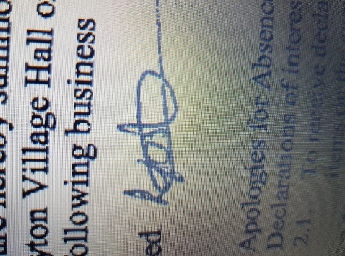A Meeting of Clifton upon Dunsmore Parish Council will be held on Monday 6th October 2025 at Townsend Memorial Hall, Lilbourne Road commencing at 7.30pm, for the purpose of transacting the following business. Your attendance is required.

30th September 2025

Lindsay Foster

Clerk & Responsible Finance Officer

Clifton upon Dunsmore Parish Council

[clerk@cliftonupondunsmore.org.uk](mailto:clerk@cliftonupondunsmore.org.uk)

**AGENDA**

|  |
| --- |
| To receive apologies for absence |
| 1. Declarations of interest as defined by the Code of Conduct for Councillors;  * Non-Pecuniary Interests and Disclosable Pecuniary Interests * Requests for dispensations received |
| 1. Public Participation: |
| 1. To approve the minutes of previous meetings held in September 2025 ( meeting of 1st September and extraordinary meeting 8th September) |
| 1. Matters Arising from previous minutes not on this Agenda and progress against resolutions |
| * To receive reports from Borough and County Councillors on matters relating to the parish * To Discuss and approve co-option (if any applications)  1. Financial Matters:  * To approve the list of payments made in accordance within the budget since last meeting (Appendix 1) * To approve the list of payments to be made in accordance with the budget * To approve Financial Statements September * To approve Bank reconciliations September * To discuss cost and approve further works to telephone box * To discuss projects 2026-27 |
|  |
| 1. To discuss planning applications received:  * To approve response to R25/0565 * To approve response to Saxon Field appeal * R25/0767 at 25, SOUTH ROAD, CLIFTON UPON DUNSMORE, RUGBY, CV23 0BY for Demolition of existing conservatory and erection of single storey rear extension with alterations to existing rear extension roof.. |
| 1. To receive any applicable progress reports from Parish Councillors  * **Parish Land**                                                     Cllr Dignan                                   Glebe (Newton Rd) Allotment                                  North Rd Allotment                                  Newall Close Allotment                                  Grazing Land     * **Conservation Group**                           Cllr Dignan * **Play area project** * **Playing Fields**                                                Cllr Harris                                   Football Pitch                                  Pavilion                                  Trees                                  Playparks:                                  Tennis Club                                  Pickleball   * **TMH Liaison**                                                     Cllr Harris * **Car Park**                                                           Cllr Harris * **Neighbourhood Plan**                                  Cllr Edwards * **Grant applications**                                      Cllr Edwards * **Churchyard**                                                     Cllr Edwards/Cllr Moore * **Houlton Residents Liaison** Cllr Edwards * **Joint burial committee** Cllr Moore/Cllr Dignan      * **Street Scene**                                                    Cllr Moore                                   Streetlights                                  Litter Bins                                  Road Signs                                  Notice Boards                                  Bus Shelter                                  Phone Box                                    Cllr Edwards   * **Village Upkeep** (Lengthsman)                              Cllr Moore * **Police Liaison**                                                 Cllr Moore * **Parish website and Facebook page**   Clerk * **Christmas** * **Asset of Community Value** |
| 1. Correspondence  * Village planters  1. To receive Members motions for the next meeting. |
| 1. Motion under the Public Bodies (admission to meetings act) as amended:   *“In view of the special and confidential nature of the business to be transacted, it is advisable in the public interest that the public be temporarily excluded and that they be instructed to withdraw”*   1. Confidential Matters 2. To approve date and location of next meeting 3rd November 2025 |