CLIFTON UPON DUNSMORE PARISH COUNCIL
NOTICE OF MEETING
Dear Councillor

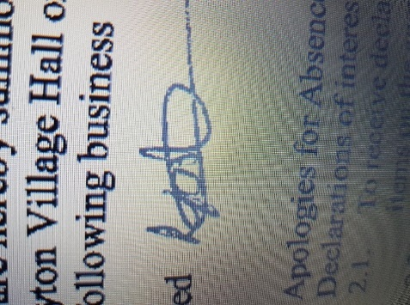
A Meeting of Clifton upon Dunsmore Parish Council will be held on Monday 3rd November 2025 at Townsend Memorial Hall, Lilbourne Road commencing at 7.30pm, for the purpose of transacting the following business. Your attendance is required.

28th October 2025

Lindsay Foster
Clerk & Responsible Finance Officer
Clifton upon Dunsmore Parish Council
clerk@cliftonupondunsmore.org.uk
AGENDA

To receive apologies for absence
- Declarations of interest as defined by the Code of Conduct for Councillors;
- Non-Pecuniary Interests and Disclosable Pecuniary Interests
- Requests for dispensations received
- Public Participation:
- To approve the minutes of previous meetings held in October 2025
- Matters Arising from previous minutes not on this Agenda and progress against resolutions
- To receive reports from Borough and County Councillors on matters relating to the parish
- To Discuss and approve co-option (if any applications)

- Financial Matters:

- To approve the list of payments made in accordance within the budget since last meeting (Appendix 1)
- To approve the list of payments to be made in accordance with the budget
- To approve Financial Statements October
- To approve Bank reconciliations October
- To discuss cost and approve further works to telephone box
- To approve bin costs at car park
- To approve further costs as part of play area improvements
- To approve Christmas expenditure £700.20 trees
- To approve line marking paint expenditure £105.48
- To discuss projects 2026-27
- To approve debit card for Clerk and approve spending limit
- To approve purchase laptop, Microsoft office and anti-virus £550
- To discuss planning applications received:

- To receive any applicable progress reports from Parish Councillors

- Parish Land Cllr Dignan
Glebe (Newton Rd) Allotment
North Rd Allotment
Newall Close Allotment
Grazing Land

- Conservation Group Cllr Dignan

- Play area project
Plans to open play area
- Playing Fields Cllr Harris
Football Pitch
Pavilion
Trees
Playparks:
Tennis Club
Pickleball
- TMH Liaison Cllr Harris
- Car Park Cllr Harris

- Neighbourhood Plan Cllr Edwards
- Grant applications Cllr Edwards
- Churchyard Cllr Edwards/Cllr Moore
- Houlton Residents Liaison Cllr Edwards

- Joint burial committee Cllr Moore/Cllr Dignan

- Street Scene Cllr Moore
Streetlights
Litter Bins
Road Signs
Notice Boards
Bus Shelter
Phone Box Cllr Edwards/Moore/Dignan
Village planters

- Village Upkeep (Lengthsman) Cllr Moore
- Police Liaison Cllr Moore

- Parish website and Facebook page Clerk
- Christmas
To approve Christmas tree risk assessment
To discuss plans for light switch on
To discuss power supply to tree
- Asset of Community Value
- Correspondence

- To receive Members motions for the next meeting.

- Motion under the Public Bodies (admission to meetings act) as amended:
“In view of the special and confidential nature of the business to be transacted, it is advisable in the public interest that the public be temporarily excluded and that they be instructed to withdraw”

- Confidential Matters

- To approve date and location of next meeting 8th December 2025

