CLIFTON UPON DUNSMORE PARISH COUNCIL
NOTICE OF MEETING
Dear Councillor

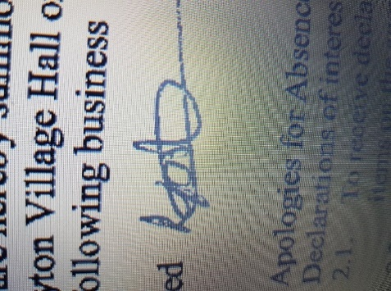
A Meeting of Clifton upon Dunsmore Parish Council will be held on Monday 9th February 2026 at Townsend Memorial Hall, Lilbourne Road commencing at 7.30pm, for the purpose of transacting the following business. Your attendance is required.

3rd February 2026

Lindsay Foster
Clerk & Responsible Finance Officer
Clifton upon Dunsmore Parish Council
clerk@cliftonupondunsmore.org.uk
AGENDA

To receive apologies for absence
- Declarations of interest as defined by the Code of Conduct for Councillors;
- Non-Pecuniary Interests and Disclosable Pecuniary Interests
- Requests for dispensations received
- Public Participation:
- To approve the minutes of previous meetings held in January 2026
- Matters Arising from previous minutes not on this Agenda and progress against resolutions
- To receive reports from Borough and County Councillors on matters relating to the parish
- To Discuss and approve co-option (if any applications)

- Financial Matters:

- To approve the list of payments made in accordance within the budget since last meeting (Appendix 1)
- To approve the list of payments to be made in accordance with the budget
- To approve Financial Statements January
- To approve Bank reconciliations January
- To approve Trevor Gill as internal auditor
- To discuss planning applications received:
- R25/0565 at Land South East Of, Rugby Road, Clifton Upon Dunsmore for Outline application with some matters reserved for the demolition of all buildings and the residential development of up to 160 dwellings, and creation of associated vehicular access off Rugby Road, pedestrian/cycle access points, parking, landscaping, drainage features, open space, childrens play area and associated infrastructure (all matters reserved except for vehicular access off Rugby Road).. Planning Appeal
- Local Plan updates

- To receive any applicable progress reports from Parish Councillors

- Parish Land Cllr Dignan
Glebe (Newton Rd) Allotment
North Rd Allotment
Newall Close Allotment
Grazing Land
To discuss formation of allotment committee Cllr Dignan/Plummer

- Conservation Group Cllr Dignan

- Playing Fields Cllr Harris
Football Pitch
Pavilion
Trees
Playparks:
Tennis Club
Pickleball
Croquet
- TMH Liaison Cllr Harris
- Car Park Cllr Harris

- Neighbourhood Plan Cllr Edwards
- Grant applications Cllr Edwards
- Churchyard Cllr Edwards/Cllr Moore
- Houlton Residents Liaison Cllr Edwards

- Joint burial committee Cllr Moore/Cllr Dignan

- Street Scene Cllr Moore
Streetlights
Litter Bins
Road Signs
Notice Boards
Bus Shelter
Phone Box Cllr Edwards/Moore/Dignan
Village planters

- Village Upkeep (Lengthsman) Cllr Moore
- Police Liaison Cllr Moore

- Parish website and Facebook page Clerk
- Asset of Community Value
- Correspondence
To discuss extension of existing footpath

- To receive Members motions for the next meeting.

- Motion under the Public Bodies (admission to meetings act) as amended:
“In view of the special and confidential nature of the business to be transacted, it is advisable in the public interest that the public be temporarily excluded and that they be instructed to withdraw”

- Confidential Matters

- To approve date and location of next meeting 2nd March 2026

