CLIFTON UPON DUNSMORE PARISH COUNCIL
NOTICE OF MEETING
Dear Councillor

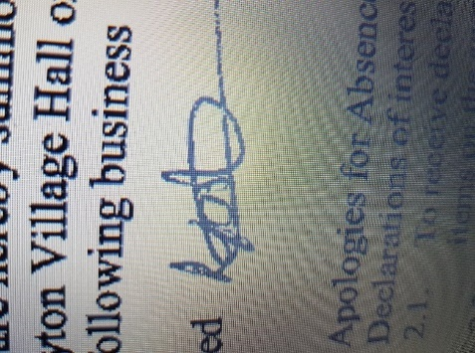
A Meeting of Clifton upon Dunsmore Parish Council will be held on Monday 30th March 2026 at Townsend Memorial Hall, Lilbourne Road commencing at 7.30pm, for the purpose of transacting the following business. Your attendance is required.

25th March 2026

Lindsay Foster
Clerk & Responsible Finance Officer
Clifton upon Dunsmore Parish Council
clerk@cliftonupondunsmore.org.uk
AGENDA

To receive apologies for absence
- Declarations of interest as defined by the Code of Conduct for Councillors;
- Non-Pecuniary Interests and Disclosable Pecuniary Interests
- Requests for dispensations received
- Public Participation:
- To approve the minutes of previous meetings held in March 2026
- Matters Arising from previous minutes not on this Agenda and progress against resolutions
- To receive reports from Borough and County Councillors on matters relating to the parish
- To Discuss and approve co-option (if any applications)

- Financial Matters:

- To approve the list of payments made in accordance within the budget since last meeting (Appendix 1)
- To approve the list of payments to be made in accordance with the budget
- To discuss and approve tree works
- To discuss planning applications received:
- R26/0117 at LAND SOUTH OF LILBOURNE ROAD, CLIFTON UPON DUNSMORE, RUGBY for Outline planning application with all matters reserved except for access for up to 180 residential dwellings (Use Class C3) including public open space; access from Lilbourne Road; landscaping; suitable drainage systems and associated infrastructure and ancillary community uses.
- R26/0210 at RUGBY RADIO STATION, WATLING STREET, CLIFTON UPON DUNSMORE, RUGBY, CV23 0AS for Variation of Condition 1 of R21/0873 of reserved matters approval R21/0873 (Key Phase 3 Parcel D - Submission of reserved matters comprising access, appearance, landscaping, layout and scale for the erection of 147 dwellings, access roads, garages and parking, landscaping, open space and associated works pursuant to outline planning permission R17/0022 dated 28th June 2017.) for design changes including surface treatments, bin collection points, handing of house types and landscaping.
- To discuss Rugby Road appeal

- To receive any applicable progress reports from Parish Councillors

- Parish Land Cllr Dignan
Glebe (Newton Rd) Allotment
North Rd Allotment
Newall Close Allotment
Grazing Land
To discuss formation of allotment committee Cllr Dignan/Plummer

- Conservation Group Cllr Dignan

- Playing Fields Cllr Harris
Football Pitch
Pavilion
Trees
Playparks:
Tennis Club
Pickleball
Croquet
- TMH Liaison Cllr Harris
- Car Park Cllr Harris

- Neighbourhood Plan Cllr Edwards
- Grant applications Cllr Edwards
- Churchyard Cllr Edwards/Cllr Moore
- Houlton Residents Liaison Cllr Edwards

- Joint burial committee Cllr Moore/Cllr Dignan

- Street Scene Cllr Moore
Streetlights
Litter Bins
Road Signs
Notice Boards
Bus Shelter
Phone Box Cllr Edwards/Moore/Dignan
Village planters

- Village Upkeep (Lengthsman) Cllr Moore
- Police Liaison Cllr Moore

- Parish website and Facebook page Clerk
- Asset of Community Value
- Correspondence

- To receive Members motions for the next meeting.

- Motion under the Public Bodies (admission to meetings act) as amended:
“In view of the special and confidential nature of the business to be transacted, it is advisable in the public interest that the public be temporarily excluded and that they be instructed to withdraw”

- Confidential Matters

- To approve date and location of next meeting 11th May 2026 at 7pm due to Annual Parish Meeting followed by Annual Parish Council meeting.

