CLIFTON UPON DUNSMORE PARISH COUNCIL
NOTICE OF MEETING
Dear Councillor

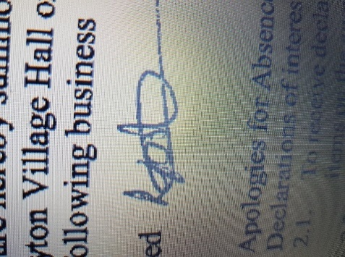
A Meeting of Clifton upon Dunsmore Parish Council will be held on Monday 1st June 2026 at Townsend Memorial Hall, Lilbourne Road commencing at 7.30pm, for the purpose of transacting the following business. Your attendance is required.

25th March 2026

Lindsay Foster
Clerk & Responsible Finance Officer
Clifton upon Dunsmore Parish Council
clerk@cliftonupondunsmore.org.uk
AGENDA

To receive apologies for absence
- Declarations of interest as defined by the Code of Conduct for Councillors;
- Non-Pecuniary Interests and Disclosable Pecuniary Interests
- Requests for dispensations received
- Public Participation:
- To approve the minutes of previous meetings held in May 2026
- Matters Arising from previous minutes not on this Agenda and progress against resolutions
- To receive reports from Borough and County Councillors on matters relating to the parish
- To Discuss and approve co-option (if any applications)

- Financial Matters:

- To approve the list of payments made in accordance within the budget since last meeting (Appendix 1)
- To approve the list of payments to be made in accordance with the budget
- To note internal audit report and any outcomes
- To approve section 1 AGAR
- To approve Section 2 AGAR
- To approve public Rights Dates of publication
- To approve asset register
- To discuss planning applications received:
- R26/0318 at 31, NORTH ROAD, CLIFTON UPON DUNSMORE, RUGBY, CV23 0BN for Proposed first floor extension, single storey rear extension, new roof with dormer windows, roof lights and a rear facing balcony. Creation of a proposed outbuilding.
- R26/0403 at 8, Great Brook Meadow Close, Rugby, CV23 1DN for Garage Conversion To A Habitable Room.
- R26/0482 at 18, Vicarage Hill, Clifton Upon Dunsmore, Rugby, Warwickshire, CV23 0DG for Single storey rear extension and two storey rear and side extension..
- R26/0436 at Dollman Road Playground, Houlton (Rugby Radio Station), Key Phase 1, Dollman Road, Rugby, CV23 1AD for Erection of Neighbourhood Equipped Area of Play (NEAP) formal open space and associated works within Key Phase 1 (application for approval of reserved matters relating to appearance, landscaping, layout and scale pursuant to outline planning permission
- Rugby Road Planning Appeal outcome

- To receive any applicable progress reports from Parish Councillors

- Parish Land Cllr Dignan
Glebe (Newton Rd) Allotment
North Rd Allotment
Newall Close Allotment
Grazing Land
To discuss formation of allotment committee Cllr Dignan/Plummer

- Conservation Group Cllr Dignan

- Playing Fields Cllr Harris
Football Pitch
Pavilion
Trees
Playparks:
Tennis Club
Pickleball
Croquet
- TMH Liaison Cllr Harris
- Car Park Cllr Harris

- Grant applications Cllr Edwards
- Churchyard Cllr Edwards/Cllr Moore
- Houlton Residents Liaison Cllr Edwards

- Joint burial committee Cllr Moore/Cllr Dignan

- Street Scene Cllr Moore
Streetlights
Litter Bins
Road Signs
Notice Boards
Bus Shelter
Phone Box Cllr Edwards/Moore/Dignan
Village planters

- Village Upkeep (Lengthsman) Cllr Moore
- Police Liaison Cllr Moore

- Parish website and Facebook page Clerk
- Asset of Community Value
- Motion under the Public Bodies (admission to meetings act) as amended:
“In view of the special and confidential nature of the business to be transacted, it is advisable in the public interest that the public be temporarily excluded and that they be instructed to withdraw”

- Confidential Matters

- To approve date and location of next meeting 6th July 2026 at 7pm.

