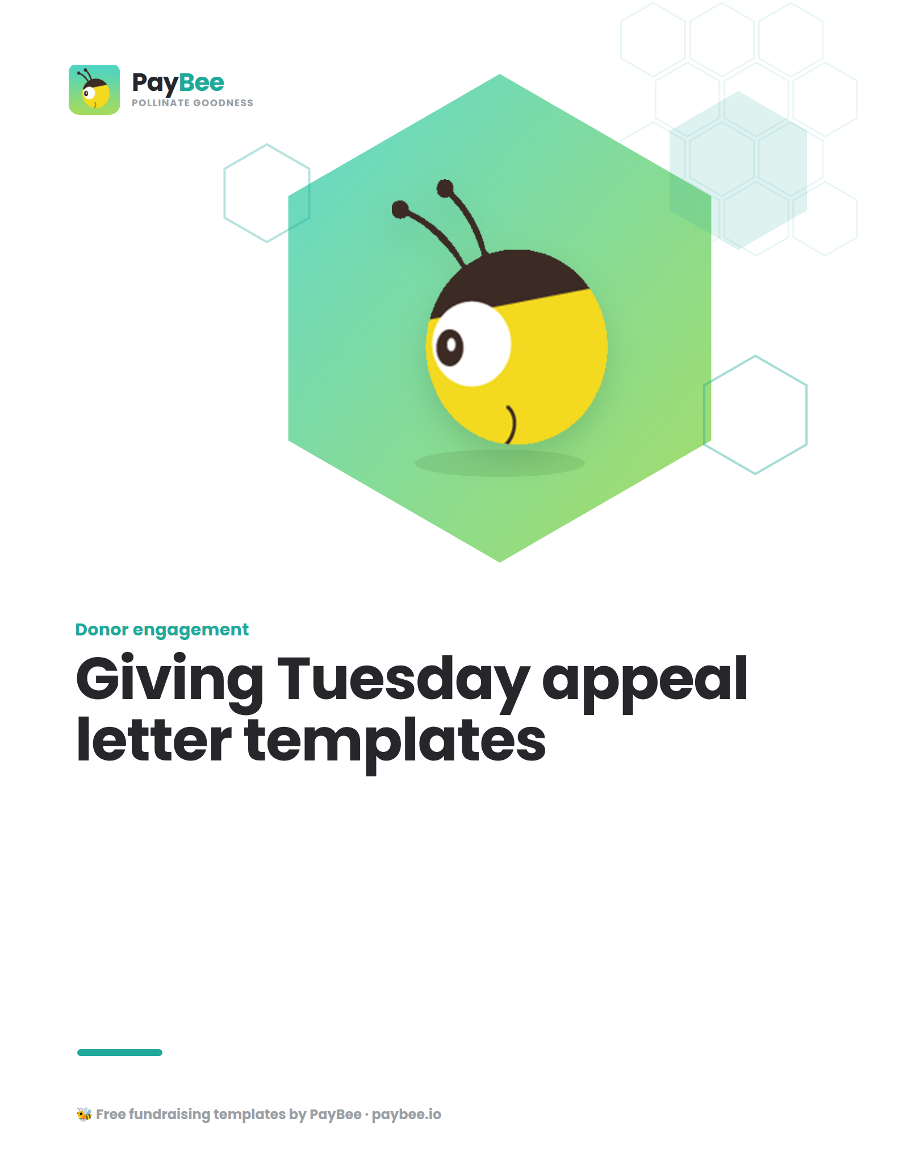

Giving Tuesday letter templates 💚

With these simple yet engaging letter templates, you can capture the attention of your supporters and encourage them to donate to your Giving Tuesday campaign.

How to use: Customize the bolded text in the brackets below to match your organization’s goals, impact, and donor information. Then, copy and paste the text into PayBee’s email & SMS outreach tool for easy distribution. You can print your letters for free or pay a small fee per mailing to let PayBee handle everything for you.

Giving Tuesday donation request letter template 💰

[FULL NAME, TITLE]
[ORGANIZATION]
[CONTACT ADDRESS]
[CONTACT PHONE]
[WEBSITE/EMAIL ADDRESS]

[DATE]
[POTENTIAL DONOR NAME]
[ADDRESS]
Dear [RECIPIENT NAME],
On behalf of [ORGANIZATION], I’m writing to ask for your support for our upcoming Giving Tuesday fundraising campaign.

As you know, we are committed to [ASPECT OF MISSION]. In the past year, we were able to [SPECIFIC IMPACT—INCLUDE SHORT ANECDOTE IF POSSIBLE]. This year, we strive to raise even more and have a greater impact than ever before.

Giving Tuesday is a global day of giving back coming up on [DATE], and we need contributions from generous community members like you to reach our fundraising goal of $[AMOUNT]. Throughout the day, we’ll be [DETAILS ABOUT CAMPAIGN], and we’d be so grateful for your involvement.

A $[AMOUNT] donation will help us [SPECIFIC IMPACT] in the coming year. Please help us reach our fundraising goal this Giving Tuesday!

You can learn more about our campaign and donate at [URL], or scan the QR code to give right from your smartphone.

[QR CODE]

Thank you for being a part of our caring community. We couldn’t do this work without your help!

Happy Holidays,

[SIGNATURE]
[FULL NAME]
[ORGANIZATION NAME]

Giving Tuesday thank you letter template 💐

[FULL NAME, TITLE]
[ORGANIZATION]
[CONTACT ADDRESS]
[CONTACT PHONE]
[WEBSITE/EMAIL ADDRESS]

[DATE]
[POTENTIAL DONOR NAME]
[ADDRESS]

Dear [RECIPIENT NAME],
[ORGANIZATION]’s Giving Tuesday campaign has come to a close, and I’m delighted to share that we raised a total of $[AMOUNT]!

Our success would not have been possible without your generous support.

This year, we [ACTIVITIES OR HIGHLIGHTS FROM GIVING TUESDAY CAMPAIGN], a fun and impactful way to raise much-needed funds.

Thank you for supporting our cause by donating. Your contribution will help us [SPECIFIC IMPACT] and create a real difference for our community in [LOCATION] in the new year and beyond.

Happy Holidays!

[SIGNATURE]
[FULL NAME]
[ORGANIZATION NAME]

