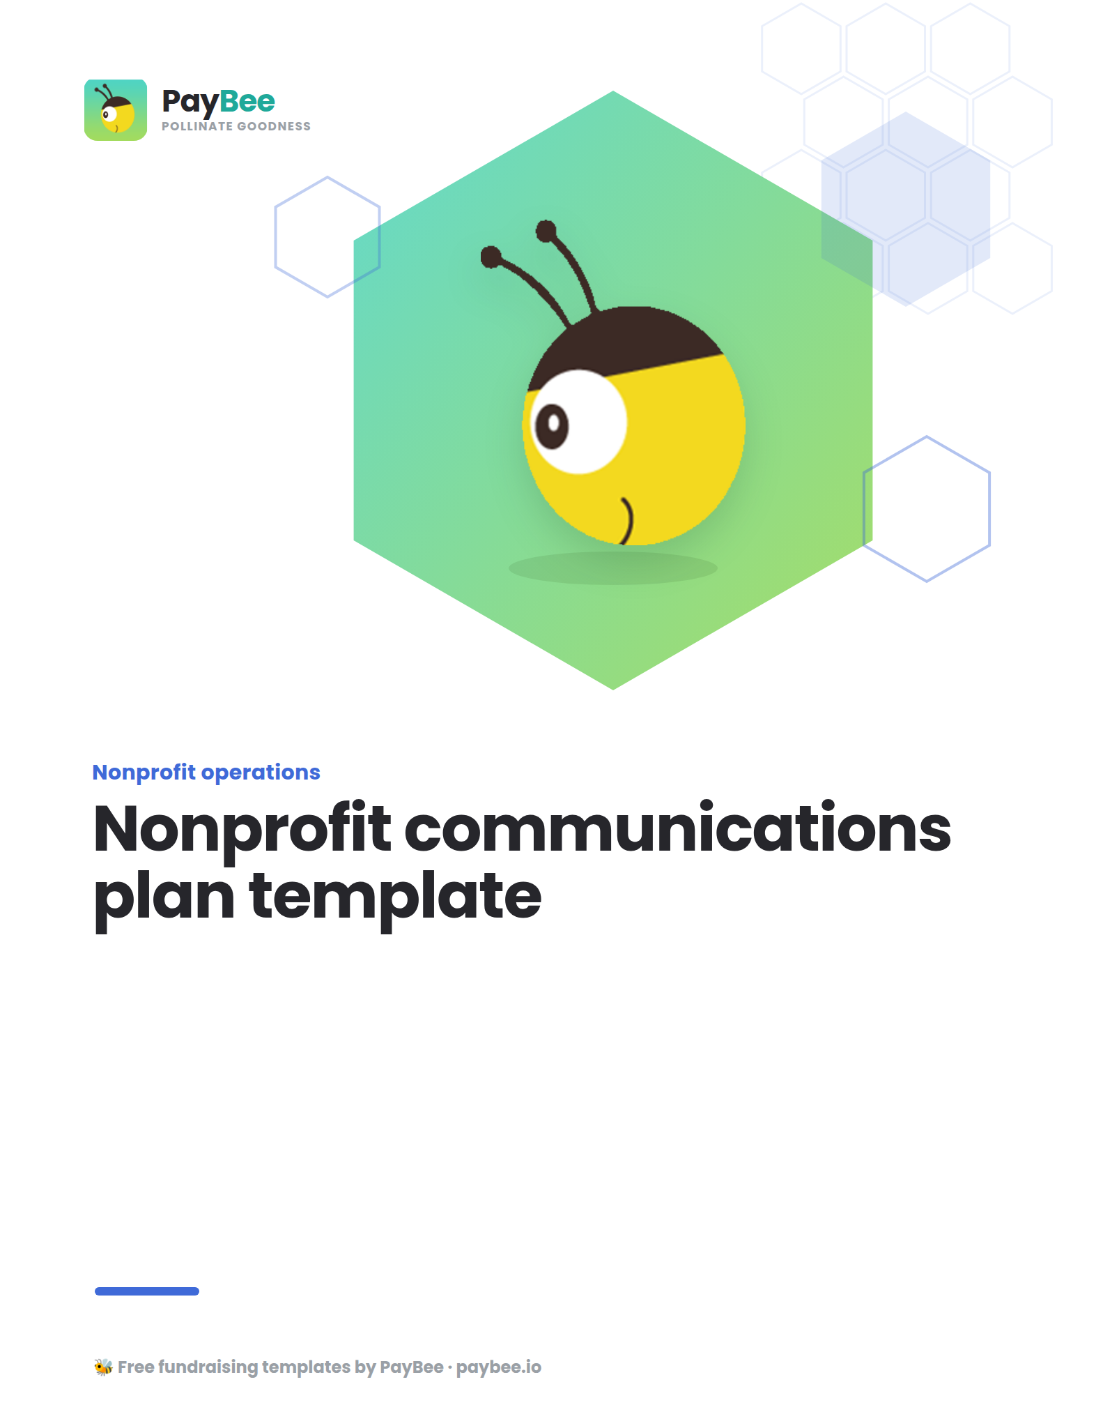

Nonprofit communications plan template 📢

1. Executive Summary

Mission statement
Briefly state your nonprofit's mission and core values

Purpose
Identify the campaign for which you are creating this communications plan (e.g., “Giving Tuesday 2024”) or the timeframe for this plan if it’s a more general roadmap for your organization.

Communications plan overview
Summarize the key components of the plan, including your goal and primary objective.

2. Communication audit results
List your current communication channels and how they’re performing, such as:

Social media
List each platform (Instagram, Facebook, etc.)

Email marketing

Website

Blog

Print materials

Press engagement

4. SWOT Analysis
Provide a detailed audit of your organization's internal strengths and weaknesses, as well as external opportunities and threats that may influence the success of this campaign.

Strengths  What you are doing well (e.g., strong engagement on Instagram posts) | Opportunities  External factors that could help your communication strategy (e.g., a new volunteer who has experience with a particular social media platform).
Weaknesses  Areas where your communication efforts fall short (e.g., inconsistent messaging, low website traffic). | Threats  External challenges that could impact your communication efforts (e.g., negative media coverage, loss of a funding stream).

5. Audience
Include a brief overview of your target audience, including your primary and secondary audiences (e.g., new donors, volunteers, recurring donors). You can also choose to go a step further here and create detailed personas for each audience segment, including demographics, interests, and communication preferences.

6. Goals and objectives

Campaign goal
Make sure the overall goal you set for your campaign is SMART (specific, measurable, achievable, relevant, and time-bound). For example, you may set a campaign goal to “Increase the number of recurring donors from #% to #% of our overall donor base by December 20##.

Objectives
Define each of the strategic objectives that will support your campaign goal. Following the example above, you may have objectives that include sending appeals to # of one-time donors, creating an exclusive monthly email series for recurring givers, etc.

7. Necessary resources
Outline all the resources and materials you’ll need to accomplish your goal and objectives, including:

Technology and tools

Channels

Messaging

Staff

Budget

8. Evaluation and adjustment

Evaluation metrics
Establish metrics to evaluate the success of your communication efforts (e.g., engagement rates, website traffic, donor retention).

Outline of review process
Identify how and when you’ll review and analyze performance data.

