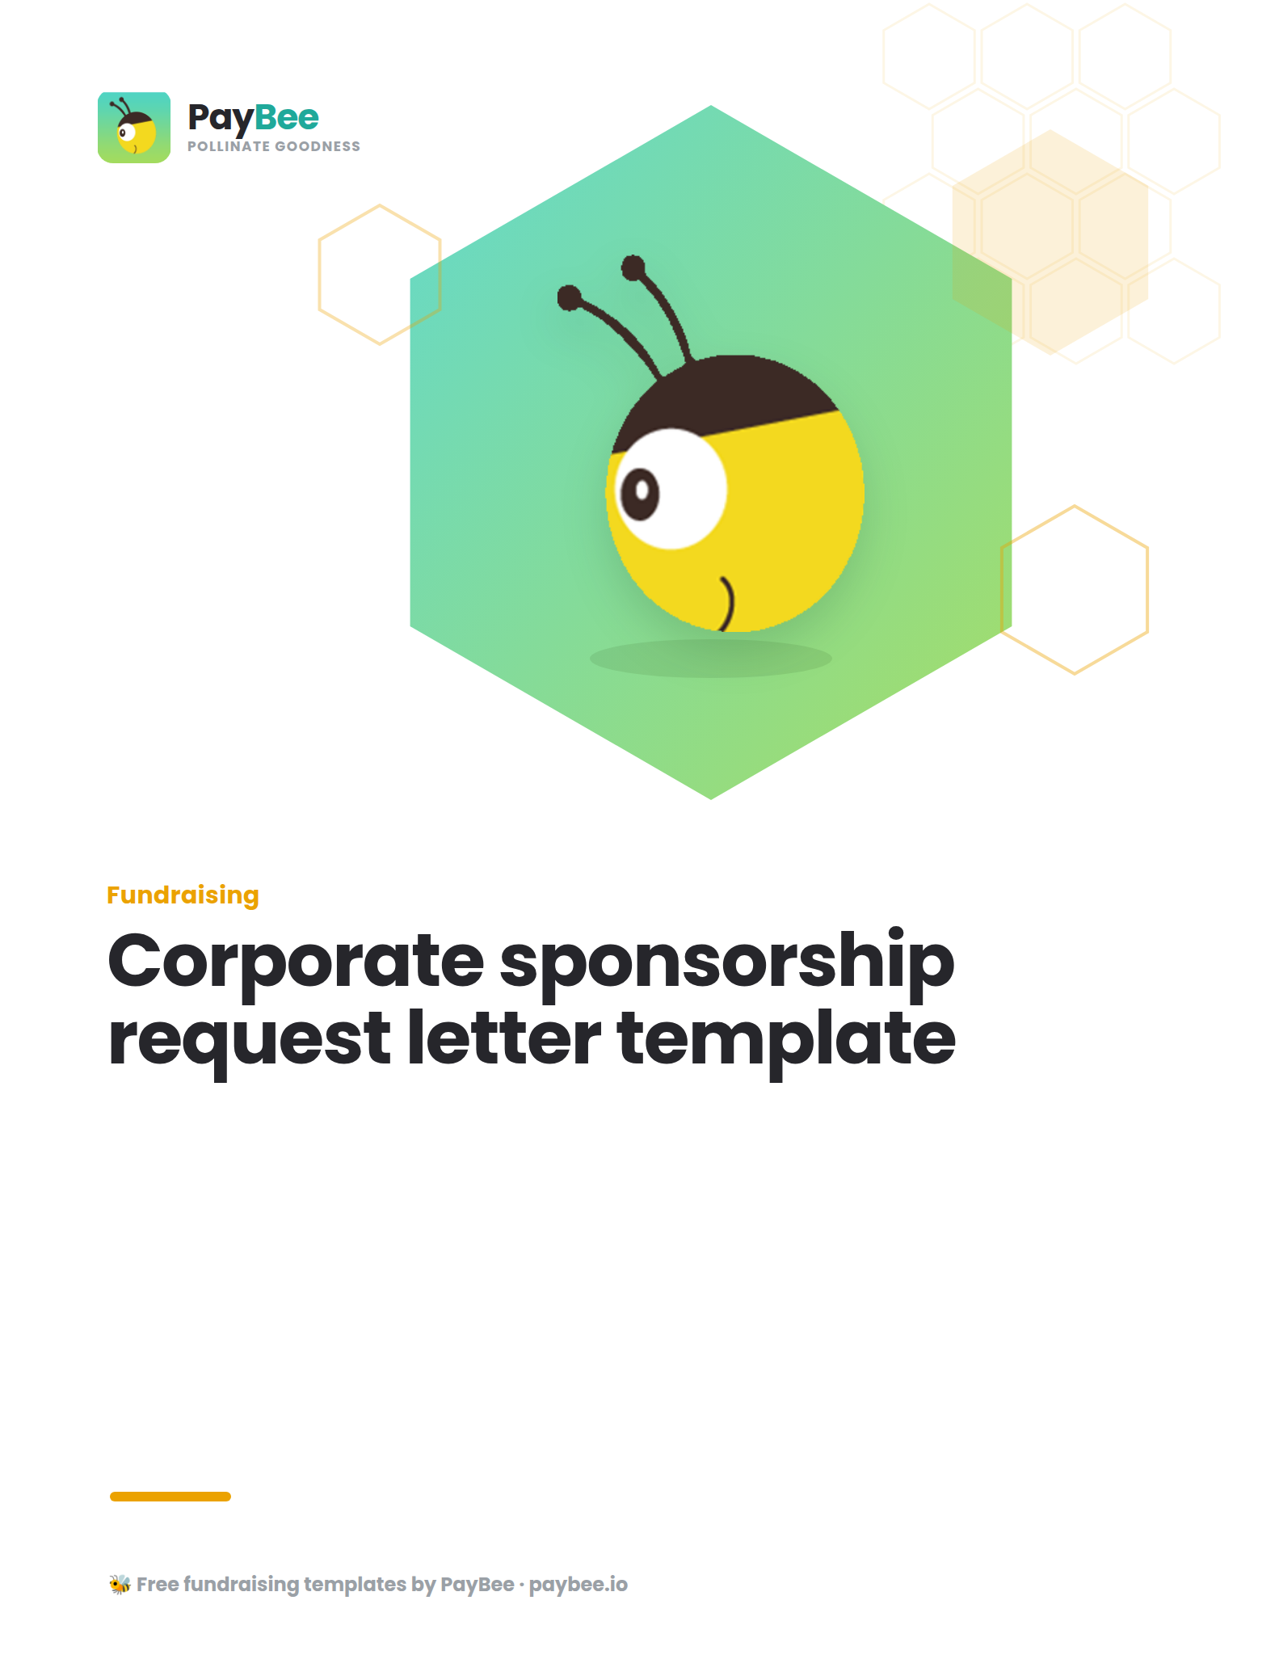

Corporate sponsorship request letter template ✉️

[YOUR NONPROFIT LETTERHEAD/LOGO]
[DATE]

Dear [RECIPIENT NAME],

I’m [YOUR NAME] and I work at [NONPROFIT NAME]. I’m writing to tell you about our upcoming event, [EVENT NAME] to see if you would be interested in joining as a sponsor.

[EVENT NAME] is a highlight in our year and helps us raise vital funds for [CAUSE]. Last year, we raised a total of [DOLLAR AMOUNT], had [AMOUNT] attendees, and partnered with influential companies like [PREVIOUS SPONSORS].

This year, our event is taking place at [VENUE] on [DATE] and it’s going to be bigger and better than ever.

We’d love you to join us as a sponsor or event partner. We have some exciting options available that I feel would be especially beneficial for [NAME OF BUSINESS], including:

- [SPONSORSHIP PACKAGE 1]
- [SPONSORSHIP PACKAGE 2]
- [SPONSORSHIP PACKAGE 3]

If you’re interested in working together on this, I will follow up to share more details, or you’re welcome to contact me directly any time at [EMAIL ADDRESS] or [PHONE NUMBER].

Thank you for your time and consideration,

[YOUR NAME]
[YOUR TITLE]
[NONPROFIT NAME]

