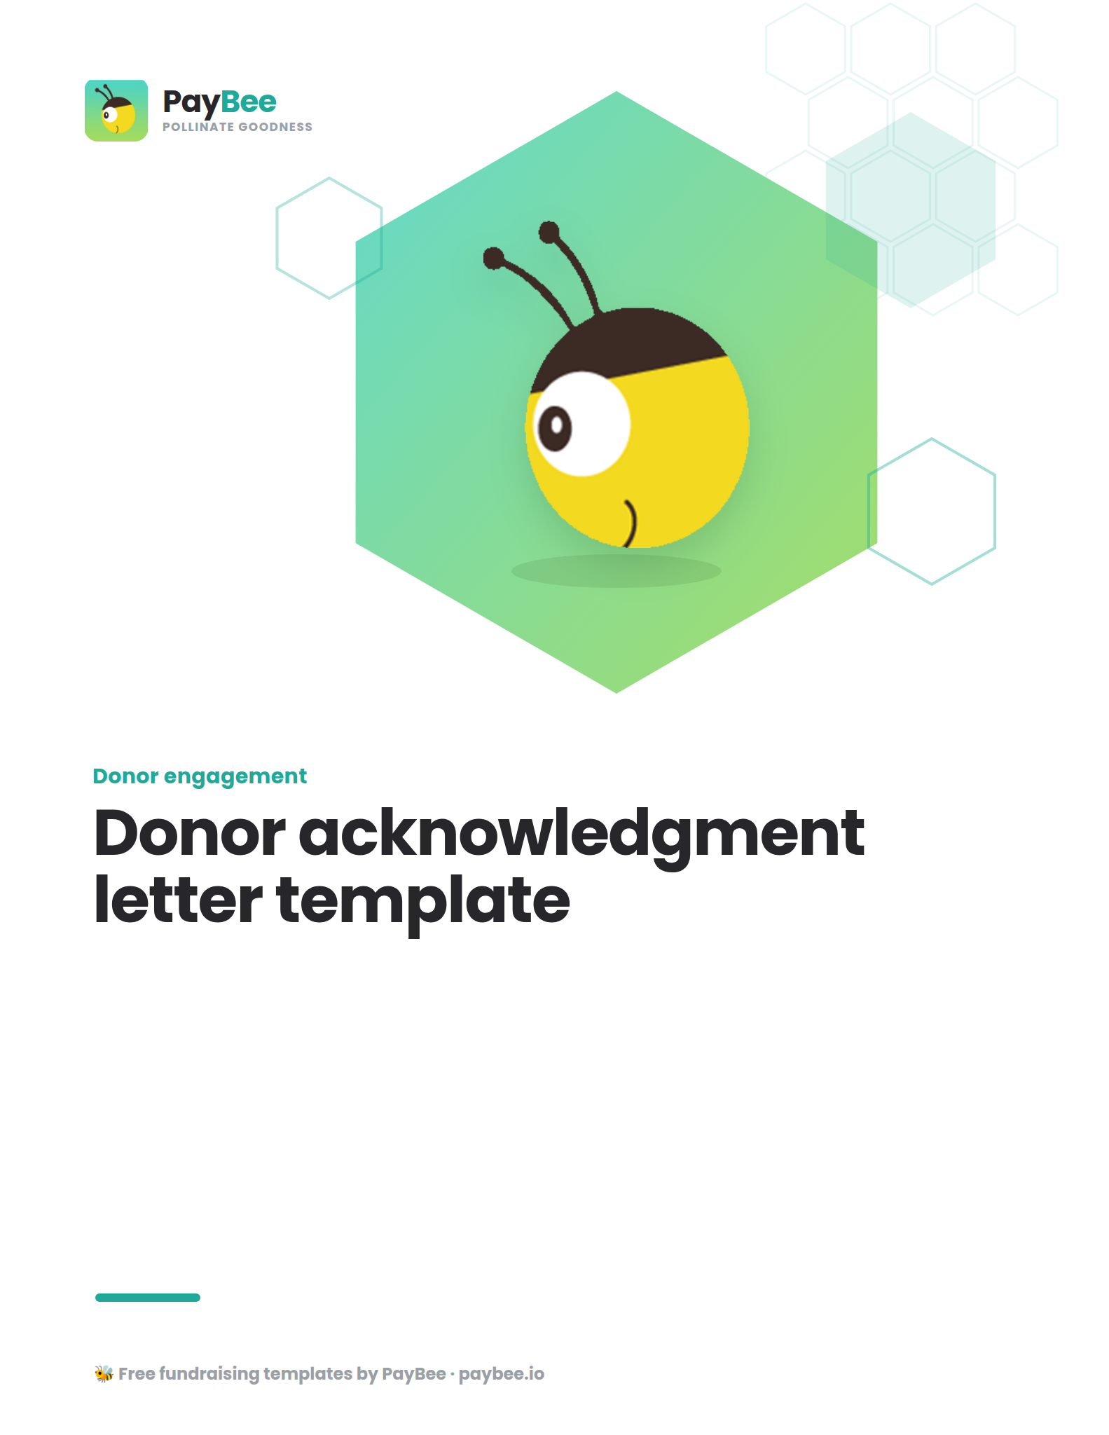

Donation acknowledgment letter template ✉️

[YOUR NONPROFIT LETTERHEAD/LOGO]
[DATE]

Dear [DONOR'S NAME],

On behalf of [NONPROFIT NAME], I extend my deepest gratitude for your recent contribution of [DONATION AMOUNT] on [DATE]/at [EVENT].

Your generosity will help [BENEFICIARIES OR THE COMMUNITY YOU SERVE/ASPECT OF YOUR MISSION YOU WANT TO HIGHLIGHT] In fact, your gift has [RECENT IMPACT OR PROGRAM].

As a tax-exempt organization under section 501(c)(3) of the Internal Revenue Code, your contribution is tax-deductible to the extent allowed by law. Please retain this letter as an official receipt for your records' No goods or services were provided in exchange for your generous donation.

- [YOUR NONPROFIT]
- [DONATION AMOUNT]
- [DESCRIPTION FOR NON-CASH CONTRIBUTION, IF NECESSARY]
- [GOOD FAITH ESTIMATE OF THE VALUE OF GOODS OR SERVICES, IF ANY]

If you have any questions or would like to speak about the impact of your gift, please do not hesitate to contact me at [EMAIL ADDRESS] or [PHONE NUMBER]. And please follow us on social media to learn more about our work, get exciting updates, and be the first to know about volunteer opportunities: [YOUR SOCIAL HANDLE(S)].

Once again, thank you for your unwavering support. Your generosity fuels our hope for a brighter future.

With heartfelt thanks,

[YOUR NAME]
[YOUR TITLE]
[YOUR NONPROFIT]

