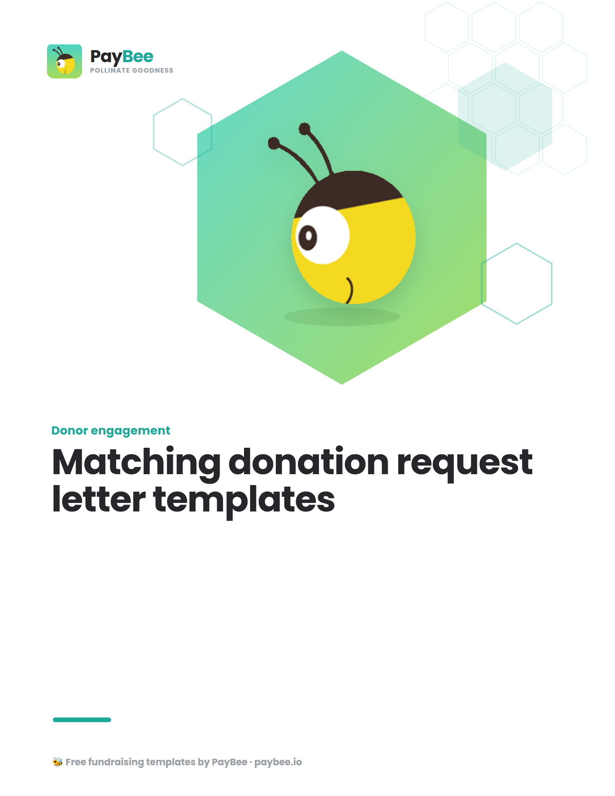

Matching donation request letter template 📫
FOR PDF OR PRINT

FULL NAME
TITLE, ORGANIZATION NAME
CONTACT ADDRESS
CONTACT PHONE
WEBSITE
EMAIL ADDRESS

DATE

POTENTIAL DONOR COMPANY NAME
ADDRESS

Dear [POINT OF CONTACT AT COMPANY OR COMPANY NAME],

I hope this letter finds you well. Today, our organization, [ORGANIZATION NAME], is excited to reach out with a special opportunity that we sincerely hope you’ll take part in—one that is sure to make a lasting difference in our community.

At [ORGANIZATION NAME], we are committed to [BRIEF DESCRIPTION OF ORGANIZATION’S MISSION AND CAMPAIGN]. Our latest fundraising campaign, [CAMPAIGN NAME], aims to [BRIEF DESCRIPTION OF HOW FUNDS RAISED WILL BE USED; E.G., PROVIDE ESSENTIAL RESOURCES TO UNDERSERVED COMMUNITIES, SUPPORT EDUCATIONAL INITIATIVES, ETC.].

Today, we’re reaching out to ask if you’d like to help us double that impact by [SPECIFIC ASK; E.G., BEING ONE OF OUR MATCHING DONATION SPONSORS, PARTAKING IN OUR MATCHING GIFT CAMPAIGN, ETC.]. For every dollar raised during our campaign, we hope to offer a matching donation opportunity where [COMPANY NAME] would match donations with a ratio of [MATCH RATIO; E.G., 1:1, 2:1, ETC.], up to a total of [MATCH AMOUNT] from [START DATE] to [END DATE]. This would [ALIGN WITH MATCH RATIO; E.G., DOUBLE, TRIPLE, ETC.] the impact of contributions made by our supporters—and showcase [COMPANY NAME]'s commitment to social responsibility.

In return for your generous support, we would prominently feature [COMPANY NAME]'s logo on our [ALL PLACEMENT OPPORTUNITIES; E.G., WEBSITE, SOCIAL MEDIA PLATFORMS, PROMOTIONAL MATERIALS, ETC.], highlighting [COMPANY NAME]'s crucial role in creating positive change.

If you’d like to be a part of this powerful matching donation opportunity, please [CLEAR NEXT STEPS; E.G., VISIT OUR WEBSITE, GIVE THROUGH THIS DONATION PAGE, FILL OUT THIS SPONSORSHIP FORM, ETC.] here: [SHORT URL].

If you would like to learn more about our organization and the impact of your support, please don't hesitate to contact [CONTACT NAME] at [CONTACT EMAIL OR PHONE].

Thank you for considering this opportunity to help [IMPACT/MISSION OF YOUR ORGANIZATION]. Every dollar makes a difference.

Warm regards,

Sincerely,

SIGNATURE
FULL NAME
ORGANIZATION NAME

Matching donation request email template ✉️

SUBJECT LINE: Will you help us make double the difference?

PREVIEW TEXT: [COMPANY NAME] has the opportunity to create a lasting impact in our community—will you join us as a matching sponsor?

BODY OF EMAIL:

Dear [POINT OF CONTACT AT COMPANY OR COMPANY NAME],

I hope this email finds you well. I am reaching out on behalf of [ORGANIZATION NAME], a nonprofit dedicated to [BRIEF DESCRIPTION OF ORGANIZATION’S MISSION]. I’m getting in touch with you today with an important proposal as we gear up for our upcoming fundraising campaign, [CAMPAIGN NAME].

At [ORGANIZATION NAME], we are committed to making a positive impact in our community by [BRIEF OVERVIEW OF SPECIFIC PROGRAMS, SERVICES, OR IMPACT OF ORGANIZATION]. As we prepare to launch [CAMPAIGN NAME] to help us raise [CAMPAIGN GOAL AMOUNT] for [CAMPAIGN OBJECTIVES], we are seeking support from corporate partners with like-minded values to help us reach our goals.

Given [REASON COMPANY IS RELEVANT TO YOUR CAUSE], I am excited to invite [COMPANY NAME] to join us as a matching sponsor for our campaign. Your support would allow us to [ALIGN WITH MATCH RATIO BELOW; E.G., DOUBLE, TRIPLE, ETC.] the impact of contributions made by our supporters, showcasing [COMPANY NAME]'s commitment to social responsibility.
For every dollar raised during our campaign, we hope to offer donors a matching donation opportunity where [COMPANY NAME] would match donations with a ratio of [MATCH RATIO; E.G., 1:1, 2:1, ETC.], up to a total of [MATCH AMOUNT].
In recognition of your support, we would be delighted to offer prominent logo placement on our [ALL PLACEMENT OPPORTUNITIES; E.G., WEBSITE, SOCIAL MEDIA PLATFORMS, PROMOTIONAL MATERIALS, ETC.], highlighting [COMPANY NAME]'s crucial role in creating positive change.

Will you help us make a difference?

[INSERT CTA BUTTON LIKE “Become a sponsor” & HYPERLINK TO DONATION PAGE OR SPONSORSHIP FORM]

If you would like to discuss this opportunity further or explore other ways to collaborate, please do not hesitate to contact me at [PHONE NUMBER] or [EMAIL].

Thank you for considering this partnership opportunity. Together, we can make a difference.

Warm regards,

FULL NAME
TITLE, ORGANIZATION NAME

PHONE NUMBER
WEBSITE

Matching donation thank you letter template 🙏
FOR PDF OR PRINT

FULL NAME
TITLE, ORGANIZATION NAME
CONTACT ADDRESS
CONTACT PHONE
WEBSITE
EMAIL ADDRESS

DATE

COMPANY NAME
ADDRESS

Dear [CORPORATE SPONSOR NAME],

On behalf of everyone at [ORGANIZATION NAME], I want to extend our sincerest gratitude for your generous support as a donation match sponsor for our recent campaign, [CAMPAIGN NAME].

Your commitment has helped us raise [TOTAL AMOUNT RAISED], which will [SPECIFIC IMPACT FUNDS RAISED WILL HAVE / HOW FUNDS RAISED WILL BE USED].

Thanks to sponsors like you, we can continue to [SPECIFIC PROGRAMS, SERVICES, OR IMPACT OF ORGANIZATION] and make a lasting difference in the lives of [ORGANIZATION BENEFICIARIES]. Your generosity inspires others in our community and reminds us of the power of giving.

Once again, thank you for your unwavering support. We look forward to continuing our partnership and achieving even greater milestones together.

Warm regards,

SIGNATURE
FULL NAME
ORGANIZATION NAME

Matching donation thank you email template 💌

SUBJECT LINE: You’ve made a difference!

PREVIEW TEXT: Thank you for supporting [CAMPAIGN NAME] at [ORGANIZATION NAME]

BODY OF EMAIL:

Dear [CORPORATE SPONSOR NAME],
I am writing on behalf of [ORGANIZATION NAME] to express our heartfelt gratitude for your invaluable support as a donation match sponsor for our recent campaign, [CAMPAIGN NAME].

Your commitment to matching donations has made a significant impact on our ability to fulfill our mission. By [DOUBLING, TRIPLING, ETC.] the contributions made by our supporters, you helped us raise [TOTAL AMOUNT RAISED], which will help [CAMPAIGN GOAL / OBJECTIVES]. With your generosity, we can continue to expand our programs and initiatives and help [ORGANIZATION’S BENEFICIARIES].

Thank you again for your unwavering support. We are truly grateful for your dedication to making a difference.

Warm regards,

FULL NAME
TITLE, ORGANIZATION NAME

PHONE NUMBER
WEBSITE

