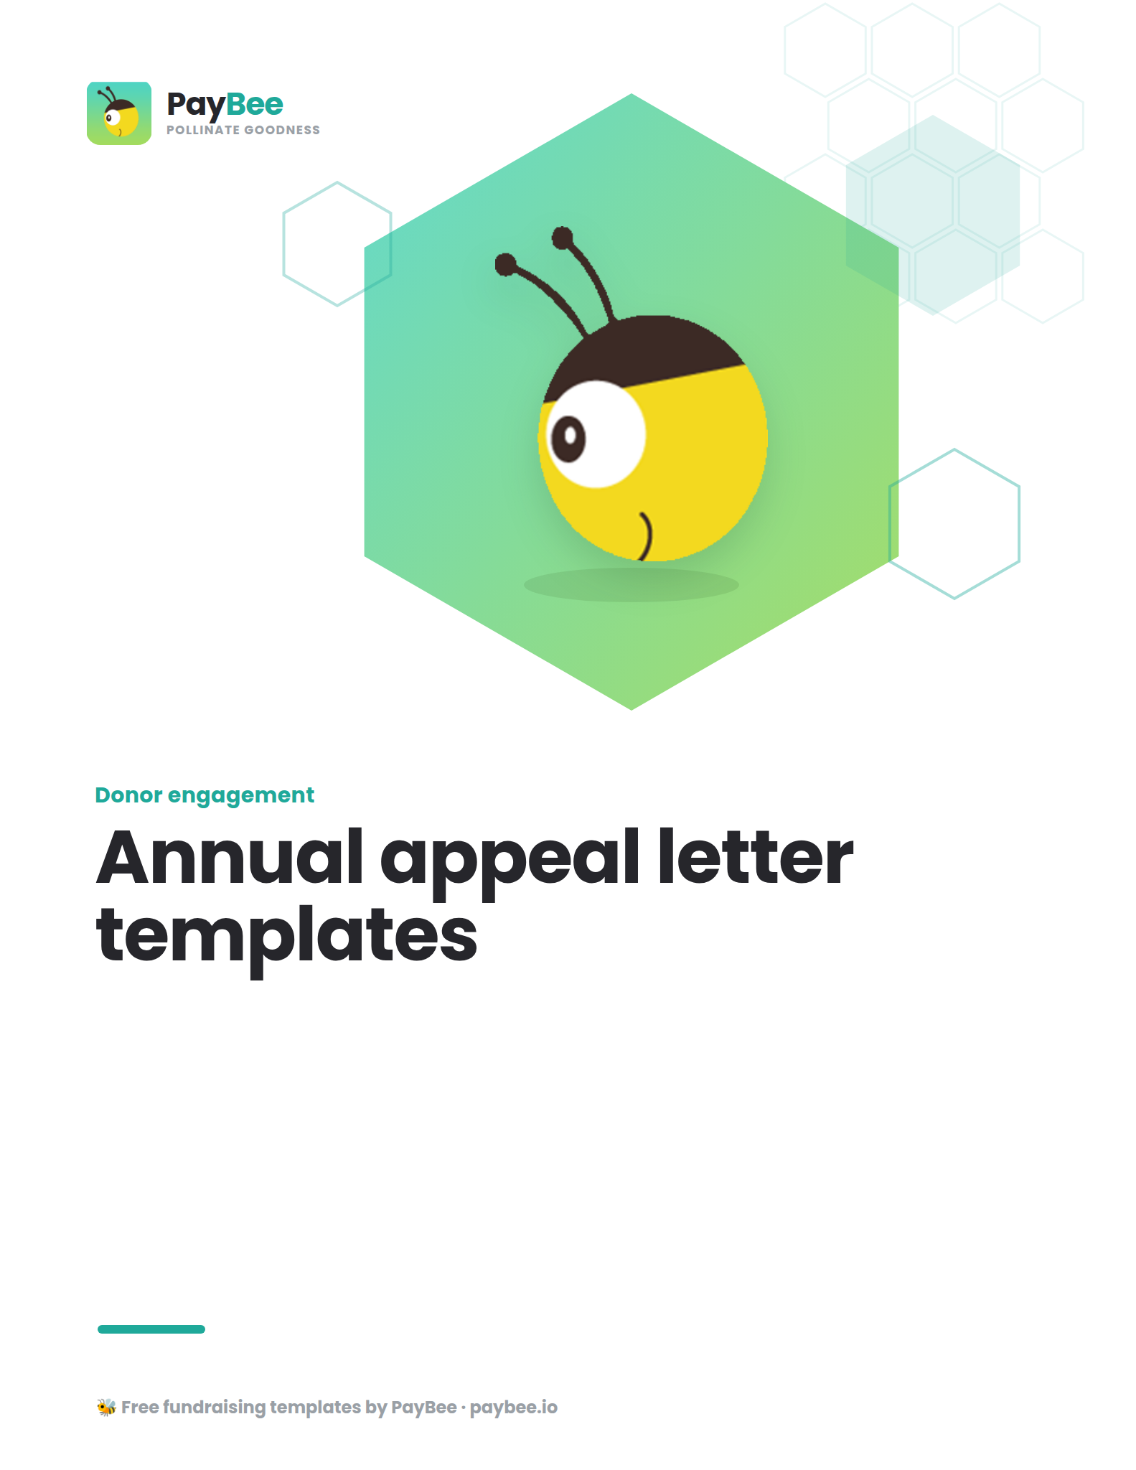

Template #1 💌

[YOUR NONPROFIT’S LETTERHEAD]
[DATE]

Dear [DONOR’S NAME],

At [NONPROFIT], we have always been dedicated to changing lives and making the world a better place—one step at a time. And thanks to your ongoing contributions, we’ve been able to do just that. In the last year alone, your cumulative donations of [DONATION AMOUNT] have helped [IMPACT], [IMPACT], and [IMPACT].

More than that, your ongoing support has instilled hope and joy in the hearts of some of the folks who need it most: [BRIEF IMPACT STORY]. But there is still so much more that must be done.

Today, we invite you to be part of our journey as we continue to [DESCRIBE YOUR ORGANIZATION'S MISSION AND HOW IT ADDRESSES CRITICAL NEEDS]. As we approach the end of the year, we hope you will join us in reaching our goal of [FUNDRAISING GOAL] before the year's end, to help us [INTENDED IMPACT] in the new year.

Your donation, no matter the size, makes a tremendous difference. You can make your contribution at this link [SHORT URL TO YOUR DONATION PAGE] or complete the enclosed donation form and return it in the pre-addressed envelope.

Thank you for creating hope for those that need it most. Together, we can make a difference.

With sincere gratitude,

[YOUR NAME]
[YOUR TITLE]
[YOUR NONPROFIT]

Template #2 💌

[YOUR NONPROFIT’S LETTERHEAD]
[DATE]

Dear [DONOR’S NAME],

I hope this letter finds you well.

Last year, you donated [DONATION AMOUNT] to [CAMPAIGN] to help us [CAUSE]. Today I’m
excited to share with you how your contributions created a lasting impact on one remarkable
individual, [BENEFICIARY NAME].

Before your help, [BENEFICIARY NAME] was [BRIEFLY DESCRIBE THE INDIVIDUAL’S
CHALLENGES THEY FACED].

But then, thanks to your unwavering support, we were able to extend a helping hand to
[BENEFICIARY NAME] by [INSERT SPECIFIC IMPACT] through [PROGRAM OR SERVICES]. More
than that, your contributions helped [BENEFICIARY NAME] find hope and a community of
people dedicated to their success. Today, [BENEFICIARY NAME] is thriving in ways they never
thought possible—all because of you.

Though [BENEFICIARY NAME] is just one example of someone your generosity has touched,
[BENEFICIARY NAME]’s story speaks volumes. As we approach the end of the year, we invite you
to consider contributing to [CAMPAIGN] to help more people like [BENEFICIARY NAME] in the
coming year. We are just shy of our fundraising goal of [FUNDRAISING GOAL] and need your
help now more than ever.

Your tax-deductible donation can be made securely online at [NONPROFIT WEBSITE], or you can
use the enclosed donation form and pre-addressed envelope to mail your contribution.

From the bottom of our hearts and from [BENEFICIARY NAME], thank you for being the heart of
our organization.

With deepest appreciation,

[YOUR NAME]
[YOUR TITLE]
[YOUR NONPROFIT]

