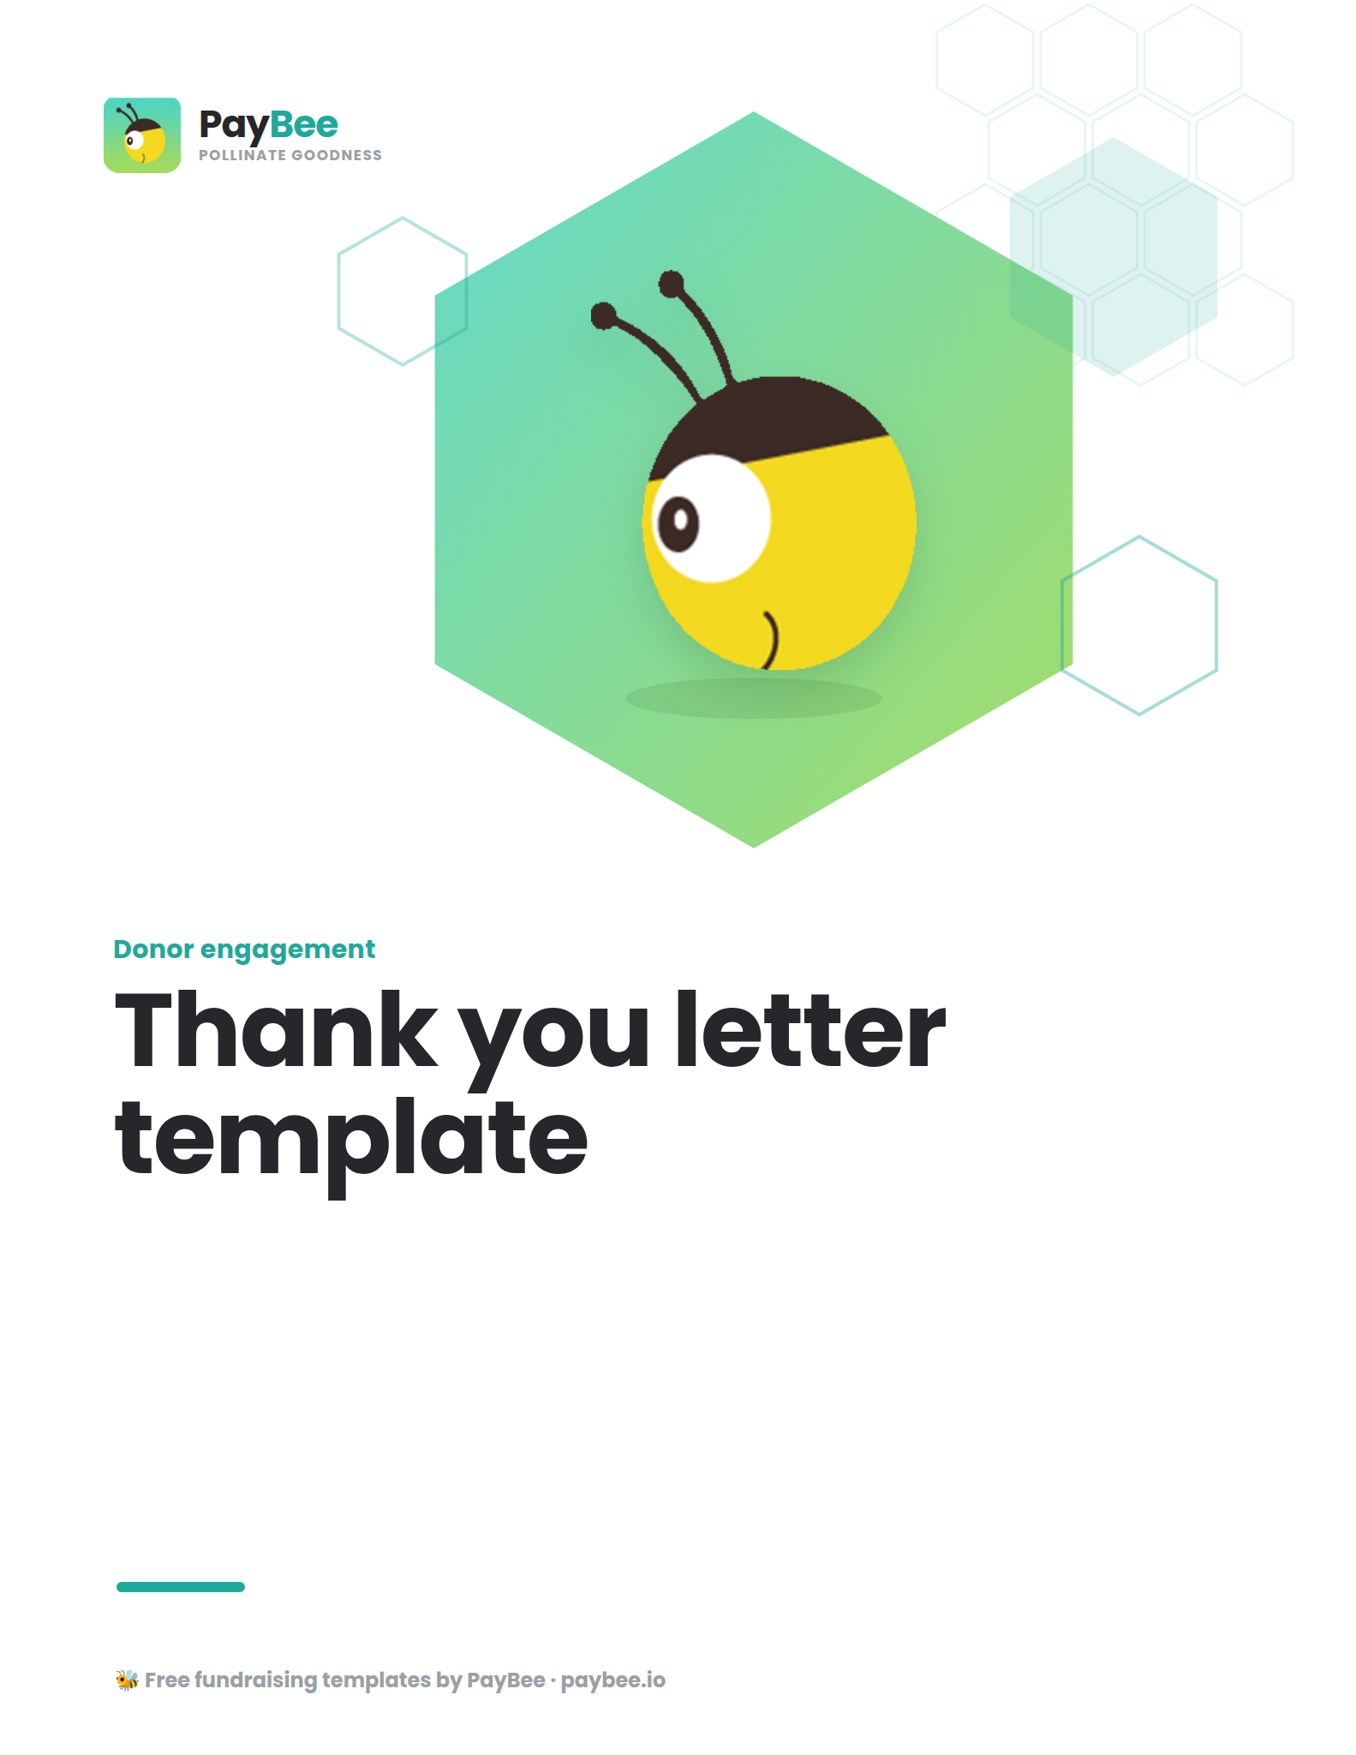

Thank you letter template ✉️

Use this template to save time crafting your own thank-you letters! Copy and paste the text below into your PayBee mailings editor, then customize and send!

Dear [FIRST NAME],

I wanted to reach out and personally thank you for your generous contribution to [NAME OF ORGANIZATION] for [NAME OF CAMPAIGN]. Your donation of [AMOUNT] will help provide [SPECIFIC EXAMPLE OF IMPACT].

I am delighted to share that thanks to donors like you, we have successfully raised [TOTAL AMOUNT RAISED]. These funds will be used to [WIDER SCOPE OF IMPACT]. In fact, [WHAT’S MOVING FORWARD ALREADY—SHORT BUT DETAILED].

When [BRIEF PERSONAL STORY RELATED TO CAUSE or DATA-BACKED, DEEPER EXPLANATION OF YOUR MISSION].

I hope you know how much your gift plays a significant role in making this vision a reality.

To learn more about how your contribution will continue to make a difference and discover additional ways to get involved, [NAME OF ORGANIZATION] on [SOCIAL MEDIA HANDLE)] to see our progress each week.

Thank you again for being part of our caring community.

Sincerely,
[YOUR NAME]
[YOUR ROLE]
[NAME OF ORGANIZATION]

See it in action 💪

Example thank you letter #1  From a beneficiary | Darlington School raised over $60K through independent giving in just 24 hours on PayBee.  If you're looking to thank donors on behalf of  your school, your thank you message might look  like this:

Dear Stephen,

Thank you so much for your donation of $55. Your generous gift will bring plenty of smiles to the students and teachers of Darlington School!

We are so pleased to announce that in just a single day of giving, we were able to raise $61,000. This money will be used to buy supplies and resources for our students and teachers, who have been working so hard this past year during the pandemic.

I'm an alumnus of Darlington School myself, and my mom worked in the advancement office. I know the positive impact this school has on its students—because I was one!—so I can't thank you enough for your contribution.

To learn more about how your support makes a difference in students’ and teachers’ lives, we invite you to visit DarlingtonSchool.org/GivingDay. You can also visit our Facebook page to see future events.

Once again, thank you for your donation. Go Tigers!

Best,
Julia

Example thank you letter #2  From a campaign member | The Bululu Well Project raised $7K to provide  clean water in Uganda. If you were one of the  many volunteers or campaign organizers who  made this happen, you might find yourself writing  thank yous that look like this:

Dear Taylor,

I just wanted to reach out and personally thank you for your donation to the Bululu Well Project. Your donation of $100 will help provide clean, safe drinking water to 1,200+ Obur Village residents.

I am so pleased to announce that we successfully raised $7,000 to provide clean drinking water in Uganda. In fact, we already wired the funds this Wednesday, and they will begin drilling a new well shortly thereafter. Soon, the Obur Village and the Bululu Secondary School will have access to clean
drinking water.

When you bring clean, safe water to a population, it directly impacts young people's ability to attend
school. It even changes the health and hygiene of the community and decreases the risk of early death. I hope you know your generous contribution played a significant role in this trickle-down effect.

To learn more about how your gift makes real change, I invite you to follow Call to Care Uganda on Instagram, Facebook, and X (Twitter).

Once again, thank you kindly for your generosity.

Best,
Josh
CEO of Earth2

Even more ways to engage 💛

Sending thank you letters via direct mail can make a big difference in your donor relationships. To complement this, you can also acknowledge donations in more immediate ways, ensuring donors feel appreciated right away.

Customize your donation receipts 🧾

When your donors contribute to your PayBee fundraising page, event, or donation form, they immediately receive an automatic donation receipt email confirming their payment and providing all the details for their records.

To add a personal touch to an otherwise transactional email message, customize your donation receipts with a message of appreciation. For example:

Subject line: Your receipt from [NAME OF ORGANIZATION]

Thank you for your generous contribution to [NAME OF ORGANIZATION], [FIRST NAME]!

Your tax-deductible donation of [DONATION AMOUNT] on [DATE] will ensure that [ASPECT OF YOUR MISSION].

With the support of our incredible community (that’s you!), we look forward to [OUTCOME] this year.

Thank you again for being a part of our caring community.

Sincerely,
[NAME, ROLE]
[NAME OF ORGANIZATION]

Set up an automatic thank you email 💌

In addition to a donation receipt, you may also want to send a thank you email follow-up to provide a personal touch point for your donor before their letter arrives in the mail. This message can offer more information about your organization and include other ways for the donor to connect, such as following you on social media or reading a recent news article about your work.

With PayBee, you can set up an easy workflow that automatically sends this email after the initial donation receipt is sent!

When to send: Within 24 hours of the donation

Subject line: Thank you for your generous donation, [FIRST NAME]

Body of email:

Hi [FIRST NAME],
I wanted to take a moment to express my deepest gratitude for your recent donation to [Name of organization or specific campaign].
Your generous support makes a significant impact for [Insert program or audience served by your organization], and your gift will go a long way toward ensuring [Insert abbreviated mission/vision]
In the coming weeks, I’ll share more updates on the impact of your gift. I hope you will join us on social media to stay up to date with our latest news and wins [Link]!
Your commitment to our mission inspires me and the whole team here at [NAME OF ORGANIZATION], and we're honored to have you in our caring community of support.
Warmly,
[YOUR NAME AND ROLE]
[NAME OF ORGANIZATION]

