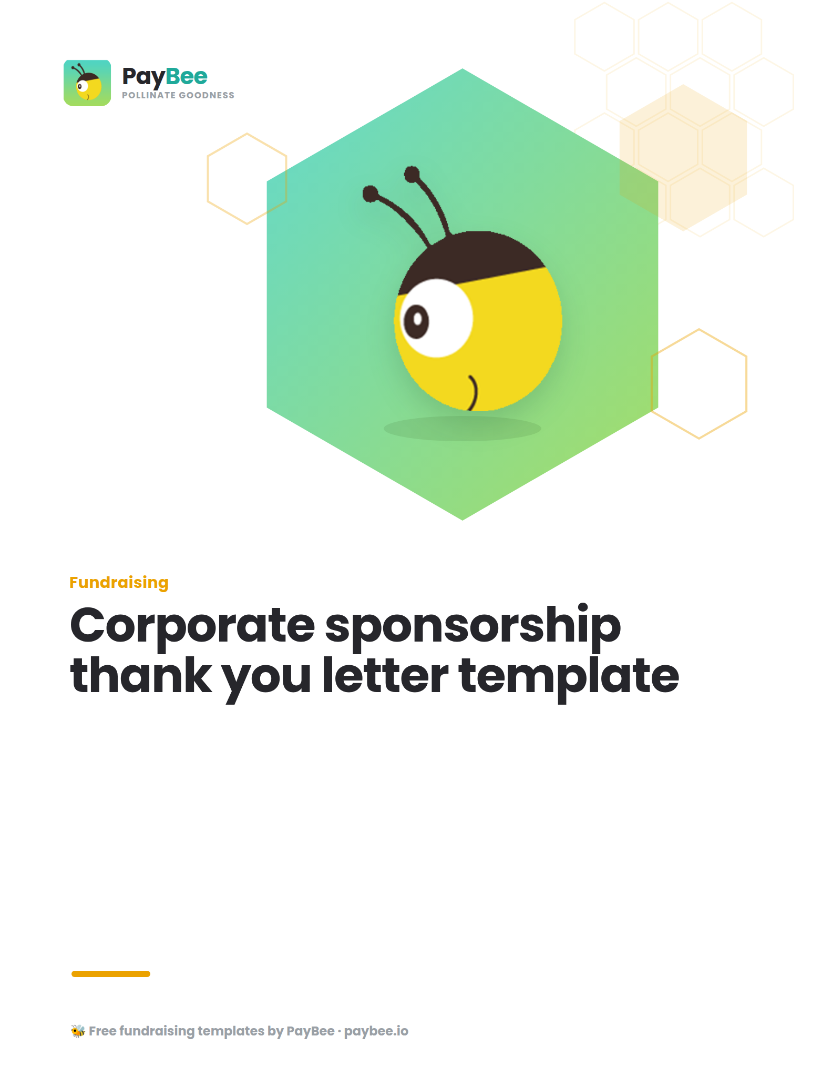

Corporate sponsorship thank you letter template ✉️

[YOUR NONPROFIT LETTERHEAD/LOGO]
[DATE]

Dear [DONOR'S NAME],

Thank you for your generous commitment to our cause by becoming a sponsor for [EVENT NAME].

By joining us as a [SPONSORSHIP TIER] sponsor, you’re making it possible for us to stage an incredible event to raise much-needed funds for [CAUSE].

We can’t thank you enough for your involvement and I’m excited to work with you on this partnership.

If you need anything, I’m always available at [EMAIL ADDRESS] or [PHONE NUMBER].

Yours sincerely,

[YOUR NAME]
[YOUR TITLE]
[YOUR NONPROFIT]

