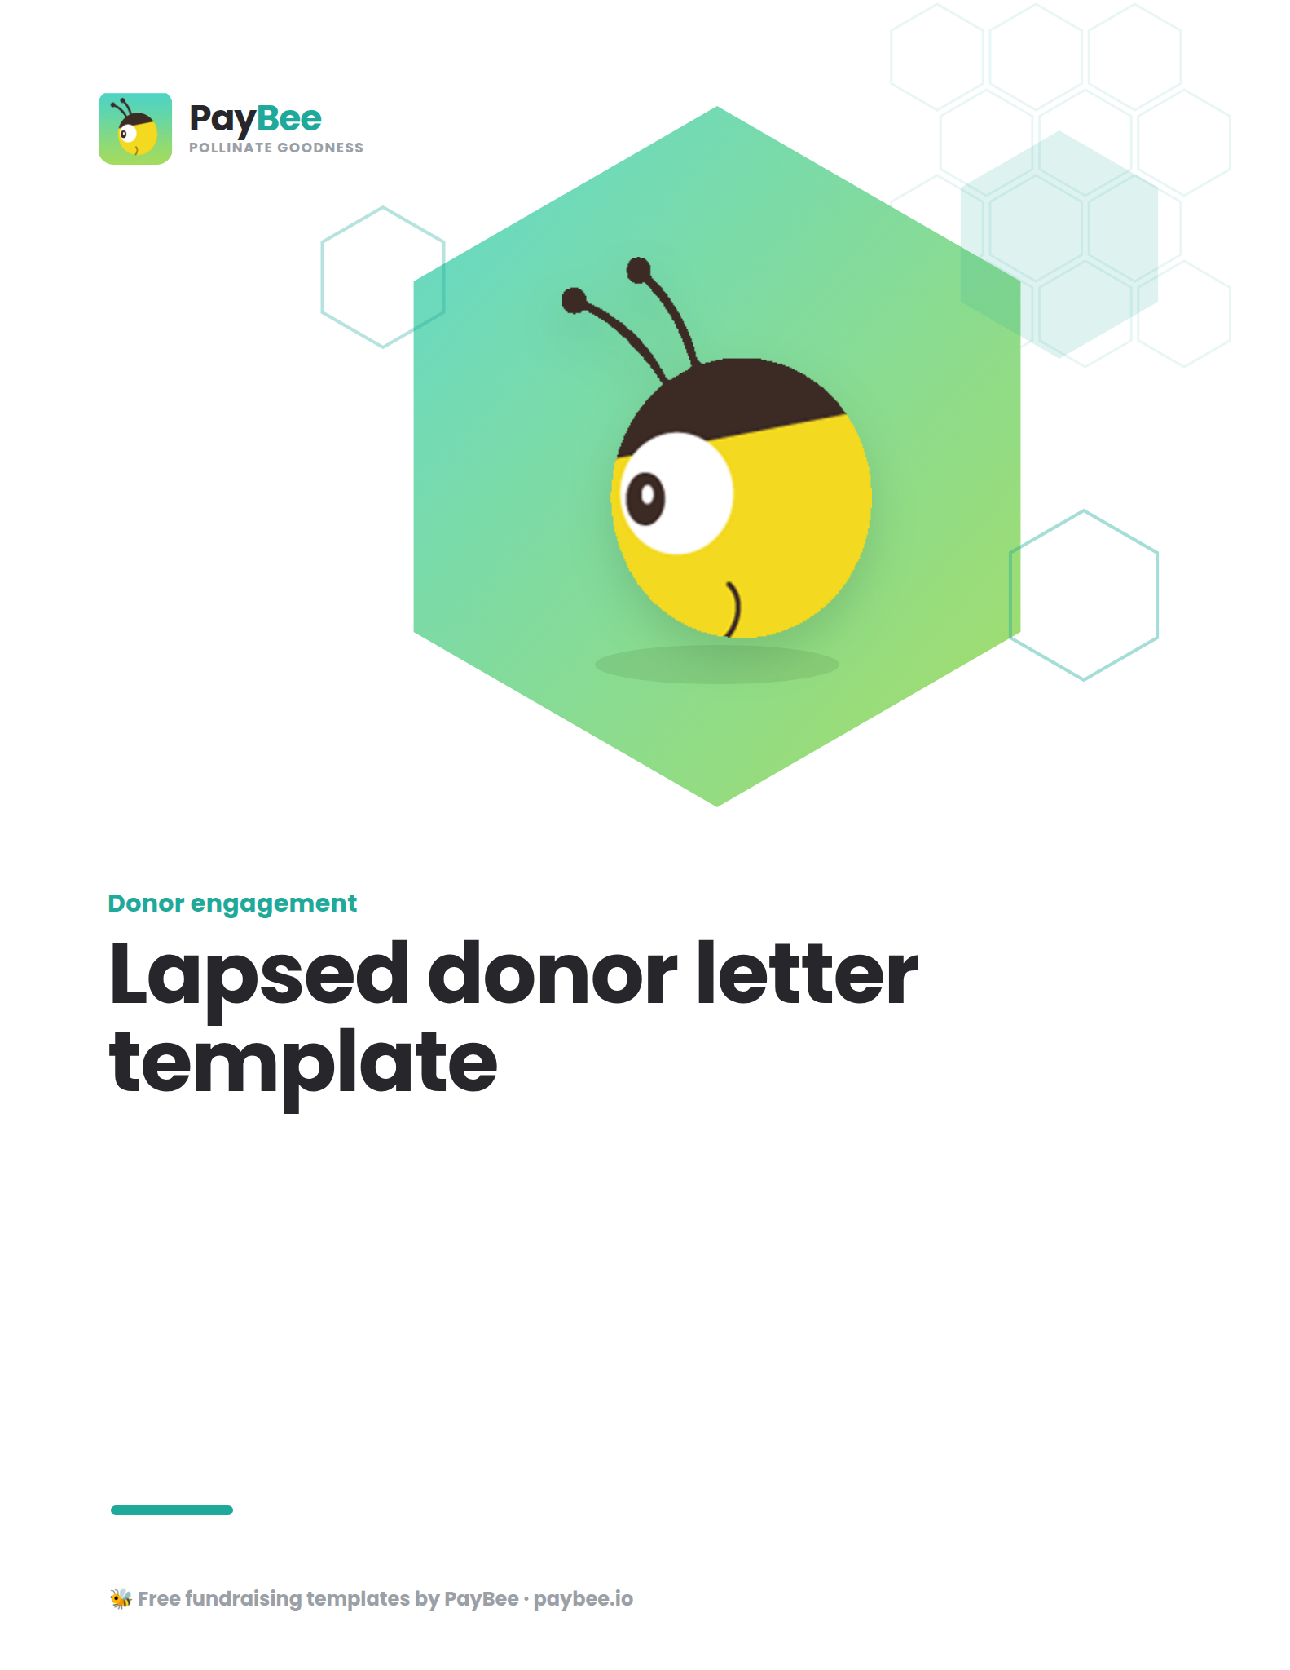

Lapsed donor letter template 👋

Customize the bolded text in the brackets below to match your organization and personal donor information. Then, copy and paste the message below into PayBee’s email & SMS outreach tool for easy distribution to your LYBUNT and SYBUNT donor segments.

FULL NAME
TITLE, ORGANIZATION
CONTACT ADDRESS
CONTACT PHONE
WEBSITE
EMAIL ADDRESS

DATE

POTENTIAL DONOR NAME
ADDRESS

Dear [DONOR FIRST NAME],
I hope this letter finds you well. As someone who has been an important part of our [ORGANIZATION NAME] family, I wanted to reach out personally to let you know how much we've missed your presence and support this year.
[LAST YEAR or IN 20##], your generous contribution of [DONATION AMOUNT] made a significant impact on [briefly describe a specific project or initiative]. Thanks to your support, we were able to [mention a specific achievement or milestone]. Your kindness helped us move closer to our mission of [state your mission or goal], and for that, we are truly grateful.
This year, we hope to [details about new challenges/initiatives/programs]. However, we can’t do it alone—we’re reaching out today to reconnect and invite you to join us once again in making a positive change.
Would you consider renewing your support for [ORGANIZATION NAME]? Every contribution, no matter the size, plays a crucial role in our continued success and the fulfillment of our mission. You can easily donate online at [DONATION URL] or by using the enclosed donation form.
We understand that circumstances change, and if there are specific reasons why you’ve paused your giving, we’d love to hear your feedback. Your insights are invaluable to us as we strive to improve and better serve our community.
Thank you once again for being a part of our journey. We hope to welcome you back soon and continue making a difference together.

Warm regards,

SIGNATURE
FULL NAME
ORGANIZATION

P.S. As a token of our appreciation, we’d like to offer you [mention any incentive or exclusive content]. Please feel free to reach out if you have any questions or need further information.

