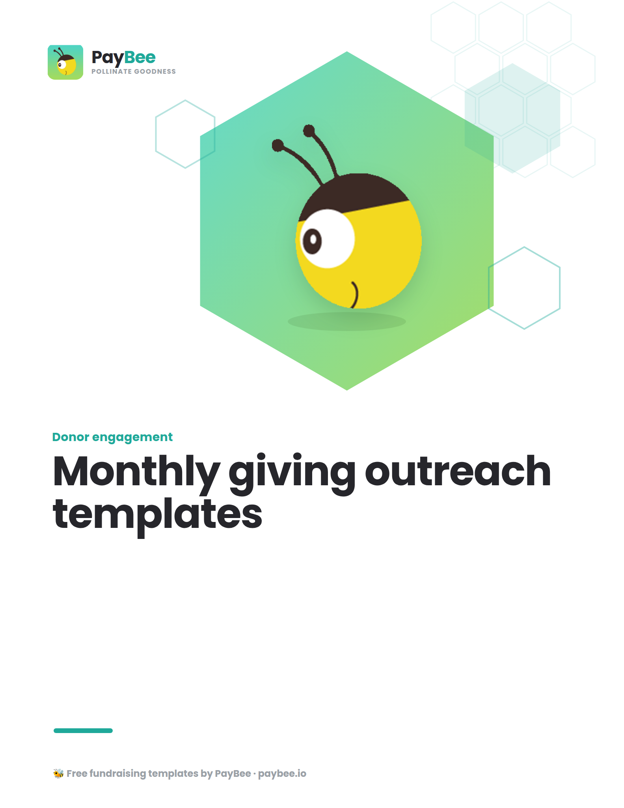

Monthly giving letter template 📫

Write to your supporters and encourage them to join your monthly giving program with this simple yet effective request letter template.

How to use: Copy and paste the message below into PayBee’s email & SMS outreach tool for easy distribution to your community members. Customize the bolded text in the brackets below to match your organization.

[FULL NAME]
[ORGANIZATION NAME]
[ORGANIZATION ADDRESS]

[DATE]

[POTENTIAL DONOR NAME]
[ADDRESS]

Dear [FIRST NAME],

Thank you for being a loyal supporter of [ORGANIZATION NAME] and the work we do for [organization’s mission, ideally including a short impact story].

With your support, we have been able to [a specific impact you’ve been able to achieve in the past year]. We couldn’t have accomplished all of this without your generosity.

We have big plans for [upcoming season, year, etc.], and to ensure that we continue to make a difference for [community you serve], we are inviting our community of supporters to join our monthly giving program, [PROGRAM NAME].

Making a monthly contribution is one of the most rewarding ways you can help [NAME OF ORGANIZATION], and [PROGRAM NAME] offers a convenient way to support our mission consistently and sustainably. Our [PROGRAM NAME] members are known as [MEMBERSHIP NAME] in recognition of [reason that aligns with why you chose that name for your members].

Every month, donations from our [PROGRAM NAME] enable us to:

- [Outcome of donation—e.g., distribute books to schools around the country]
- [Outcome of donation—e.g., continue to run our popular [Program name] program]
- [Outcome of donation—e.g., sustain our programs and services so we can continue to support our beneficiaries every month]
- [Outcome of donation—e.g., plan impactful programs into the future]

Becoming a [MEMBERSHIP NAME] is easy. Simply sign up at [CAMPAIGN URL] and choose the amount you’d like to contribute automatically each month.

It’s easy to change your monthly donation amount or pause donations at any time, and we’ll use these funds towards our goal of [ORGANIZATION GOAL] for as long as you remain a member.

Thank you for continuing to support our mission to [MISSION] and being part of our journey!

Sincerely,

[SIGNATURE]
[FULL NAME]
[ORGANIZATION NAME]

[CONTACT PHONE]
[WEBSITE]
[EMAIL ADDRESS]

Monthly giving email template 📨

Call upon your existing donors to join your monthly giving program with this targeted email template.

How to use: Copy and paste the message below into PayBee’s email editor or the advanced email editor within PayBee, then customize it with your own details. Create donor segments to tailor messages for specific audiences.

Hi [FIRST NAME],

Thank you for being a loyal member of the [NAME OF ORGANIZATION] community and for your recent donation towards [PROGRAM/BENEFICIARY].

With your support, we have been able to [a specific impact you’ve been able to achieve in the past year]. We couldn’t have accomplished all of this without your generosity.

We have big plans for [upcoming season, year, etc.], and to ensure that we continue to make a difference for [community you serve], we are inviting our community of supporters to join our monthly giving program, [PROGRAM NAME].

Making a monthly contribution is one of the most rewarding ways you can help [NAME OF ORGANIZATION], and [PROGRAM NAME] offers a convenient way to support our mission consistently and sustainably. Our [PROGRAM NAME] members are known as [MEMBERSHIP NAME] in recognition of [reason that aligns with why you chose that name for your members].

Every month, donations from our [PROGRAM NAME] enable us to:

- [Outcome of donation—e.g., distribute books to schools around the country]
- [Outcome of donation—e.g., continue to run our popular [Program name] program]
- [Outcome of donation—e.g., sustain our programs and services so we can continue to support our beneficiaries every month]
- [Outcome of donation—e.g., plan impactful programs into the future]

Becoming a member is easy. Simply sign up at [CAMPAIGN URL] and choose the amount you’d like to give every month. You can easily change your monthly donation amount and pause donations at any time.

Once you’ve joined us as a [MEMBERSHIP NAME], your donation will be automatically collected every month, and we’ll use these funds towards our goal of [ORGANIZATION GOAL] for as long as you remain a member.

Thank you for continuing to support our mission to [MISSION] and being part of our journey!

Warm regards,

[FULL NAME]
[ORGANIZATION NAME]

Monthly giving text message template 💬

Use this short and sweet text message template to alert your community members to your new or improved monthly giving program.

How to use: Copy and paste the message below into the PayBee text message editor, where you can customize your text messages and send them to your chosen donor segments with ease. You’ll even get to see a preview of how the message will look on their mobile device!

Hi [FIRST NAME]! We’re so excited to [launch/relaunch/introduce you to] [ORGANIZATION]’s monthly giving program, [PROGRAM NAME]!
[PROGRAM NAME] is an easy, rewarding way to support our work every single month with an automatic gift. Choose your donation level, set the frequency, and feel good knowing you’re helping us to [MISSION/GOAL] every month.

Find out more about the program and how to join at [SHORT CAMPAIGN URL]

Thank you for your support! ❤️

Monthly giving social media caption template 📱

Whether your monthly program is brand new or you want to remind your supporters that it exists with a big relaunch, social media is a fantastic tool to spread the word. Use our template below to tell your community members all about your program.

How to use: Copy and paste the message below into your social media platform of choice, along with an appealing photo or attention-grabbing graphic that highlights your program and its impact.

Did you know we have a monthly giving program? 👀

[PROGRAM NAME] is one of the easiest and most powerful ways to support [ORGANIZATION NAME] now and into the future as we [MISSION/GOAL]. 🚀

Becoming a member is easy. All you need to do is choose your donation level, and each month, that amount is automatically sent to [ORGANIZATION NAME] so that we can [current goal/impact].

Find out more and become a [program/membership name] at [CAMPAIGN URL].

Thank you for being part of our caring community and making a difference for [your community/population you serve]! ❤️

Monthly giving donation landing page template 💻

A landing page gives you a dedicated place to introduce your monthly giving program, explain how it works, and encourage your supporters to sign up.

How to use: Copy and paste the text below into a new page on your website. Customize it with your own details and flair. Add imagery that highlights the work you do and the impact these donations make. Don’t forget to embed a donation form or donate button onto this page so taking action is easy!

When you join [PROGRAM NAME], you can make a difference for [OUTCOME/BENEFICIARIES] for months to come!

[PROGRAM NAME] is [ORGANIZATION NAME]’s monthly giving program—an easy, powerful way for caring community members like you to support our cause on a regular basis. It’s a rewarding way to make an impact and help us to [MISSION/GOAL] in a sustainable way.

Our [PROGRAM NAME] members are known as [MEMBERSHIP NAME] in recognition of [reason that aligns with why you chose that name for your members].
Every month, donations from our [MEMBERSHIP NAME] enable us to:

- [Outcome of donation—e.g., distribute books to schools around the country]
- [Outcome of donation—e.g., sustain our programs and services so we can continue to support our beneficiaries every month]
- [Outcome of donation—e.g., plan impactful programs into the future]

We’ve designed [PROGRAM NAME] to be as friction-free as possible. That’s why you can:

- Choose your own donation level
- Change your preferred donation amount at any time
- Pause or leave the program at any time

Your donations will be collected automatically every month, so there’s no extra work involved for you. Just sit back, relax, and feel confident that every month you’ll be helping us to make a difference in a meaningful way.

Becoming a member is easy. Simply fill out the form below and choose the amount you’d like to give every month. We’ll take care of the rest. Thank you for your support!

Monthly giving phone script template ☎️

Reach out to your donors in a more personal way by calling them up as part of a monthly giving program appeal.

How to use: Personalize the phone script below, then ask your callers to follow it when they dial your donors.

Hi [FIRST NAME],

I’m [YOUR NAME], the [TITLE] at [ORGANIZATION NAME].

I’m calling to thank you for your continued support, which has enabled us to [an impact you’ve been able to achieve]. We couldn’t do this work without you!

I also want to share a new way you can continue supporting our mission—our monthly giving program, [PROGRAM NAME]. This program is an easy and powerful way to help us [MISSION/GOAL] every single month with automatic donations.

Many of our members (we call them [MEMBERSHIP NAME]) choose to give $[AMOUNT] per month, but you can choose to give at any level that works for you. Would you be interested in joining us as a [MEMBERSHIP NAME]? [Pause]

If leaving a message: If so, all you have to do is go to [SHORT URL] and fill out the brief form to choose your monthly donation amount. I will follow up with you via email or text to confirm, and you can reach me at [EMAIL OR PHONE NUMBER] with any questions. Thank you for your time and continued support!

If yes: Thank you so much! All you have to do is go to [SHORT URL]—I can send it to you via email or text to confirm. What is the best way to reach you? [Pause] Great, I will follow up shortly. Please let me know if you have any questions. I can’t thank you enough for your support!

If not sure: No problem. I can send you more information about the program in an email or text message. Please let me know if you have any questions at all. What is the best way to reach you? [Pause] Thank you for your time and continued support of [ORGANIZATION NAME]!

If no/not at this time: I understand. Thank you for your time, and we will be sure to let you know about other opportunities to support [ORGANIZATION NAME] in the future!

Supercharge your monthly giving program with PayBee ⚡

With PayBee, your nonprofit can save time and money—and maximize donations—with task tracking, workflows, automated communications, and more. PayBee also offers users an advanced email editor, text messaging, and discounted direct mail to take donor engagement to the next level.

How to use: Follow the checklist below to set your monthly giving program up for success.

Make sure you’re maximizing your PayBee tools for monthly giving success:
- Automate first-time follow-up:
Set up a custom workflow that sends a personalized welcome message to a new monthly donor after they receive your standard donation receipt message.

- Streamline your to-dos:
Create a workflow that reminds you or a member of your team to reach out personally to a new recurring donor with a phone call or an additional email.
- Create a new monthly giving email series:
Set up an automated email drip campaign for new monthly donors that shows your appreciation and builds a sense of belonging with exclusive perks, behind-the-scenes insights, and more.
- Customize monthly giving receipts:
Create engaging, personalized monthly donation receipts that are sent automatically when their recurring donation is fulfilled each month. Remind them of their impact and keep the gratitude flowing.
- Use templates for end-of-year and milestone emails:
Recurring donors should receive a thoughtful overview and acknowledgment of their contributions at year-end and at specific milestones (one year, two years, etc.). Create, customize, and save templates so they’re ready to go when the time is right.

