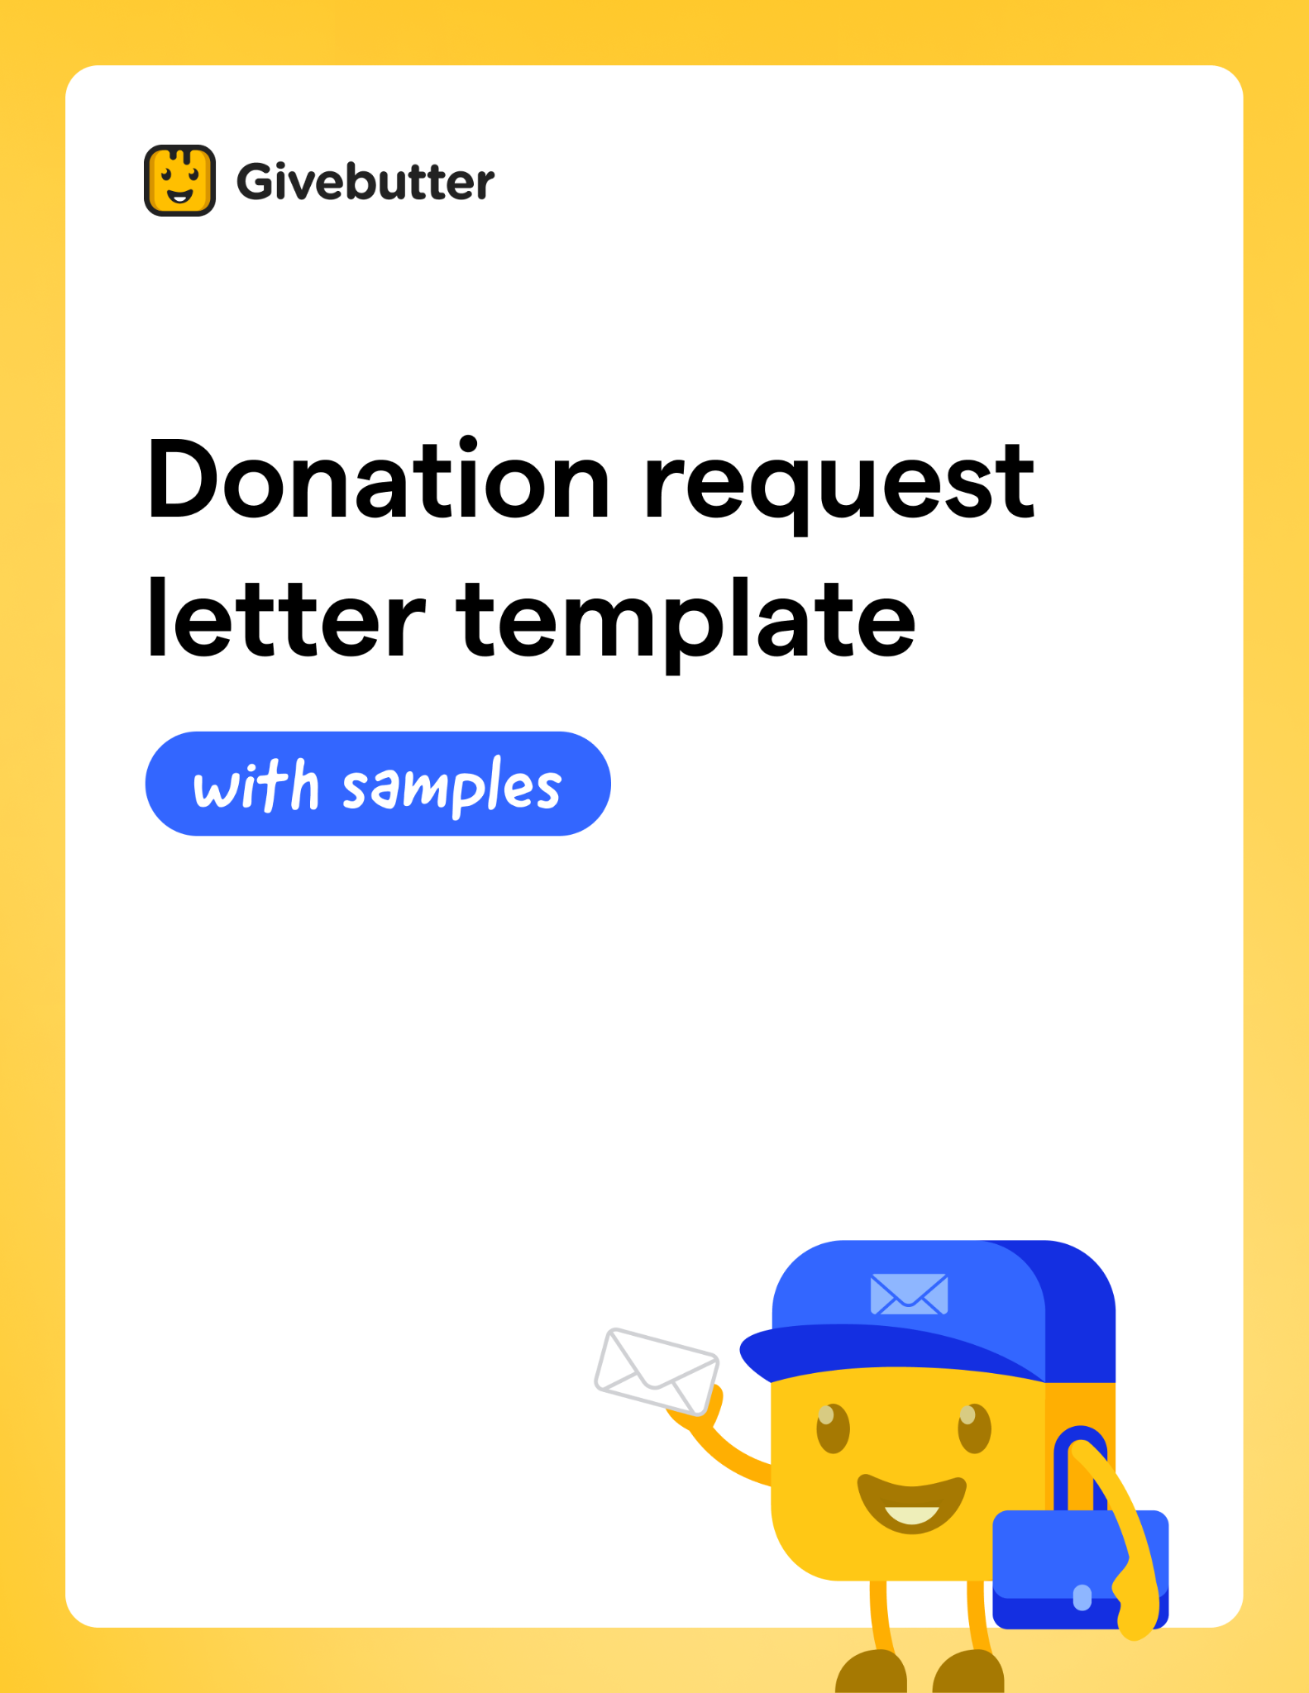

How to use these templates

1. Copy and paste the template text into PayBee’s free Engage messaging tool for verified nonprofits (or whichever email system you use), or into a text editor (for direct mail).

2. Personalize the message for your potential donor or donor segment.

3. Send!

Deep Dive ⭐  Read the complete guide for writing donation request letters  Learn more | 

More to Explore 💛  Check out 8 fundraising email best practices  to boost opens and clicks  Learn more | 

Donation request letter template ✉️
FOR PDF OR PRINT

FULL NAME
TITLE, ORGANIZATION NAME
CONTACT ADDRESS
CONTACT PHONE NUMBER
YOUR PAYBEE
QR CODE HERE
CO

WEBSITE
EMAIL ADDRESS

DATE

POTENTIAL DONOR COMPANY NAME
ADDRESS

Dear [POTENTIAL DONOR NAME],

[Draw the reader in with a short but powerful story, quote, statistic, or another example of why your cause matters. Use details that spark emotion and show the impact a donation will make.]

People like you are the reason that NAME OF YOUR ORGANIZATION has been able to [List your major successes or any projects in the works. If you’re reaching out to a previous donor, explain what you specifically accomplished with their past gifts].

Now, we need your help to [Add your call to action. Tell the potential donor exactly how they can contribute and be a hero for your cause].

Can you make it possible to reach our goal by donating [the specific amount of money, in-kind donations, or services you need]? Your donation will be used to [briefly explain how you’ll use their donation and where exactly they can make their contribution].

Your support truly makes a difference. Thank you for your consideration.
Sincerely,

SIGNATURE
FULL NAME

Donation request letter template for body of email ✉️

SUBJECT LINE: We're making a difference, but we need your help!

PREVIEW TEXT: Hi [DONOR NAME], are you able to make a donation?

BODY OF EMAIL:

Dear [POTENTIAL DONOR NAME],

[Draw the reader in with a short, powerful story, quote, statistic, or another example of why your cause matters. Use details and include photos or a video that sparks emotion and shows the impact a donation will make.]

People like you are the reason that NAME OF YOUR ORGANIZATION has been able to [List your major successes or any projects in the works. If you’re reaching out to a previous donor, explain what you specifically accomplished with their past gifts.]

Now, we need your help to [Add your call to action. Tell the potential donor exactly how they can contribute and be a hero for your cause].

Can you make it possible to reach our goal by donating [the specific amount of money, in-kind donations, or services you need]? Your donation will be used to [briefly explain how you’ll use their donation and where exactly they can make their contribution—e.g. "by clicking the link below].

[INSERT CTA BUTTON LIKE “Donate Now” HYPERLINKED TO YOUR PAYBEE PAGE/FORM OR YOUR ORG'S DONATION PAGE]

Your support truly makes a difference. Thank you for your consideration.

Sincerely,

FULL NAME
TITLE, ORGANIZATION NAME
PHONE NUMBER
WEBSITE

Sample letter #1 💌

Audience: Friends and family
Purpose: Request for a donation

Hi Judy,

I hope you're doing well! I'm reaching out to see if you would consider making a donation to a cause that I know we both care a lot about.

Every night, you and I are lucky to have a safe and warm place to sleep in our homes. But increasingly, so many people in our community are forced to sleep outside. I know the past few years have been tough on all of us, but for those who experience homelessness, times are especially difficult.

I'm writing to ask for your support for the annual Solidarity Sleepout. On April 30, adults, teens, and children will sleep outside to raise funds and awareness for people experiencing homelessness throughout Essex County.

Proceeds from the event will benefit Springfield's overnight shelter, A Friend's Place, offering emergency shelter for homeless adults in the region.

Would you be willing to donate $60 to the cause? Your contribution will sponsor five nights of shelter and care for one adult.

To make a donation, simply visit PayBee.com/sleepout23.

Thank you for your consideration!

All my love,
Jean

Sample letter #2 💌

Audience: A local business
Purpose: Request for a silent auction item

Dear Sloan,

I hope you're having a great week at Green Grape Wines. I'm writing to ask for your support for the annual St. Andrew’s School fundraiser that's coming up next month.

I know your daughter Liz attended St. Andrews, and you contributed much of your time and energy toward school events and activities.

As you know, the Silent Auction Fundraiser is one of the school's three main fundraisers, accounting for 10% of the budget for the calendar year. This year, our goal is to raise $40,000 to support the 3,500 students who attend the school.

Would your shop be willing to donate a special wine basket to be featured in the silent auction?

We hope to offer items from 10 local businesses, and we'd be so excited to have Green Grape Wines among them. I will follow up with a call to the store next week to speak in more detail. If you have any questions at all, please don't hesitate to reach out (you can find my contact information at the bottom of this email).

I appreciate your consideration, and I hope you have a great weekend!

All the best,

Helen Holbrook
St. Andrews PTA Vice President
Helen@standrewspta.org
123-456-7890

Sample letter #3 💌

Audience: A local business
Purpose: Request for a silent auction item

Dear Mr. Butters,

I'm writing to ask for VisionMaxCorp's support for the Bark in the Park 5k Run/Walk happening at Marshall Park on October 10. All proceeds from this event support the hundreds of rescue cats and dogs we serve each year at the Happy Paws & People shelter, just down the road from the VisionMaxCorp headquarters.

Would VisionMaxCorp be willing to sponsor the event?

We have sponsorships available at the $500, $1,000, and $2,500 level, and each sponsor is featured on all of our promotional materials. Our highest level sponsors are also invited to speak to the crowd at our pre-run pep rally at 10 am on Oct 10.

I'm sure you get a high number of requests for sponsorships and donations each year. However, we set a lofty goal of $20,000 to support the shelter as we ramp up our services to take care of 500 additional animals this year who need homes.

For additional information and to access our FAQ page, please visit PayBee.com/happypawsandpeople.

All the best,

Hazel Washington
Executive Director, Happy Paws & People
hazel@happypawsandpeople.org
123-456-7890

