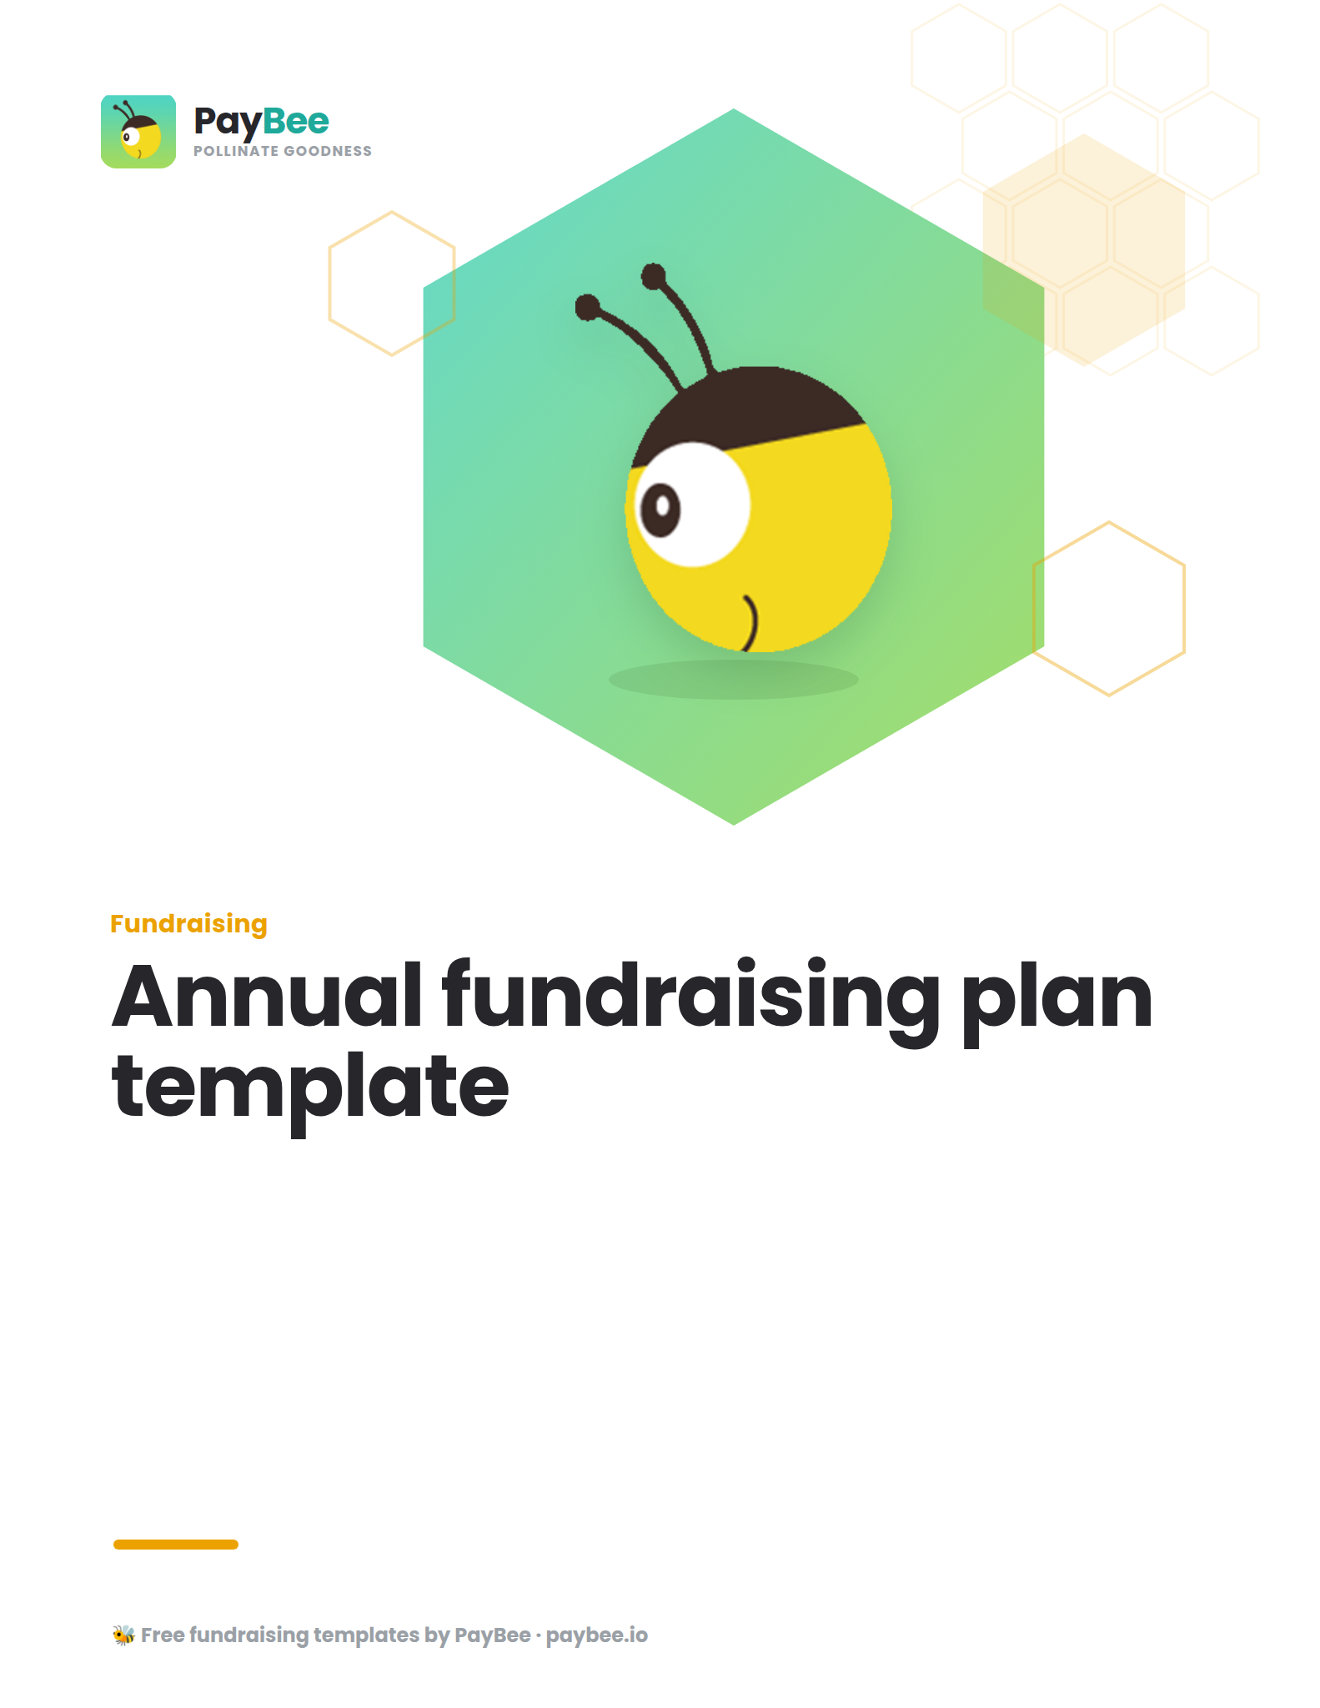
How to use this template:

Go to “File” → “Save a copy” to create an editable version of this template. You can either type directly into the new document, or print it out and write by hand.
Respond to the prompts and start drafting your strategic plan in each section below.
When you’re done drafting, delete these template instructions and customize the new document with your organization’s branding and any additional information you want to add.

💡 Read PayBee’s guide to creating an annual fundraising plan →

[INSERT NONPROFIT LOGO]

Mission, vision, and values 💛
[Insert your organization's formal mission statement]

Vision
[Insert your long-term vision for change]

Values
[List 3-5 core organizational values]

Impact
Document the following:
- Primary beneficiaries of your work
- Geographic area served
- Key demographic information
- Current reach and impact

Evaluation of [YEAR]’s fundraising efforts 🔍
For each major campaign/event from last year, analyze:

Campaign | Goal | Actual | ROI | Key learnings, challenges, and areas for improvement
[Name] | $ | $ | % | [Notes, summaries, etc.]

SWOT analysis ⚖️
Gather your key stakeholders (board, staff, volunteers) and evaluate your organization's:
- Internal strengths (like strong donor relationships or skilled staff)
- Internal weaknesses (such as funding gaps)
- Potential external opportunities (like new grant possibilities or partnerships)
- Potential external threats (such as changing regulations or increased competition)

Strengths | Weaknesses
Opportunities | Threats

Goals & objectives 🎯
Create goals that are:
- Specific: Define exactly what you want to accomplish
- Measurable: Include concrete numbers and percentages
- Achievable: Set ambitious but realistic targets
- Relevant: Align goals with your mission and capacity
- Time-bound: Establish clear deadlines
Example format: "Increase [metric] by [amount] by [date] through [methods].

Fundraising activities & funding sources 🎉
Determine the funding activities you’ll use to achieve your goals outlined above.

Activity | Goal | Target audience | Estimated costs | Timeline | Resources needed | Success metrics
[P2P campaign] | $ | [Group] | $ | [Dates] | [Resource]  [Resource]  [Resource] | [ROI]

Communication details & timeline 📣
List all the communication details required for every fundraising initiative.

Month | Target audience/donor segment | Channel | Assets needed | Start and end date
[Month] | [Group] | [Email, social media, direct mail, etc.] | [Social media graphics, videos, etc.] | [Dates]

Roles & responsibilities 💪
List all stakeholders involved in fundraising and clearly outline their responsibilities, estimated time commitment, and how you’ll measure their progress and success.

Stakeholder | Responsibilities | Estimated time commitment | Success metrics
[Name] | [Create assets, manage volunteers, etc.] | [X hours] | [ROI]

High-level overview of budget 💰
Compare the previous year’s revenue with current projections.

2024 revenue | Est. 2025 revenue | 2024 expenses | Est. 2025 expenses
$ | $ | $ | $

Fundraising calendar 🗓️
Put your plan into a fundraising calendar to keep track of all your dates and deadlines in one place.
Free template here!

