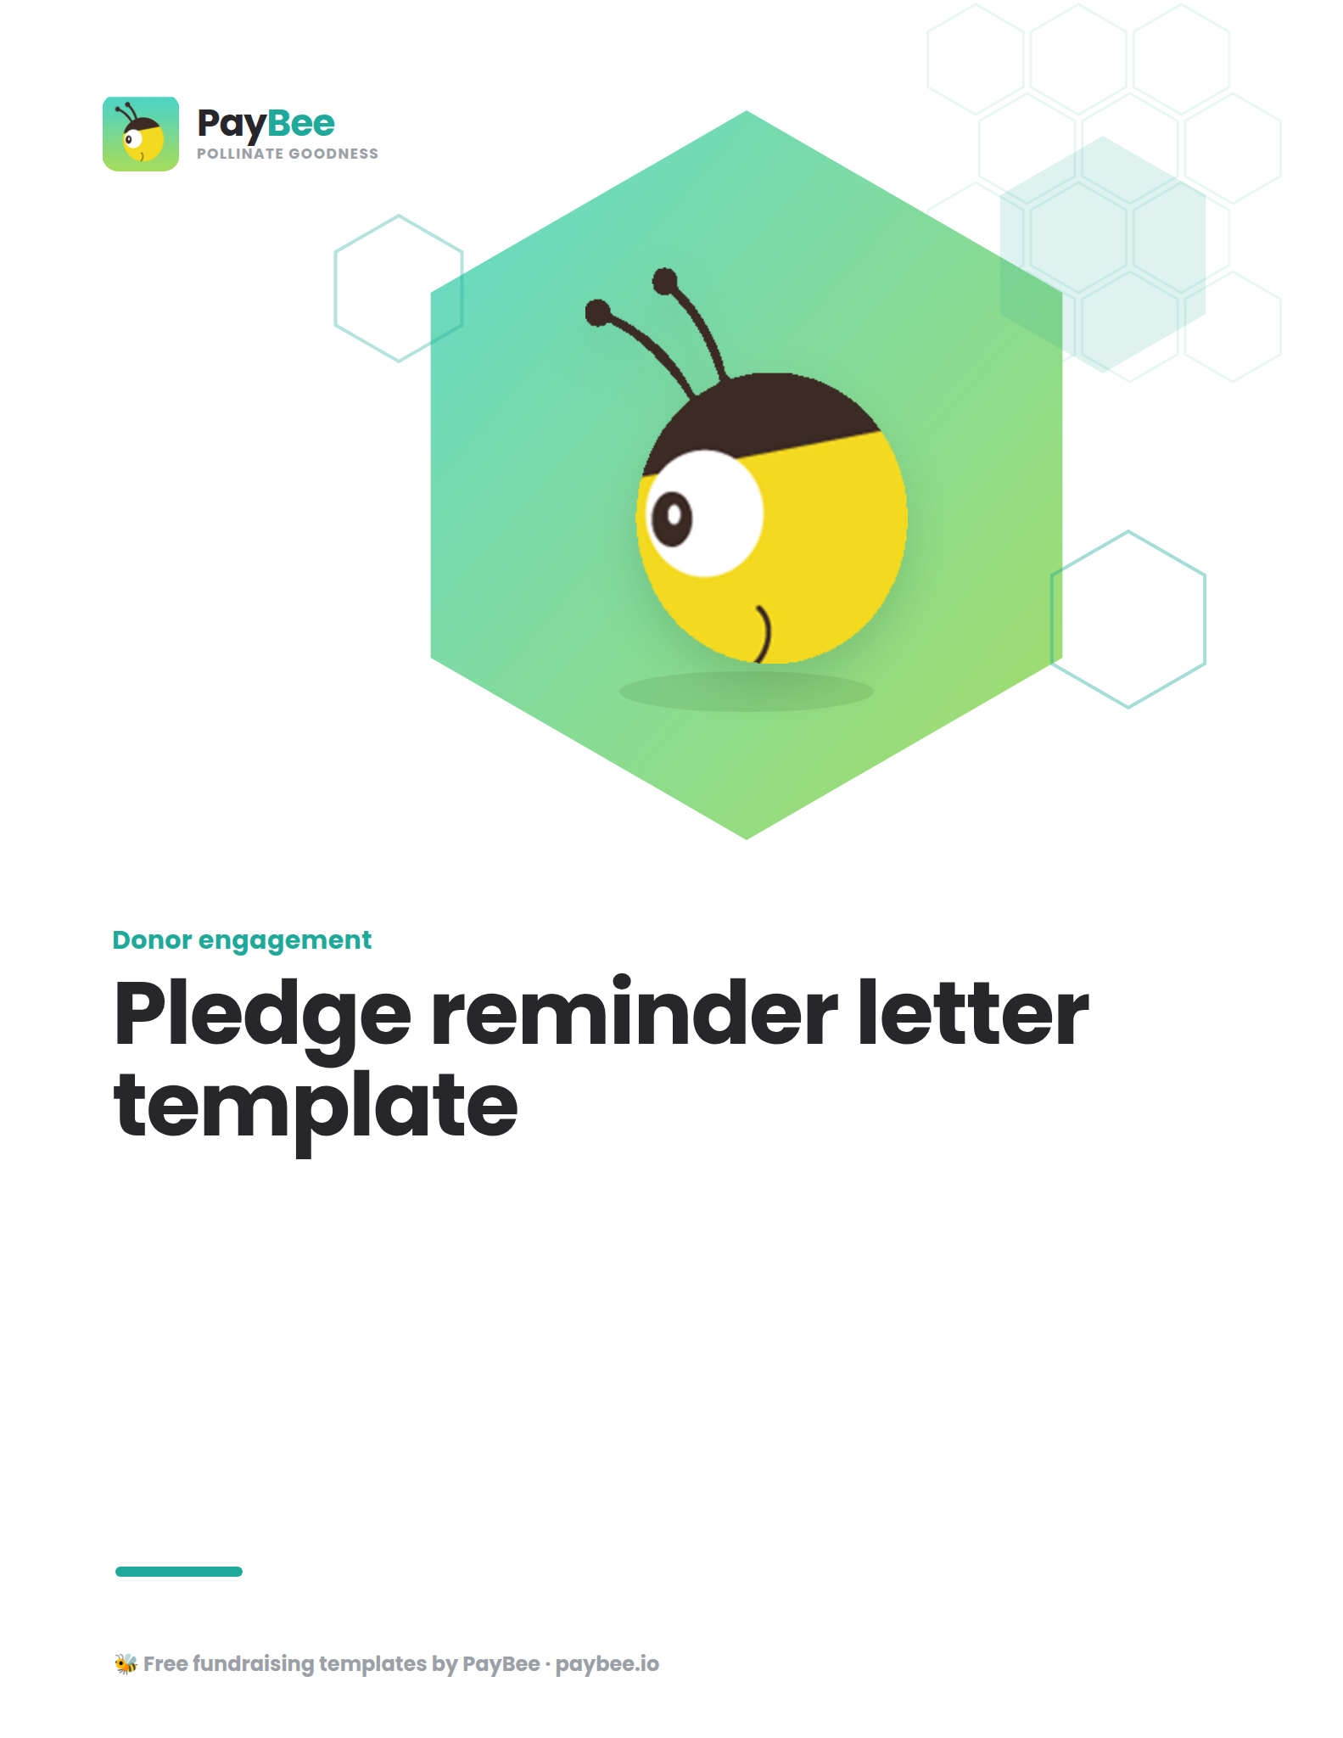

Pledge reminder letter template ✉️
Encourage your supporters to fulfill their donation commitments with this customizable pledge reminder template, perfect for email, direct mail, or both!

📝 How to use: Personalize the pledge reminder message below to match your organization’s voice and branding. Be sure to update all bolded text in brackets. Once finalized, copy and paste the message into PayBee’s email editor, direct mail editor, or use it as a reminder message directly in the pledge management tool. This is also where you can find your secure payment portal link to share with donors and easily track, manage, and fulfill pledge donations—all from your PayBee dashboard.

[EMAIL SUBJECT: Friendly Reminder: Fulfill Your Pledge 💛]

Dear [RECIPIENT NAME],

We want to express our deepest gratitude for your commitment to supporting [NONPROFIT NAME] and our mission to [BRIEFLY MENTION THE MISSION OR KEY INITIATIVES]. Your contributions have [INSERT IMPACT], and we couldn't be more grateful.

We're reaching out today to remind you that your upcoming payment deadline of [DATE] is approaching.

Here are the payment details for your convenience:

- Pledge amount: [$ AMOUNT]
- Payment due date: [DATE]
- Payment options: [INFORMATION ON HOW THEY CAN MAKE THE PAYMENT: ONLINE USING SECURE PAYMENT LINK, WHERE TO MAIL A CHECK, ETC.]

If you have any questions or need further assistance, please feel free to reach out to our team at [EMAIL AND PHONE NUMBER].

Once again, thank you for being a valued member of [NONPROFIT ORGANIZATION]. Together, we are making a positive difference in the lives of [MENTION BENEFICIARIES OR COMMUNITY MEMBERS], and it wouldn't be possible without supporters like you.

Best regards,

[NAME, TITLE]
[NONPROFIT NAME]
[CONTACT INFORMATION]

