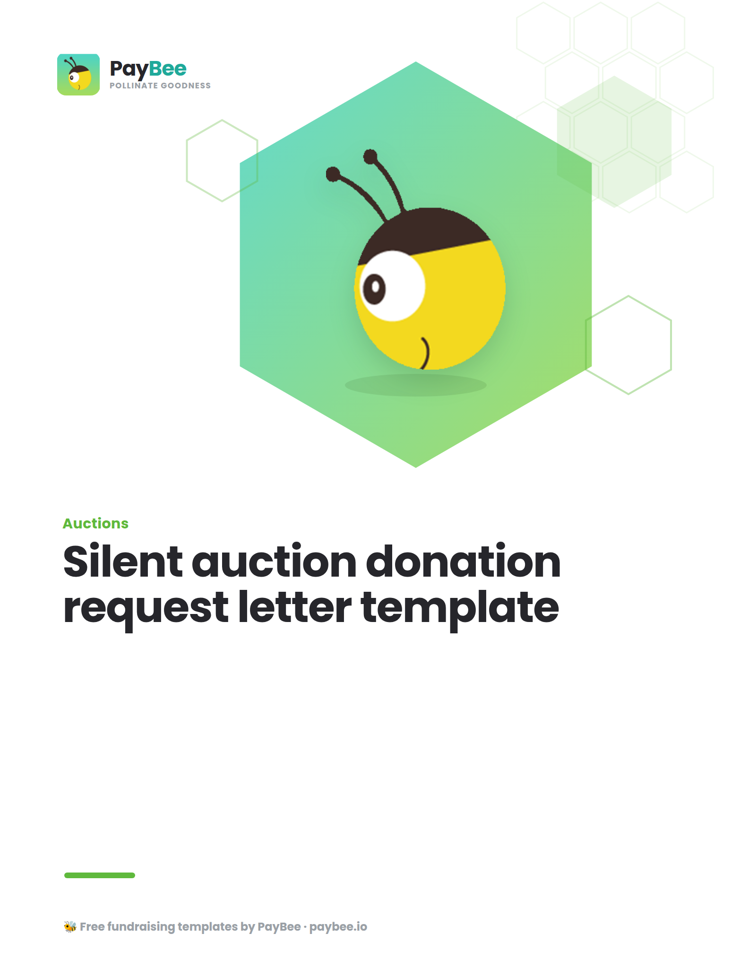

Silent auction donation request letter template ✉️

How to use this template:

1. Go to “File” → “Save a copy” to create an editable version of this template
2. Customize the new document with your organization’s information and personalized appeal
3. Copy and paste the message below into PayBee’s email & SMS outreach tool for easy distribution

💡 Read the complete guide for writing silent auction donation requests →

FULL NAME [LOGO]
TITLE, ORGANIZATION NAME
CONTACT ADDRESS
CONTACT PHONE NUMBER
WEBSITE
EMAIL

DATE

POTENTIAL DONOR NAME
BUSINESS NAME
BUSINESS ADDRESS

[SALUTATION]
Dear Mario’s Specialty Foods team,

[BRIEF, attention-getting story about how your organization has helped ONE particular person]

A few months after she had her first baby, Nicole landed a great job, but there was one big problem. Childcare was going to cost her most of her paycheck. That’s when she found Dana’s Happy Helpers. Instead of dropping out of the workforce entirely, Nicole is now able to follow her dream and feel confident that her baby is receiving quality care while she is at work.

[Concisely explain your organization’s mission and programs]

Here at Dana’s Happy Helpers, we provide quality sliding-scale childcare for families who would otherwise not be able to afford this critical service. Each year we support 150 families in the greater Springfield area and connect thousands more to community resources like diaper banks, WIC programs, and affordable healthcare options.

[Then move on to the fundraising event that the silent auction will be a part of]

This spring marks our fifth anniversary, and we are celebrating with a gala at The Big Inn on May 7th. The evening will also include a silent auction to raise funds, so we can serve more families and keep our programs going for years to come.

[Make the ask in Bold]

Will you consider supporting our event and mission of Dana’s Happy Helpers by donating an item or basket for our silent auction? We are huge fans of Mario’s Specialty Foods, and it would mean so much to us if we could feature some of your fantastic products among our offerings from across the community. Businesses that contribute items will be listed as sponsors in our gala materials, in addition to the auction display and written description.

[Provide logistical information]

I will call to follow up about next steps, but if you are ready to move forward, you can reply to this message to share a description of the item(s) and share any needs you have for tax documentation, etc. A volunteer will then arrange to pick up your donation during the week leading up to May 7.

Thank you for your support!

Sincerely,
Dana Warbler

[Don’t forget a P.S. where you repeat the ask!]

P.S. — Thank you for considering donating an item for our silent auction! We love Mario’s and would be honored to have your support.

