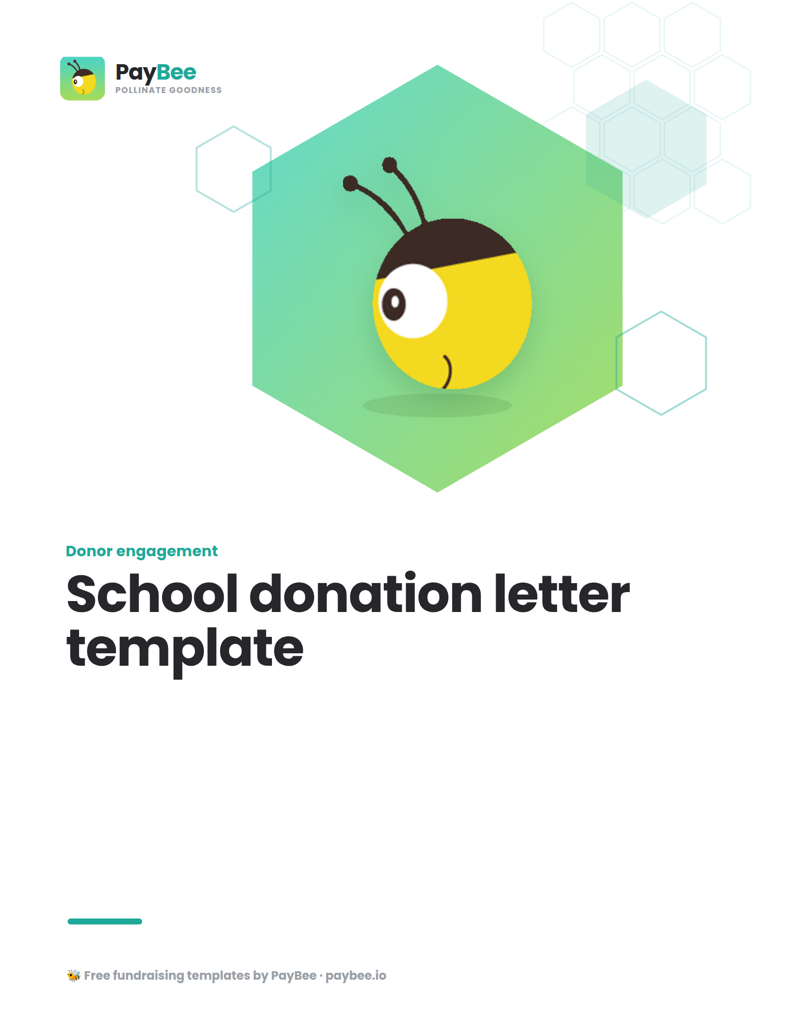

School donation request letter template 🎒

FULL NAME, TITLE
SCHOOL NAME
CONTACT ADDRESS
CONTACT PHONE
WEBSITE / EMAIL ADDRESS

DATE

POTENTIAL DONOR NAME
ADDRESS

Dear [RECIPIENT NAME],
Here at [SCHOOL NAME], our mission is to provide students with the best educational opportunities possible. As we prepare for the upcoming year, we seek your support to ensure that all our students have the resources they need to succeed.
One of our most successful programs has been [details about program, including a brief story or statistic about impact].

This year, we hope to [specific need within the program, e.g., improve classroom technology]. We aim to [specifics of direct impact/necessity of donations, e.g., purchasing 100 new laptops].

To make this dream a reality, we need to raise [your fundraising goal]. We’re reaching out today to ask for a contribution of [DONATION AMOUNT] to help us fund this project by [DEADLINE]. Every dollar raised will go directly towards [specific impact you anticipate].
In appreciation of your support, we look forward to acknowledging your donation in our school newsletter and inviting you to a special donor recognition event in [MONTH]—stay tuned for more details!

To contribute to this effort, please visit [LINK], mail a check to [ADDRESS], or contact our office at [PHONE NUMBER].

Thank you for being a part of our caring school community. Your support is greatly appreciated, and any amount you can give will have a lasting impact on our students.

Sincerely,

SIGNATURE
FULL NAME
SCHOOL NAME

School sponsorship request letter template 💼

FULL NAME, TITLE
SCHOOL NAME
CONTACT ADDRESS
CONTACT PHONE
WEBSITE / EMAIL ADDRESS

DATE

POTENTIAL DONOR COMPANY NAME
ADDRESS

Dear [RECIPIENT NAME],
I am writing to you on behalf of [SCHOOL NAME], where we are committed to nurturing the minds and talents of our students. Every year, we organize an [YOUR EVENT OR PROGRAM] in order to [PURPOSE OF EVENT], and I am writing to ask for your support to make this year our most successful yet.

[Brief description of the event or program and its importance, e.g., "Our annual science fair brings together young innovators and provides them with the opportunity to showcase their projects."]

As a sponsor of this event, [NAME OF COMPANY] will receive significant visibility across all of our marketing materials, including [specifics, e.g., in the event program, on event signs, on social media]. We offer several sponsorship levels, including [reference sponsorship levels and benefits], each with unique opportunities for recognition and engagement.

Your sponsorship will directly support [specific aspects of the event or program, e.g., "providing materials for student projects, funding awards, and ensuring a memorable experience for all participants"].

We would be honored to partner with [NAME OF COMPANY] for this event. Please find the enclosed sponsorship package with detailed information. If you have any questions or want to discuss this opportunity further, please contact me at [PHONE NUMBER] or [EMAIL ADDRESS].

Thank you for your time and considering our request. Your support will make a tremendous difference in the lives of our students for years to come.

Sincerely,

SIGNATURE
FULL NAME
SCHOOL NAME

Thank you letter template for donation to school 💛

FULL NAME, TITLE
SCHOOL NAME
CONTACT ADDRESS
CONTACT PHONE
WEBSITE / EMAIL ADDRESS

DATE

POTENTIAL DONOR COMPANY NAME
ADDRESS

Dear [DONOR NAME],
On behalf of everyone at [SCHOOL NAME], I want to express our heartfelt gratitude for your generous donation of [amount or description of in-kind donation]. Your support means the world to our students, staff, and school community.

Thanks to your contribution, we will be able to [specific use of donation, e.g., enhance our arts program, provide scholarships for students in need]. Your generosity is helping us deliver a richer, more fulfilling educational experience for all our students.

We sincerely appreciate your commitment to our school and our mission. As a token of our gratitude, we will acknowledge your donation in our upcoming newsletter and invite you to visit us and see firsthand the difference your support is making.

Thank you once again for being part of our caring community of support. We look forward to many more years of working together for our students.

Sincerely,

SIGNATURE
FULL NAME
SCHOOL NAME

