How to use this template:
Go to “File” → “Save a copy” to create an editable version of this template
[YOUR LOGO HERE]

[ITEM TITLE]

[ITEM DESCRIPTION]

Lot number: ____________________________ Fair market value: __________________
Minimum starting bid: ___________________ Bid increment requirement: _________

Buy-it-now price: ________________________ [OPTIONAL]

Name / Bidder # | Phone | Email | Bid amount

[YOUR LOGO HERE]

[ITEM TITLE]

[ITEM DESCRIPTION]

Lot number: ____________________________ Fair market value: __________________
Minimum starting bid: ___________________ Bid increment requirement: _________

Buy-it-now price: ________________________ [OPTIONAL]

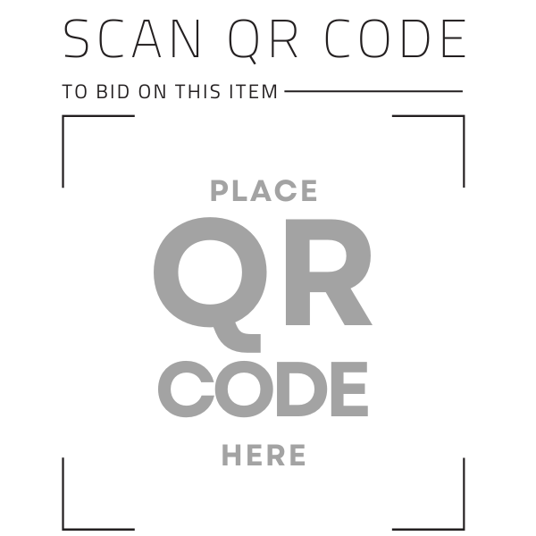
Or visit [ADD A SHORTENED URL HERE] to bid from your mobile device!

[YOU CAN EXPORT FREE QR CODES FOR ALL AUCTION ITEMS ON GIVBEUTTER]

