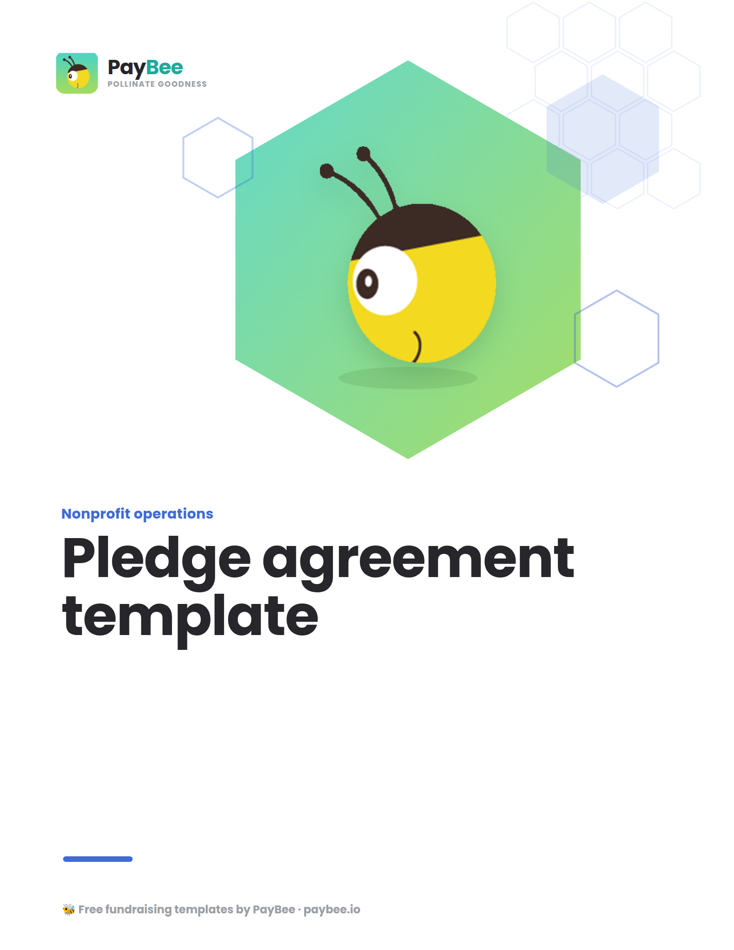

Pledge agreement template 🤝

Use this template to create your own informal pledge agreements to send to major gift donors. Make sure to update all bolded text in the brackets below. Once all parties have signed the agreement, you can track, manage, and easily fulfill pledge donations right in your PayBee dashboard.

Please note that this is designed for informal use and does not represent legal advice.

[YOUR LOGO]

Pledge agreement between [YOUR NONPROFIT] and [DONOR NAME/ORGANIZATION]

Donor name: ____________________________________________________________
Donor organization: _____________________________________________________
Donor address: _________________________________________________________
Donor phone: ___________________________________________________________
Donor email address: ___________________________________________________

This document forms a pledge agreement between [YOUR NONPROFIT] of [ADDRESS] and [DONOR NAME] of [DONOR ADDRESS] for the purpose of [PURPOSE]. The pledge is made on [DATE] and lasts for a period of [X YEARS].

As part of this pledge agreement, [DONOR NAME] agrees to the following:

1. Donor gift
The donor agrees to give [YOUR NONPROFIT] a donation to the amount of $_________. This will be made in the form of [PAYMENT METHOD] or in any other support agreed by [YOUR NONPROFIT].

2. Donation purpose
The donation pledged is to be used for [SPECIFIC CAMPAIGN/PURPOSE]. It is expected that [YOUR NONPROFIT] can supply evidence of this activity if requested by the donor. If any funds remain, or the funds are needed vitally elsewhere, the donor agrees for [YOUR NONPROFIT] to use this donation for other relevant means.

3. Payment schedule
The donor agrees to make these funds available to [NONPROFIT] at regular intervals of $_______ every _______ [MONTH/YEAR]. Payments will be made on [DAY] of every [MONTH/YEAR], with the last payment due before [END DATE].

4. Donor recognition
The donor is happy for [YOUR NONPROFIT] to mention their donation in publicity materials in line with their normal approach. In promotional materials, please refer to [DONOR] as [DONOR NAME/ORGANIZATION].

5. Reporting
The donor expects to receive a regular update on how their funds are being used to support [CAMPAIGN/NONPROFIT]. [YOUR NONPROFIT] agrees to send regular reports on progress and impact.

6. Additional gifts
The donor may choose to increase the gift amount or make any additional gifts or contributions to [YOUR NONPROFIT]. Additional gifts will fall under the same terms as this original pledge agreement.

7. Changes to the pledge agreement
Both parties may make changes to the pledge agreement with the commitment of the other party, with any changes made in writing and signed by both [YOUR NONPROFIT] and [DONOR].

I can confirm that I agree with the details set out in this pledge agreement.

For [YOUR NONPROFIT]:

______________________________________
Name and title

______________________________________
Signature date

For [DONOR]:

______________________________________
Name and title

______________________________________
Signature date

