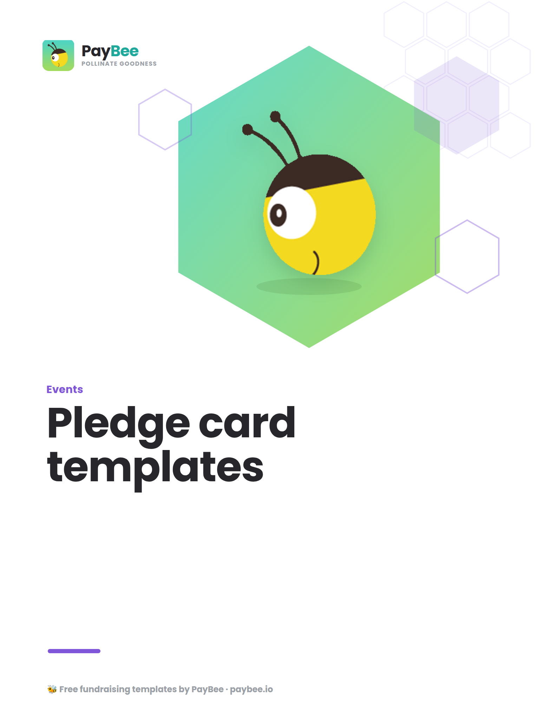

Pledge card templates 💌

Customize the following pledge card templates for your next fundraising event, capital campaign, and more! Make sure to update all text that is bolded in brackets below. Once you’ve used your pledge cards to collect commitments, you can track, manage, and easily fulfill pledge donations right in your PayBee dashboard.

1. General pledge card template

[ORGANIZATION NAME]
[LOGO]

Thank you for your generous commitment of support for [ORGANIZATION NAME]. By making a pledge today, you’re ensuring that [GOAL/MISSION].

Donation Pledge
I pledge to make a donation of $______ in total over the next _____ [Circle one: Month/Quarter/Year/Years], starting on __________ (MM/DD/YY) and ending on __________ (MM/DD/YY). My donation will be made in the following installments:
- One time
- Weekly
- Monthly
- Quarterly
- Semi-annually
- Annually
- Custom:

Payment Method
- Online donation via debit/credit card, PayPal, Venmo, or ACH
  - If you choose this payment method, you’ll receive a payment link via email
- Check made payable to [ORGANIZATION NAME]
  - Check is enclosed? [Circle one: Yes/No]
- Other method:

Contact Information
Name:
Organization:
Email address:
Phone number:

Street address:
City:
State:
Zip:

Thank you for joining our caring community of supporters! Once processed, you’ll receive a receipt for your donation.

[ORGANIZATION NAME]
[CONTACT]
[WEBSITE]

2. Event pledge card template

[ORGANIZATION NAME]
[LOGO]
[EVENT NAME]

Donation Pledge
I pledge to make a donation of $______ in total over the next _______ [Circle one: Month/Quarter/Year/Years], starting on __________ (MM/DD/YY) and ending on __________ (MM/DD/YY). My donation will be made in the following installments:
- One time
- Weekly
- Monthly
- Quarterly
- Semi-annually
- Annually
- Custom:

Payment Method
- Online donation via debit/credit card, PayPal, Venmo, or ACH
  - If you choose this payment method, you’ll receive a payment link via email
- Check made payable to [ORGANIZATION NAME]
  - Check is enclosed? [Circle one: Yes/No]
- Other method:

Contact Information
Name:
Organization:
Email address:
Phone number:

Street address:
City:
State:
Zip:

Thank you for participating in this momentous event and choosing to give generously. We appreciate your support now and in the future! Once processed, you’ll receive a receipt for your donation.

[ORGANIZATION NAME]
[CONTACT]
[WEBSITE]

3. Capital campaign pledge card

[ORGANIZATION NAME]
[LOGO]

We’re thrilled to launch our [PROGRAM/PROJECT DESCRIPTION]. With your commitment to support, we will get closer to reaching our goal of [$ AMOUNT]!
- [$ AMOUNT]] will [DESCRIPTION]
- [$ AMOUNT] will [DESCRIPTION]
- [$ AMOUNT] will [DESCRIPTION]

Donation Pledge
I pledge to make a donation of $_______ in total over the next ______ [Circle one: Month/Quarter/Year/Years], starting on __________ (MM/DD/YY) and ending on __________ (MM/DD/YY). My donation will be made in the following installments:
- One-time
- Weekly
- Monthly
- Quarterly
- Semi-annually
- Annually
- Custom:

Payment Method
- Online donation via debit/credit card, PayPal, Venmo, or ACH
  - If you choose this payment method, you’ll receive a payment link via email
- Check made payable to [ORGANIZATION NAME]
  - Check is enclosed? [Circle one: Yes/No]
- Other method:

Contact Information
Name:
Organization:
Email address:
Phone number:

Street address:
City:
State:
Zip:

Thank you for your generous support. We look forward to sharing updates as [CAMPAIGN NAME] progresses and celebrating together once it’s complete! Once processed, you’ll receive a receipt for your donation.

[ORGANIZATION NAME]
[CONTACT]
[WEBSITE]

4. Church giving pledge card template

[CHURCH NAME]
[LOGO]

Financial contributions from members of our congregation ensure that our beloved community of faith will continue to thrive and grow for years to come. Any amount you can give is deeply appreciated.

Donation Pledge
I pledge to make a donation of $_______ in total over the next ______ [Circle one: Month/Quarter/Year/Years], starting on __________ (MM/DD/YY) and ending on __________ (MM/DD/YY). My donation will be made in the following installments:
- One time
- Weekly
- Monthly
- Quarterly
- Semi-annually
- Annually
- Custom:

Payment Method
- Online donation via debit/credit card, PayPal, Venmo, or ACH
  - If you choose this payment method, you’ll receive a payment link via email
- Check made payable to [CHURCH NAME]
  - Check is enclosed? [Circle one: Yes/No]
- Other method:

Contact Information
Name:
Organization:
Email address:
Phone number:
Street address:
City:
State:
Zip:

Thank you for your generous contribution! Once processed, you’ll receive a receipt for your donation.

[CHURCH NAME]
[CONTACT]
[WEBSITE]

5. Monthly giving pledge card template

[ORGANIZATION NAME]
[LOGO]

Welcome to our wonderful community of [BRANDED NAME FOR MONTHLY SUPPORTERS]! With your ongoing gift, we will be able to increase our impact and [DESCRIPTION] for [GOAL/MISSION].

As part of our monthly giving program, you can choose your donation amount. Every dollar makes a difference:
- [$ AMOUNT] will [DESCRIPTION]
- [$ AMOUNT] will [DESCRIPTION]
- [$ AMOUNT] will [DESCRIPTION]

Donation Pledge
I pledge to donate $_______ every month starting on __________ (MM/DD/YY) and ending on __________ (MM/DD/YY).

Payment Method
- Online donation via debit/credit card, PayPal, Venmo, or ACH
  - If you choose this payment method, you’ll receive a payment link via email
- Check made payable to [ORGANIZATION NAME]
  - Check is enclosed? [Circle one: Yes/No]
- Other method:

Contact Information
Name:
Organization:
Email address:
Phone number:
Street address:
City:
State:
Zip:

Thank you for choosing to become a [BRANDED NAME FOR MONTHLY SUPPORTERS]! Once your donation is processed, you’ll receive a receipt, and you can look forward to receiving [SPECIAL BENEFIT (E.G., FIRST-LOOK EMAIL UPDATES & UNIQUE INVOLVEMENT OPPORTUNITIES)].

[ORGANIZATION NAME]
[CONTACT]
[WEBSITE]

6. Annual appeal pledge card template

[ORGANIZATION NAME]
[LOGO]

[YEAR] has been [DESCRIPTION] for [ORGANIZATION NAME]. Some of our major accomplishments this year include [DESCRIPTION]. None of this would be possible without the support of our generous, caring community (that’s you!). This year, we look forward to [GOAL/DESCRIPTION], and we need your continued support to ensure our success.

Donation Pledge
I pledge to make a donation of $_______ in total over the next ______ [Circle one: Month/Quarter/Year/Years], starting on __________ (MM/DD/YY) and ending on __________ (MM/DD/YY). My donation will be made in the following installments:
- One-time
- Weekly
- Monthly
- Quarterly
- Semi-annually
- Annually
- Custom:

Payment Method
- Online donation via debit/credit card, PayPal, Venmo, or ACH
  - If you choose this payment method, you’ll receive a payment link via email
- Check made payable to [ORGANIZATION NAME]
  - Check is enclosed? [Circle one: Yes/No]
- Other method:

Contact Information
Name:
Organization:
Email address:
Phone number:

Street address:
City:
State:
Zip:

Thank you for your critical support for our ongoing work! Your generosity is deeply appreciated. Once processed, you’ll receive a receipt for your donation.

[ORGANIZATION NAME]
[CONTACT]
[WEBSITE]

7. Company sponsorship pledge card template
[ORGANIZATION NAME]
[LOGO]

Thank you for your generous partnership in support of [ORGANIZATION/EVENT/CAMPAIGN NAME]. With your contribution, we will be able to [IMPACT].

Donation Pledge
I pledge to make a donation of $______ in total over the next _____ [Circle one: Month/Quarter/Year/Years], starting on __________ (MM/DD/YY) and ending on __________ (MM/DD/YY). My donation will be made in the following installments:
- One time
- Weekly
- Monthly
- Quarterly
- Semi-annually
- Annually
- Custom:

Payment Method
- Online donation via debit/credit card, PayPal, Venmo, or ACH
  - If you choose this payment method, you’ll receive a payment link via email
- Check made payable to [ORGANIZATION NAME]
  - Check is enclosed? [Circle one: Yes/No]
- Other method:

Sponsor Information
Name, Title:
Organization:
Email address:
Phone number:

Street address:
City:
State:
Zip:

Thank you for making a difference for [COMMUNITY/ORGANIZATION NAME]! Once processed, you’ll receive a receipt for your donation.

[ORGANIZATION NAME]
[CONTACT]
[WEBSITE]

8. Matching donation pledge card template
[ORGANIZATION NAME]
[LOGO]

Thank you for your generous partnership in support of [ORGANIZATION/EVENT/CAMPAIGN NAME]. With your contribution, we will be able to [DOUBLE/TRIPLE/QUADRUPLE] donations for [IMPACT].

Matching Donation Pledge
I pledge to make a donation of $_______ to be used to match donations made to [CAMPAIGN] on a [1:1 / 2:1 / 3:1] ratio. My donation will be made in the following installments, starting on _________ (MM/DD/YY) and ending on __________ (MM/DD/YY):
- One-time
- Weekly
- Monthly
- Quarterly
- Semi-annually
- Annually
- Custom:

Payment Method
- Online donation via debit/credit card, PayPal, Venmo, or ACH
  - If you choose this payment method, you’ll receive a payment link via email
- Check made payable to [ORGANIZATION NAME]
  - Check is enclosed? [Circle one: Yes/No]
- Other method:

Contact Information*
Name:
Organization:
Email address:
Phone number:

Street address:
City:
State:
Zip:

- *We need your contact information to fulfill your pledged donation, but you can check this box if you prefer to keep your matching gift anonymous.

Thank you for helping to multiply the impact of [ORGANIZATION]! Once processed, you’ll receive a receipt for your donation.

[ORGANIZATION NAME]
[CONTACT]
[WEBSITE]

9. Item donation pledge card template

[ORGANIZATION NAME]
[LOGO]

Thank you for donating an item for our upcoming event! Your contribution will fuel an even bigger impact for [ORGANIZATION NAME] and our mission. You can find the full list of [ITEM/PRIZE] donation conditions at [WEBSITE LINK].

Item Donation Pledge
I pledge to donate:
___________________________________________________________________________________________________

Item description:
___________________________________________________________________________________________________
___________________________________________________________________________________________________

Estimated item value:
___________________________________________________________________________________________________

Item Drop-Off
- I will drop off the item at [ORGANIZATION NAME]’s address on ____________ (MM/DD/YY)
- Please collect my donation from the address given below
- I will send a copy of the digital item to [ORGANIZATION EMAIL]

Contact Information
Name:
Organization:
Email address:
Phone number:
Street address:
City:
State:
Zip:

Thank you for your generous in-kind support for our [EVENT/CAMPAIGN]. We’re so grateful for your kindness! Once processed, you’ll receive a receipt for your donation.

[ORGANIZATION NAME]
[CONTACT]
[WEBSITE]

