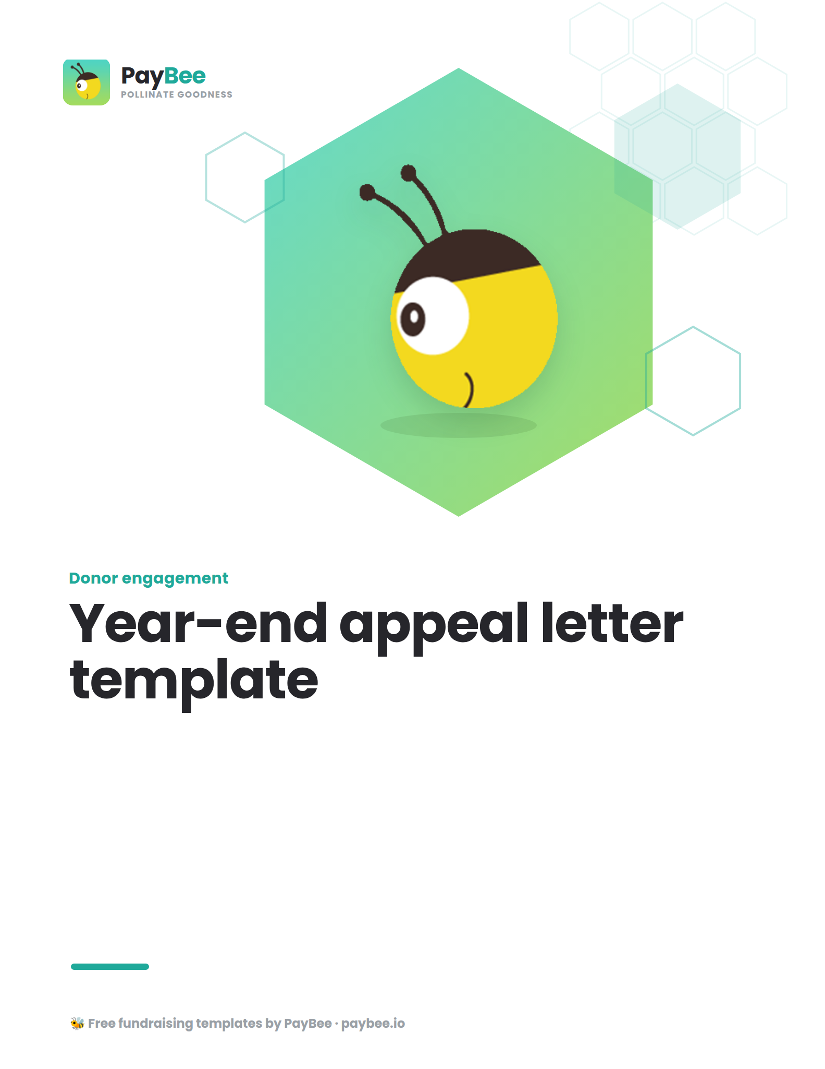

Year-end appeal letter template 💌

Use this year-end giving letter template to build a strong foundation for your own fundraising appeal campaign.

Dear [DONOR NAME],

The new year is almost here, and here at [NONPROFIT NAME], we’re gearing up for an action-packed [20##]. But before the ball drops, we’re also taking a moment to reflect on the impact we’ve made together these past 12 months.

Thanks to your generous support [OR] your generous donation of [$ DONATION AMOUNT], we have been able to continue fulfilling our mission of [MISSION]. You have helped us [OUTCOME], and we’re incredibly grateful. We could not do this without you!

The holiday season is critical for nonprofits like ours. As we head towards the end of the year, it’s our last opportunity to ask for donations to keep our work going in [20##] and beyond. In the spirit of this holiday season, I’m writing to ask you a favor:

Can you contribute [$ SUGGESTED DONATION AMOUNT] to our year-end campaign?

[Direct them on how/where to make a donation (e.g., a URL for a donation page, an attached form, or how to include a donation via check). Also, if applicable, don't forget to include any information about matching gifts!]

Our goal is to raise [$ AMOUNT] before the end of the year. Your donation will ensure that we can [OUTCOME/DELIVERY].

Thank you as always for being a part of the [NONPROFIT NAME] family. We appreciate all your support throughout our time together.

Wishing you a wonderful rest of the year and a joyful [20##]!

[DIRECTOR NAME]
[SIGNATURE]

Repurpose your year-end appeal letter into other formats 💡

Here’s how to repurpose your letter theme, story, and content to create engaging appeals across various engagement channels.`

Email:

Subject line: Be a part of the change for [20##]

Dear [DONOR NAME],

What a successful year! The past 12 months have been a time of growth and impact for [NONPROFIT NAME]. And it’s all thanks to your support!

In [20##], we were able to:
- OUTCOME 1
- OUTCOME 2
- OUTCOME 3

This time of year is critical for nonprofits like ours. I’m writing today to ask for your financial support once more before the ball drops, so we can continue to build on this momentum in [20##].

Can you contribute [$ SUGGESTED DONATION AMOUNT] to our year-end campaign?

You can make a donation of any amount here [LINK TO CAMPAIGN PAGE OR DONATION FORM] or [OTHER DONATION DETAILS (e.g., where to mail a check)].

Our goal is to raise [$ AMOUNT] before the end of the year. Your donation will ensure that we can [OUTCOME/DELIVERY]. We are so grateful that you continue to stand up for [MISSION]. We could not do this without you!

Here’s to an action-packed [20##]!

[DIRECTOR NAME]
[SIGNATURE]
Social media post:

Graphic:
A picture of your team in action or a beneficiary of your work with text overlaid that shows an aspect of your impact (e.g., “In [20##] we provided [#] of care packages for [#] homeless youth.”)

Caption:
We’re taking a moment before the ball drops to reflect on the enormous impact we’ve made together in [20##]. Please make a donation to our end-of-year campaign so that we can keep [MISSION] in the new year! We need to raise [$ AMOUNT] by the 31st. Thank you for making a difference in the lives of [WHO YOU WORK WITH]!

Donate today: [LINK TO CAMPAIGN PAGE OR DONATION FORM]

SMS Text:

Photo or video:
Include a picture or video of your team in action or a beneficiary of your work so they can see your impact when they read your text message.

Message copy:

Hi [DONOR NAME],

Thanks to your support in [20##], [NONPROFIT NAME] was able to [IMPACT (e.g., provided # of care packages for # homeless youth)]. Now, we need your help to make an even bigger impact in [20##].

Please consider making a donation to our year-end campaign before the ball drops! Thank you—and Happy New Year! [LINK TO CAMPAIGN PAGE OR DONATION FORM]
Donation page on website:

Help [NONPROFIT NAME] keep our mission growing in [20##]!

[Insert a photo or video of your team in action or a beneficiary of your work]

The past year has been a time of growth and impact for [NONPROFIT NAME]. And it’s all thanks to the support of our incredible community (that’s you!). In [20##], we were able to:

- OUTCOME 1
- OUTCOME 2
- OUTCOME 3

This time of year is critical for nonprofits, and we’re asking for our community to step up once more, so we can build on this momentum in [20##]. Will you help us?

You can make a donation of any amount below or [OTHER DONATION DETAILS (e.g., where to mail a check)]

Our goal is to raise [$ AMOUNT] before the end of the year. Your donation will ensure that we can [OUTCOME/DELIVERY].

Thank you for standing up for [MISSION]!

