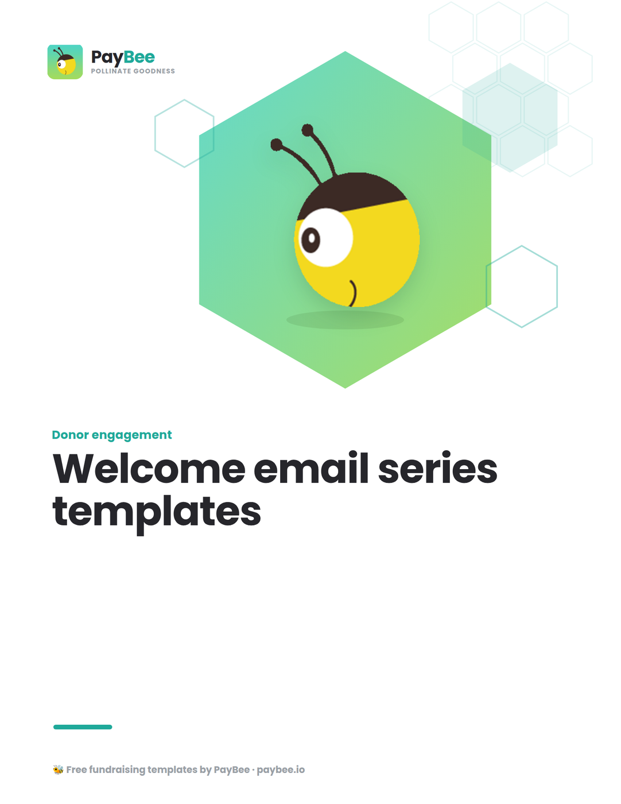

Nonprofit welcome series templates 📫

First impressions matter! Show your new supporters just how valued they are with a personalized welcome email series. This freebie features three simple templates for writing emails that build on one another to create a strong foundation from the start.

How to use: Copy and paste the messages below into PayBee’s built-in email editor for easy distribution to your community members. Customize the bolded text in brackets to match your organization.

Email #1: Welcome 👋

When to send: Immediately after supporters join your email list

Subject line: Welcome to the [ORGANIZATION NAME] community, [FIRST NAME]!
Body of message:

Dear [FIRST NAME],

You have successfully subscribed to [LIST NAME]!

Welcome to our vibrant community dedicated to [ORGANIZATION’S MISSION].

In the past year, we have been able to successfully [metric on impact made within the past year].

Below, please find [FREE RESOURCE] to dive deeper into our [area of work or organizational values].

Thank you so much for joining our incredible community.

[YOUR NAME & ROLE]
[NAME OF ORGANIZATION]

P.S. Stay up to date with our work on social media at [link to your top social media accounts]

Email #2: Partnership 🤝

When to send: 5–7 days after first email

Subject line: [NAME OF IMPACTED PERSON]’s story

Body of email:

Dear [FIRST NAME],

Allow us to explain how this entire journey began.

[#] years ago, our founder, [FOUNDER NAME], realized that [FOUNDER STORY OR PROBLEM]. They were able to [how the founder launched the nonprofit].

Today, we remain connected to our roots and more dedicated to our mission than ever. Just this year, [NAME] was [personal story from someone impacted by your organization].

To learn more about [NAME] and how [ORGANIZATION] changed their life, check out their full story on our blog: [hyperlinked title of blog post].

[Optional CTA button, e.g. “Read the full story”]]

Thank you for reading and being part of our caring community!

[YOUR NAME AND ROLE]
[NAME OF ORGANIZATION]

Email #3: Ask 🗣️

When to send: 5–7 days after second email

Subject line: How you can make a difference for [NAME OF ORGANIZATION]

Body of email:

Dear [FIRST NAME],

Every year, [statistics explaining the need for your organization].

We’re hoping to change that. So far this year [statistic showing your community impact], but to continue this work, we need your help.

A donation of just [$ DOLLAR AMOUNT] can help to [impact of donation].

[FIRST NAME], any amount you are able to give will have a huge impact for [ORGANIZATION’S MISSION].

[CTA button, e.g. “Donate”]

Thank you,

[YOUR NAME AND ROLE]
[NAME OF ORGANIZATION]

Take your welcome series to the next level with PayBee 📈

PayBee has always offered awesome, free email marketing tools for nonprofits. For organizations ready to streamline their process and take their impact even further, PayBee offers an advanced email editor with a visual drag-and-drop interface and hundreds of beautiful templates made just for nonprofits.

Here’s how to create an automated email welcome series in 5 steps:

- Create a new automation: Head over to “Workflows” in your PayBee dashboard and select “+ New Workflow.”
- Select your trigger: Under “Triggers,” select “Subscribed via signup.”
- Start building: Choose when and to whom you’d like the email sent. Then, start from a pre-built template or create a new email from scratch. You can cut and paste any ideas from the examples in this freebie right into your email editor.
- Repeat: Create the next two emails in your welcome series the same way and schedule each to be sent 5-7 days apart.
- Review and publish: Once you’re finished, hit “Next” to preview your emails as drafts. Then, once you’re ready, hit “Publish.” Voila!

Now, every new person who joins your email list will automatically be subscribed to this email series, and you don’t have to lift a finger.
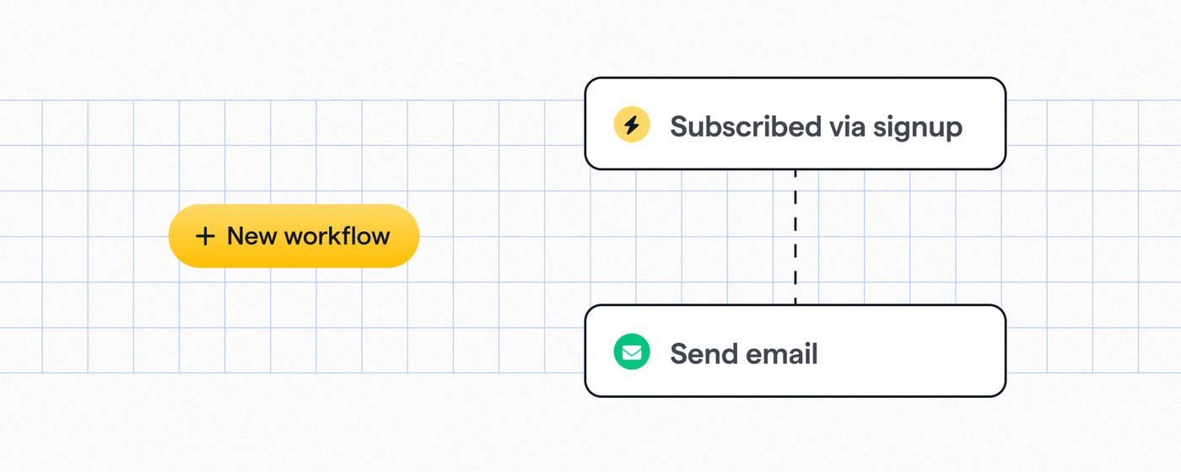
Nonprofit marketing email templates 💌

Not sure where to begin with your email series?

With PayBee, your nonprofit has access to 300+ email templates and our most advanced email editor to date, with full customization, the ability to save personal templates, and more.
