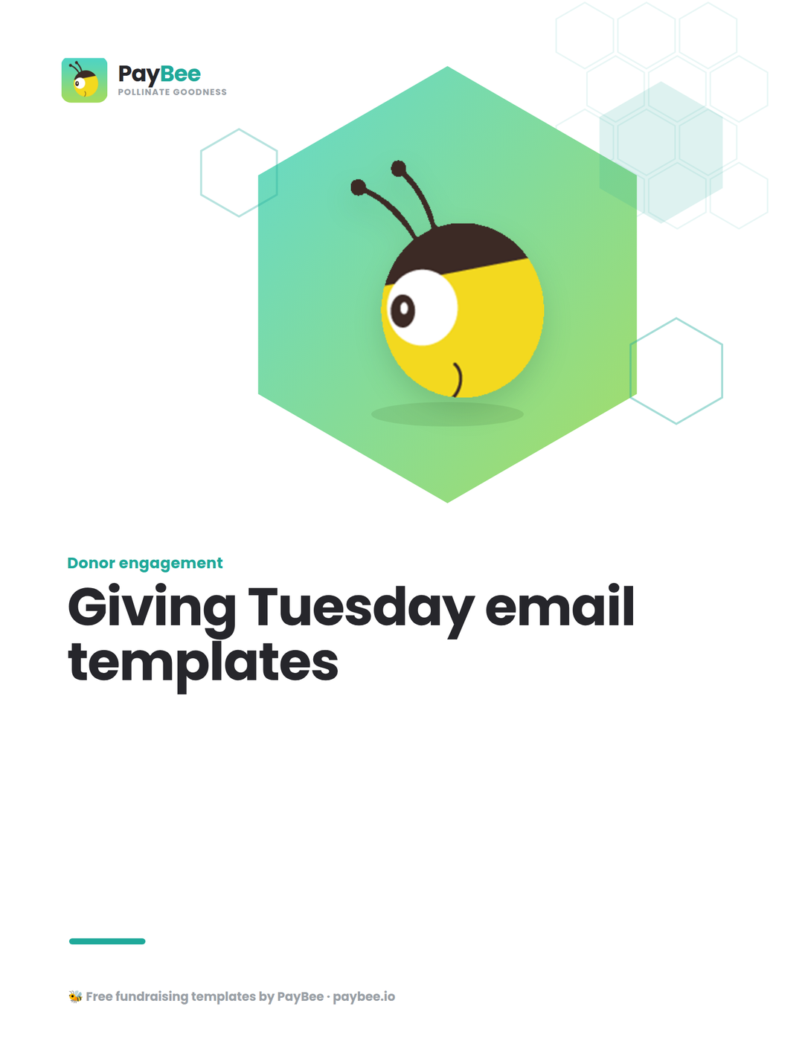

Giving Tuesday email templates 📨

Connect with your email list and turn those subscribers into donors with these simple yet engaging Giving Tuesday email templates. Take these templates, personalize them, and schedule them in advance of the big day.

How to use: Customize the bolded text in brackets to match your organization’s details. Then, copy and paste the messages below into PayBee’s built-in email editor for easy distribution to your community members.

Email #1: Campaign teaser/countdown 🕥

When to send: 1 week before

Who to send it to: All subscribers

Subject line: Giving Tuesday is approaching… ⏰
Body of message:

Dear [NAME],

Giving Tuesday is now only a week away, and we want to take this moment to thank you for your support so far. Your impact has allowed us to [DETAILS] and [SUCCESS STORY HIGHLIGHT].

With this global day of giving just around the corner, we invite you to support us once again as [ORGANIZATION] takes part. Our goal this year is to raise [AMOUNT] and we’ll be [LIST OF ACTIVITIES].

We’re looking forward to your support on Giving Tuesday.

Warm regards,

The [ORGANIZATION] team

Email #2: Campaign reminder 📝

When to send: 1 day before

Who to send it to: All subscribers

Subject line: One day to go until our big day of giving! 📆
Body of message:

Dear [NAME],

We’re excited that tomorrow is the big day—Giving Tuesday!

Your support has always meant a lot to us, enabling us to make a real difference to [BENEFACTORS OR MISSION]. As we approach Giving Tuesday, we ask you to help us start the day strong.

Our target this year is [AMOUNT] and we’ve planned an exciting program of webinars, livestreams, and challenges to help us reach it.

Ready to get started? Click here to donate now before the official launch.

Warm regards,

The [ORGANIZATION] team

Email #3: Kickoff/invitation to participate 🎉

When to send: Giving Tuesday (morning)

Who to send it to: All subscribers

Subject line: Launching [ORGANIZATION]’s Giving Tuesday fundraiser! 🎉
Body of message:

Dear [NAME],

It’s finally here! Thank you for joining us on Giving Tuesday.

Our goal this year is to [GOAL] and our fundraising target is [AMOUNT]. It’s an ambitious goal, but we’re certain that with the support of our community, we can make it.

Here’s how you can help us make a difference:

- Make a donation
- Share our campaign with friends and family
- Start your own peer-to-peer fundraising campaign
- [ADJUST/ADD TO LIST DEPENDING ON YOUR GOAL],

Let’s work together to raise as much as possible in the next 24 hours!

Warm regards,

The [ORGANIZATION] team

Email #4: Progress update/reminder to give 🎁

When to send: Giving Tuesday (afternoon)

Who to send it to: All subscribers

Subject line: There’s still time to give… 🕞
Body of message:

Dear [NAME],

We’ve been overwhelmed by the generosity of our supporters this Giving Tuesday!

With [NUMBER] hours left to go, our current total is [AMOUNT]. This means we’re so close to the finish line.

Our mission is to [MISSION/IMPACT] and with your help we can make that a reality. Donate now to help us hit our Giving Tuesday target.

Warm regards,

The [ORGANIZATION] team

Email #5: Last-chance/final call to give ⏰

When to send: Giving Tuesday (evening)

Who to send it to: All subscribers

Subject line: Time is running out… help us reach our goal! 📣
Body of message:

Dear [NAME],

It’s almost the end of the day and we’re excitedly catching up with all your social media posts, comments, and messages. Thank you for taking the time to share with us and make a donation this Giving Tuesday—and if you haven’t yet, there’s still time to act.

Your donation can help us get closer to our fundraising goal of [AMOUNT]. We’re only [AMOUNT] away, so every dollar counts!

Donate now before the clock hits midnight.

Warm regards,

The [ORGANIZATION] team

Email #6: Results/general thank you ❤️

When to send: 1 day after

Who to send it to: All subscribers

Subject line: We did it! ❤️
Body of message:

Dear [NAME],

Wow, what a Giving Tuesday that was!

Thanks to your ongoing support and commitment, we were able to [RESULTS]. The funds we’ve raised will allow us to [OUTCOME] in a big way.

It was wonderful to see so many of you on our [SOCIAL MEDIA PAGES] and at our [EVENTS]. Every message, comment, and share helps us reach more people and raise even more funds for [ORGANIZATION].

Thank you again for your supporting our Giving Tuesday campaign!

Warm regards,

The [ORGANIZATION] team

Email #7: Personalized thank you email ✍️

When to send: Two days after

Who to send it to: New and existing donors

Subject line: Thank you for your generous support 🎁
Body of message:

Dear [NAME],

Thank you for your generous donation of [AMOUNT] toward our Giving Tuesday campaign. Donors like you allow us to [MISSION/IMPACT STATEMENT].

Your donation helped us hit our fundraising goal of [AMOUNT] and we’re excited to use these funds to make a difference in our world.

Thank you again for your generosity.

Warm regards,

The [ORGANIZATION] team

BONUS: Add new donors to a welcome series 👋

If your Giving Tuesday campaign brought in new donors, congrats! It’s time to introduce them to your organization the right way with a welcome series. Tell them about your mission and values, highlight your achievements, and call on their support for ongoing or future campaigns. Use our free welcome email series template to create your own email campaign in no time.

Streamline your Giving Tuesday campaigns with PayBee 💛

PayBee has everything you need to send emails to your subscribers for free, but if you’re serious about raising funds this Giving Tuesday then consider upgrading to PayBee. With an advanced email editor, hundreds of email templates for nonprofits, and customizable automated workflows, it’s now even easier to create and send impactful emails to your audience.

