HIST 4340 Philosophies of History
Professor David McNally

Tuesdays, 2:30- 5:30 PM, Room B1, Bates Law Building

Does history have a meaning? Does it tend toward justice, or is it merely a litany of violence and domination? This course engages these debates through a number of major philosophies of history and in relation to a primary event—the Haitian Revolution of 1791-1804, which saw the abolition of slavery and the creation of the world’s first independent Black republic. To ground our discussions we will use a primary historical text, C.L.R. James’s classic, The Black Jacobins: Toussaint L’Ouverture and the San Domingo Revolution. We will examine the events described by James in relation to liberal, radical, feminist, and post-structural philosophies of history and their views on history and human freedom. Below: CLR James in his study.

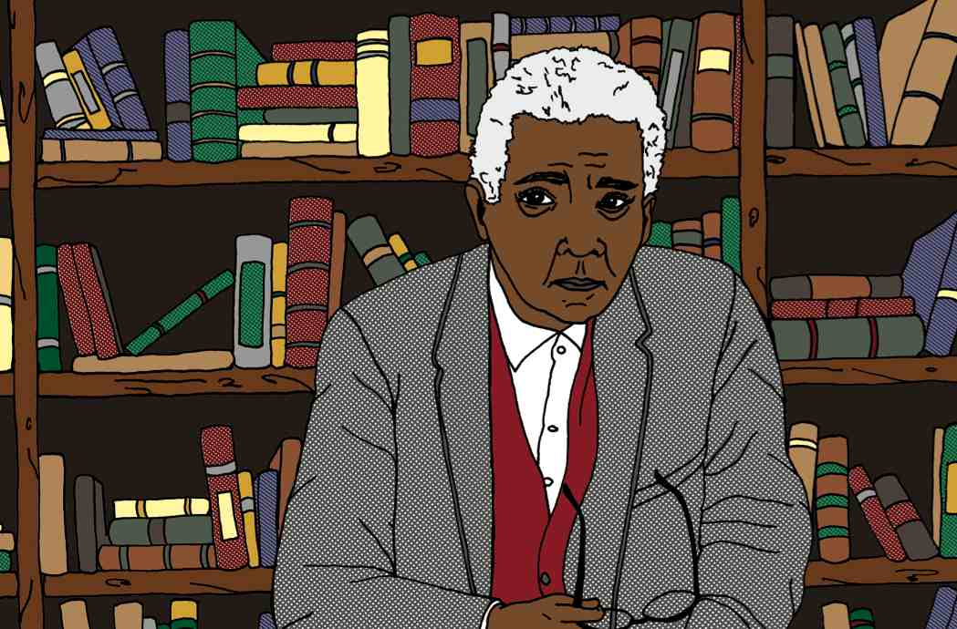

Grading Scheme
- Paper proposal (15%)—Due March 10
- Short research presentation (15%)—Date varies according to theme.
- In class quiz (15%)—March 31
- Seminar participation (20%)
- Final essay (35%)—Due May 1
Core Readings
Note: PDFs of many core readings will be provided by the instructor.
- C.L.R. James, The Black Jacobins: Toussaint L’Ouverture and the San Domingo Revolution
- Immanuel Kant, “The Contest of Faculties”
- G.W.F. Hegel, The Philosophy of History (selections). See also:
- -----------------, “Lordship and Bondage” from The Phenomenology of Spirit:
- -----------------, The Philosophy of Right (selections)
- Karl Marx and Friedrich Engels, The German Ideology: Part One
- Friedrich Nietzsche, “On the Uses and Disadvantages of History for Life”
- Michel Foucault, “Nietzsche, Genealogy, History”
- David Scott, “The Re-Enchantment of Humanism: An Interview with Sylvia Wynter,” small axe 8 (September 2000)
- Aimé Césaire, Discourse on Colonialism
- Frantz Fanon, The Wretched of the Earth, Ch. 3
Some Recommended Secondary Readings
- Susan Buck-Morss, Hegel, Haiti, and Universal History
- C.L.R. James, Mariners, Renegades, and Castaways
- Aaron Kamugisha, “The Hearts of Men? Gender in the Late CLR James,” small axe 34 (March 2011)
- David McNally, Slavery and Capitalism
- Nick Nesbitt, “Troping Toussaint” Research in African Literatures, v. 35, n. 2 (2004)
- Nick Nesbitt, Universal Emancipation: The Haitian Revolution and Radical Enlightenment
- Michel-Rolph Trouillot, Silencing the Past: Power and the Production of History

COURSE SCHEDULE

January 20 Course Introduction

January 27 The Haitian Revolution, 1
CLR James, The Black Jacobins, Ch. 1-6

February 3 The Haitian Revolution, 2
CLR James, The Black Jacobins, Ch. 7-13

February 10 Liberalism, History, Human Progress, and Europe
Immanuel Kant, “The Contest of Faculties” and

GWF Hegel, selections from Introduction to The Philosophy of History
https://historyofeconomicthought.mcmaster.ca/hegel/history.pdf
See also Lawrence Evans, “Hegel on History”:
https://philosophynow.org/issues/129/Hegel_on_History

February 17 History and the Struggle Between Master and Bondsman
GWF Hegel, “Lordship and Bondage” from The Phenomenology of Spirit (scanned text, or
https://www.marxists.org/reference/archive/hegel/works/ph/phba.htm

February 24 Slavery, Freedom, and Revolution
GWF Hegel, The Philosophy of Right, sections 57, 75, 124-128, 230-249
https://historyofeconomicthought.mcmaster.ca/hegel/right.pdf

March 3 History, Freedom, and Class Struggle
Karl Marx and Friedrich Engels, The German Ideology: Chapter One, Part A, following sections: “First Premises of the Materialist Method” “History: Fundamental Conditions”, “History as a Continuous Process” Part B, following sections: “Civil Society and the Conception of History” and “Conclusions from the Materialist Conception of History” and “Ruling Class and Ruling Ideas” https://www.marxists.org/archive/marx/works/1845/german-ideology/ch01.htm

March 10 History as Will to Power
Friedrich Nietzsche, “On the Uses and Disadvantages of History for Life”
https://dn790007.ca.archive.org/0/items/NietzscheOnTheUsesDisadvantagesOfHistoryF.LifeCamb.Perf/Nietzsche%20%3D%20%27%27On%20the%20Uses%20%26%20Disadvantages%20of%20History%20f.%20Life%27%27%20%5BCamb.%20perf%5D.pdf

March 17 MARCH BREAK

March 24 Power Without Progress
Michel Foucault, “Nietzsche, Genealogy, History”
https://philarchive.org/archive/FOUNGH

March 31 Colonialism and the Silences of World History
Michel-Rolph Trouillot, Silencing the Past: Power and the Production of
History (selections)
https://www.metodos.work/wp-content/uploads/2021/05/Michel-Rolph-Trouillot-Silencing-the-Past_-Power-and-the-Production-of-History-20th-Anniversary.pdf

April 7 History Beyond Colonialism?
Aimé Césaire, Discourse on Colonialism
https://files.libcom.org/files/zz_aime_cesaire_robin_d.g._kelley_discourse_on_colbook4me.org_.pdf

April 14 History Beyond Colonialism? 2
Frantz Fanon, The Wretched of the Earth, Ch. 3 and Conclusion
https://monoskop.org/images/6/6b/Fanon_Frantz_The_Wretched_of_the_Earth_1963.pdf

April 21 Gender, History, and Emancipation
David Scott, “The Re-Enchantment of Humanism: An Interview with Sylvia
Wynter,” small axe 8 (September 2000), excerpt pp. 173-207
https://files.libcom.org/files/Wynter_1_1.pdf
Aaron Kamugisha, “The Hearts of Men? Gender in the Late CLR James,”
small axe 34 (March 2011)

April 28 Revisiting Haiti and the Project of Universal Emancipation
Nick Nesbitt, “Troping Toussaint, Reading Revolution,” Research in
African Literatures (Summer 2004)
https://www.jstor.org/stable/3821342?seq=1

University Policies and Student Support Resources

Mental Health and Wellness Resources
The University of Houston has a number of resources to support students’ mental health and overall wellness, including CoogsCARE and the UH Go App. UH Counseling and Psychological Services (CAPS) offers 24/7 mental health support for all students, addressing various concerns like stress, college adjustment and sadness. CAPS provides individual and couples counseling, group therapy, workshops and connections to other support services on and off- campus. For assistance visit uh.edu/caps, call 713-743-5454, or visit a Let’s Talk location in-person or virtually. Let’s Talk are daily, informal confidential consultations with CAPS therapists where no appointment or paperwork is needed.
Need Support Now? If you or someone you know is struggling or in crisis, help is available. Call CAPS crisis support 24/7 at 713-743-5454, or the National Suicide and Crisis Lifeline: call or text 988, or chat 988lifeline.org.

Title IX/Sexual Misconduct
Per the UHS Sexual Misconduct Policy, your instructor is a “responsible employee” for reporting purposes under Title IX regulations and state law and must report incidents of sexual misconduct (sexual harassment, non-consensual sexual contact, sexual assault, sexual exploitation, sexual intimidation, intimate partner violence, or stalking) about which they become aware to the Title IX office (known at UH as the Equal Opportunity Services office or "EOS"). Please know there are places on campus where you can make a report in confidence. You can find more information about resources on the UH Title IX/Sexual Misconduct Resources page. Please note that you may also report concerns of discrimination based on your protected class identity to EOS.

Reasonable Academic Adjustments/Auxiliary Aids
The University of Houston is committed to providing an academic environment and educational programs that are accessible for its students. Any student with a disability who is experiencing barriers to learning, assessment or participation is encouraged to contact the Justin Dart, Jr. Student Accessibility Center (Dart Center) to learn more about academic accommodations and support that may be available to them. Students seeking academic accommodations will need to register with the Dart Center as soon as possible to ensure timely implementation of approved accommodations. Please contact the Dart Center by visiting the website: https://uh.edu/accessibility/ calling (713) 743-5400, or emailing jdcenter@Central.UH.EDU.
The Student Health Center offers a Psychiatry Clinic for enrolled UH students. Call 713-743-5149 during clinic hours, Monday through Friday 8 a.m. - 4:30 p.m. to schedule an appointment.
The A.D. Bruce Religion Center offers spiritual support and a variety of programs centered on well-being.
The Center for Student Advocacy and Community (CSAC) is where you can go if you need help but don’t know where to start. CSAC is a “home away from home” and serves as a resource hub to help you get the resources needed to support academic and personal success. Through our Cougar Cupboard, all students can get up to 30 lbs of FREE groceries a week. Additionally, we provide 1:1 appointments to get you connected to on- and off-campus resources related to essential needs, safety and advocacy, and more. The Cougar Closet is a registered student organization advised by our office and offers free clothes to students so that all Coogs can feel good in their fit. We also host a series of cultural and community-based events that fosters social connection and helps the cougar community come closer together. Visit the CSAC homepage or follow us on Instagram: @uh_CSAC and @uhcupbrd. YOU belong here.

Women and Gender Resource Center
The mission of the WGRC is to advance the University of Houston and promote the success of all students, faculty, and staff through educating, empowering, and supporting the UH community. The WGRC suite is open to you. Stop by the office for a study space, to take a break, grab a snack, or check out one of the WGRC programs or resources. Stop by Student Center South room B12 (Basement floor near Starbucks and down the hall from Creation Station) from 9 am to 5 pm Monday through Friday.

Academic Honesty Policy
High ethical standards are critical to the integrity of any institution, and bear directly on the ultimate value of conferred degrees. All UH community members are expected to contribute to an atmosphere of the highest possible ethical standards. Maintaining such an atmosphere requires that any instances of academic dishonesty be recognized and addressed. The UH Academic Honesty Policy is designed to handle those instances with fairness to all parties involved: the students, the instructors, and the University itself. All students and faculty of the University of Houston are responsible for being familiar with this policy.

Excused Absence Policy
Regular class attendance, participation, and engagement in coursework are important contributors to student success. Absences may be excused as provided in the University of Houston Undergraduate Excused Absence Policy and Graduate Excused Absence Policy for reasons including medical illness of student or close relative, death of a close family member, legal or government proceeding that a student is obligated to attend, recognized professional and educational activities where the student is presenting, and University-sponsored activity or athletic competition. Under these policies, students with excused absences will be provided with an opportunity to make up any quiz, exam or other work that contributes to the course grade or a satisfactory alternative. Please read the full policy for details regarding reasons for excused absences, the approval process, and extended absences. Additional policies address absences related to military service, religious holy days, pregnancy and related conditions, and disability.

Recording of Class
Students may not record all or part of class, livestream all or part of class, or make/distribute screen captures, without advanced written consent of the instructor. If you have or think you may have a disability such that you need to record class-related activities, please contact the Justin Dart, Jr. Student Accessibility Center. If you have an accommodation to record class-related activities, those recordings may not be shared with any other student, whether in this course or not, or with any other person or on any other platform. Classes may be recorded by the instructor. Students may use instructor’s recordings for their own studying and notetaking. Instructor’s recordings are not authorized to be shared with anyone without the prior written approval of the instructor. Failure to comply with requirements regarding recordings will result in a disciplinary referral to the Dean of Students Office and may result in disciplinary action.

