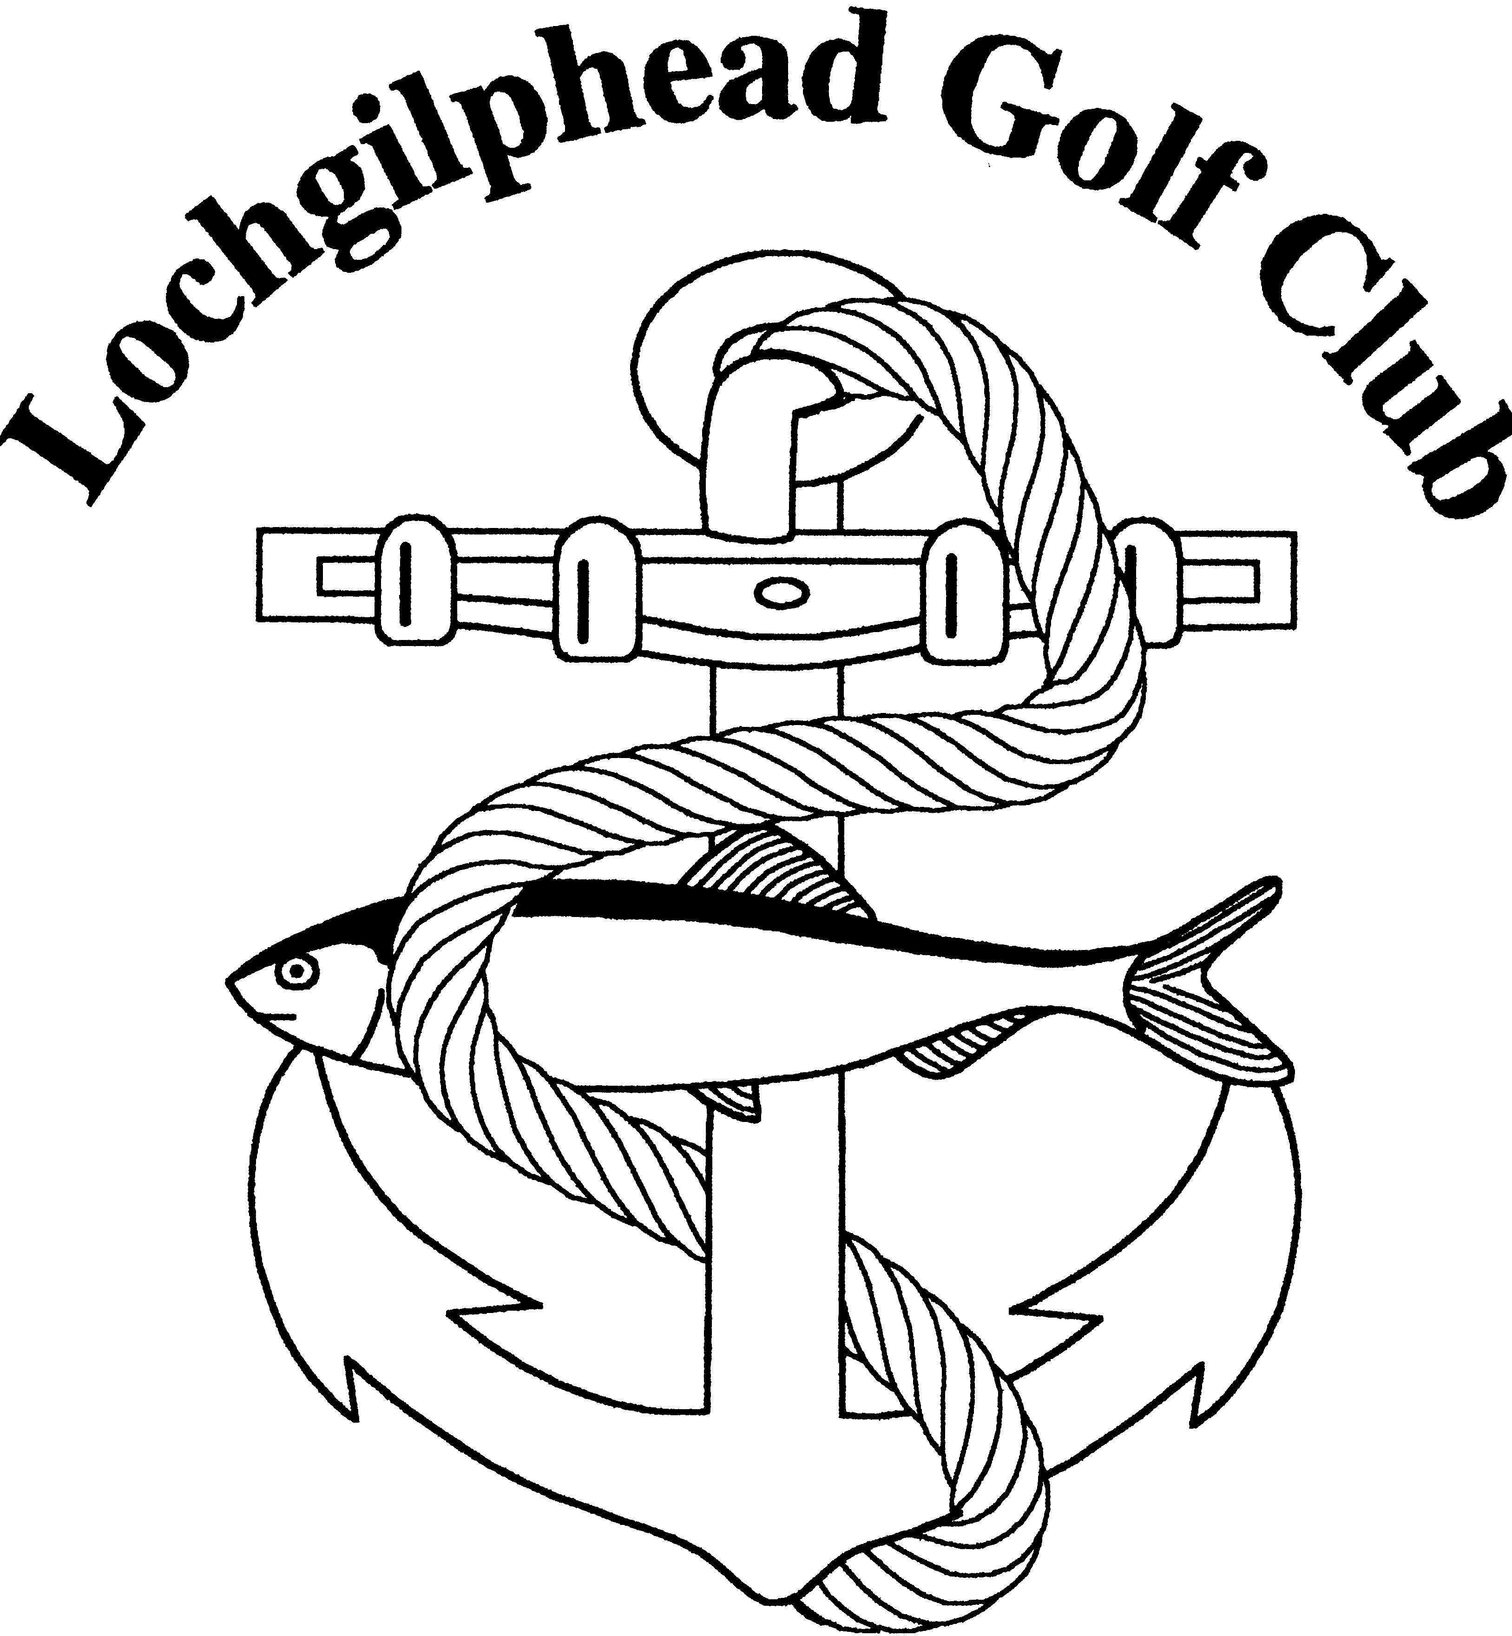
LOCHGILPHEAD GOLF CLUB
Application for Membership 2026

Personal Details

Name

Address
 |  | Post Code
Telephone No. |  | Date of Birth

Email Address

Type of Membership
 | Fees 2026  Due by 31 January |  | Monthly Standing Order Amount – to be paid  1st Monthly starting  1st January
Full | £276 |  | £24 per month
Country | £221 |  | £19 per month
5-Day | £179 |  | £15.50 per month
Senior (over 65 years of age) | £221 |  | £19 per month
Intermediate (16-18 years of age) | £91 |  | n/a
Junior (11-15 years of age) | £44 |  | n/a
Mini (10 years or under) | £11 |  | n/a
Social Member | £20 |  | n/a
Locker Rental | £20 |  | n/a
If Country, enter Home Club and CDH No.

Payment Method

Bank Details:

Sort Code 80-08-86, AccountNo. 00433066

Please quote your name as reference.

Direct Transfer to Bank
Standing Order
Cash or Cheque

Signed/Print Signature |  | Date:

ONLY full member (ordinary ladies/gents and senior) may sign up to a maximum of 5 guests during the year for £10 for 9 holes and £15 for 18 holes. 5-day and country members are not entitled to sign guests onto the course for a reduced fee.

Return form to: golfatlochgilphead@outlook.com

PLEASE READ THE GUIDELINES ON THE OPPOSITE PAGE AND MAKE YOURSELF FAMILIAR WITH THEM

Guidelines about Membership Fees
- The membership fees include golf union levies. Scottish Golf Union: £17.50, Argyll and Bute Golf Union £3.00
- The monthly standing order scheme will allow members to spread the annual membership fee over a full year, should they wish, which is especially beneficial if you are also a member of another club. When paying by standing order a £1 per month (£12 per year) admin fee has been added.
- Membership fees must be paid by 31 January 2026 if paying annually and for those paying by standing order these should commence on 1 January 2026, which means the full membership fee will be paid by 1 December 2026.
- The Club offers a family membership which is a full ordinary ladies or gents membership fee and then half price for all family members which must include at least one junior member (11-15years) and resides in the same household). Anyone wishing to pay a family membership by standing order should contact the Treasurer to agree a monthly payment.
- Should someone wish to join the club between January to September, they are due to pay the full annual membership. For those wishing to pay by standing order their first standing order will require to be a “catch-up” standing order. For example, if a new member joins in July, an initial payment of £161will be expected followed by monthly payments of £24, in order that the annual membership will be paid in full by 1 December.
- Should someone wish to join the club between October and December, they are due to pay from the month they join until the end of December. For example, if a new member joins in October, a one-off payment of £69 will be required or 3 standing orders of £24.
- Should a member default on their standing order, they will be unable to play until their standing order is re-instated. It will be at the discretion of the Golf Club Committee as to whether the standing order payment method is permitted for that member the following year.
- If a member cancels their standing order between October and December, they will only be permitted to renew their membership the following year by paying the amount outstanding from the previous year.
- ONLY full member (ordinary ladies/gents and senior) may sign up to a maximum of 5 guests during the year for £10 for 9 holes and £15 for 18 holes. 5-day and country members are not entitled to sign guests onto the course for a reduced fee.
- A 5-day member will be eligible to play in the mid-week challenge competitions but cannot gain or retain a handicap at Lochgilphead Golf Club (due to being ineligible to enter club competitions).
- If a junior member wishes to play in the adult competitions, they must pay the intermediate level fee.
- A membership form should be completed by each member, this helps us gather up to date information for the email distribution list and for the Scottish Golf app.

Visitor Green Fees
Green Fee | Fee
9 Holes | £15
18 Holes | £25

ONLY FULL MEMBERS
(ordinary ladies/gents and seniors) may sign up to a maximum of 5 guests during the year for £10 for 9 holes and £15 for 18 holes. 5-day and country members are not entitled to sign guests onto the course for a reduced fee.

