William E. Grady Career & Technical High School
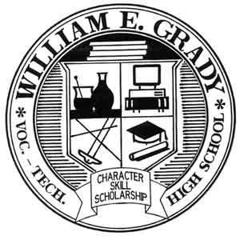
25 Brighton 4th Road, Brooklyn, NY 11235
Ph: 718-332-5000 / F: 718-332-2544 2544

Tarah Montalbano, Principal TMontalbano@schools.nyc.gov
Todd Gerber, Asst. Principal TGerber@schools.nyc.gov


How old were you when you began dreaming about what you wanted to be when you became an adult? When did you select your career path?

You are invited to come out and share your career with our students:

When: Thursday, April 18, 2024
9:30 AM to 1:30 PM

Where: William E. Grady CTE HS
25 Brighton 4th Road
Brooklyn, NY 11235

Our goal at William E. Grady HS is to introduce our students to as many colleges and career options as possible in order to help them make better career choices in the future. If you are interested in speaking or otherwise representing your organization at our Career Day, please complete survey here: https://forms.gle/nWFCBFxXmJ8NJnBe7

Contact John Jastremski jjastre@schools.nyc.gov 718 332 5000 x1090 with questions or for further details.

We hope to see you there!

