[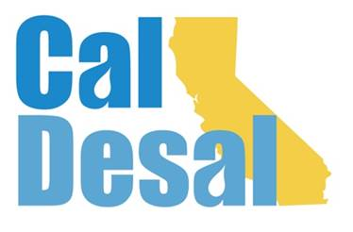](http://www.caldesal.org/)

**CalDesal Executive Committee Meeting Agenda**

**Monday, November 16, 2020**

**11:00 a.m.- 12:00 p.m.**

**Via Zoom video and phone platform**

**Agenda**

1. Call to Order by Chair Bob Shaver, Alameda County WD
2. Wendy Ridderbusch, ED reports:

**Annual CalDesal Conference**

* Wednesday afternoon, Thursday morning: February 10 & 11, 2021
* Draft agenda (attached)

**Annual CalDesal Meeting**

* Wednesday, December 2 early morning of Virtual ACWA Conference 7:00 a.m.- 8:00 a.m. Please accept Zoom invite sent from Nathan Carlson with CAMS
* Executive Committee including Officers elections will take place during this meeting

**Membership recapture, retention and recruitment efforts**

* Reaching out to targets on list to schedule pitch meetings for December and January
* Following up on lead for possible Western Growers membership

**Policy Committee and Issues Activity**

* CUWA Study partnership Update

**Communications and Social Media**

* New website update

**Governance**

* Strategic Plan third version and final draft (attached) and vote to approve
* CalDesal 2020-21 Officers and Executive Committee Elections Nominating Committee Update – Chair Bob Shaver
* Special Bylaws Committee discussion (attachment)

**ED Activity: Invitations, Requests, Meetings**

* Participated remotely on a Texas Desal Conference panel on October 15, 2020
* Participated virtually in the Public Policy Institute of California (PPIC) programs this month: Collaborative Approaches to Foster Groundwater Sustainability; Priorities for a Water Resilient California
* Participated in the California Water Association’s annual conference virtually

**Other items?**

Next Executive Committee Meeting: is **Wednesday, December 2,7:00-8:00 a.m. Zoom call before the virtual ACWA Fall Conference**

**Adjourn**