[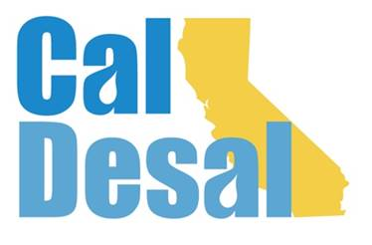](http://www.caldesal.org/)

**CalDesal Executive Committee Meeting Agenda**

**Monday, October 19, 2020**

**11:00 a.m.- 12:00 p.m.**

**conference call phone: (515) 604-9094, code: 1175-56965, NOT a Zoom call!**

**Agenda**

1. Call to Order by Chair Bob Shaver, Alameda County WD
2. Wendy Ridderbusch, ED reports:

**CalDesal Virtual Townhall Debrief**

* Number of attendees, number of non-members
* Sponsorship Funding
* Feedback on program?

**Annual CalDesal Conference**

* February 2021 moved to virtual format
* Considerations: registration fee, length, sponsorships

**Membership recapture, retention and recruitment efforts**

* Collection on outstanding invoices
* Preparing next round of outreach to potential members
* Membership Committee will determine 2021 meeting schedule

**Policy Committee Activity**

* California Urban Water Agencies (CUWA) study and $5,000 partnership with CA WateReuse and CalDesal – **vote requested** as we did not have a quorum present at September meeting

**Communications and Social Media**

* SWRCB twitter feed/CalDesal response update

**Governance**

* The third draft of the Strategic Plan will be sent next week via e-mail for final review, discussion, and vote during November 16, 2020 meeting – Please send any comments to Wendy via e-mail no later than Friday, November 6, 2020.
* CalDesal 2020-21 Officers and Executive Committee Elections Nominating Committee update
* Wednesday, December 2 Annual CalDesal Meeting during Virtual ACWA Conference 7:00 a.m.- 8:00 a.m. Elections will take place during this meeting!
* ED work during 4th quarter

**ED Activity: Invitations, Requests, Meetings**

* Participated on a Texas Desal Conference panel on October 15, 2020
* Attended the Water Agencies of County of Orange (WACO) meeting on salinity management on the Colorado River on October 2, 2020

**Other items?**

Next Executive Committee Meeting: is **Monday, November 16, 2020 11:00 a.m.-noon on Zoom**

**Adjourn**