[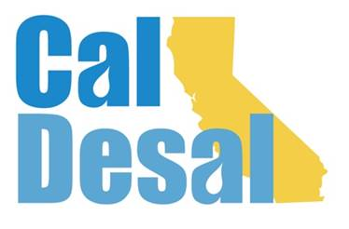](http://www.caldesal.org/)

**CalDesal Executive Committee Meeting Agenda**

**Monday, September 21, 2020**

**11:00 a.m.- 12:00 p.m.**

**On the Zoom Platform via Nathan Carlson at CAMS e-mail invite**

Agenda

1. Call to Order by Chair Bob Shaver, Alameda County WD
2. Wendy Ridderbusch, ED reports:

**CalDesal Virtual Townhall**

* **Please register to attend.** Friday, October 16th 3:00-4:00 p.m. via Zoom platform with CAMS operating dashboard
* We will have a short preview of our new website during the Townhall

**Membership recapture, retention and recruitment efforts**

* Chair Shoenberger held first membership meeting on August 31, 2020
* E-mailing Virtual Townhall invite flyer to potential members and all CalDesal February 2020 Annual Conference non-member attendees
* Great recruitment efforts by Executive Committee members – **THANK YOU!**

**Policy Committee Activity**

* Annual Conference Planning Meeting Chair Joe Monaco discussing 2021 event progress
* California Urban Water Agencies (CUWA) study and $5,000 partnership with CA WateReuse and CalDesal – vote requested

**Communications and Social Media**

* SWRCB twitter feed and CalDesal response

**Governance**

* Strategic Plan second draft (attached) for review and discussion
* CalDesal 2020-21 Officers and Executive Committee Elections Nominating Committee update

**ED Activity: Invitations, Requests, Meetings**

* Hunkered down with Strategic Plan, Virtual Townhall & Recruitment, and Nominating Committee process! No new meetings or events this past month.

Next Executive Committee Meeting: conference call (not Zoom) is **Monday, October 19, 2020 11:00 a.m.-noon**

**Adjourn**